 | Working Note | 
Comparison of slope estimates from the InSAR DEM and GTOP0’30
Kevin Tansey, UWS, 20th September 1999

Abstract & Main Conclusion
Comparisons of average slope estimates derived using 1. InSAR DEM, 2. GTOPO’30 DEM (using a GIM correction) and 3. GTOPO’30 DEM (not using a GIM correction to imitate a GEC scene) are undertaken for an ERS GTC product 32543_2475_0. The following are observed: 1. A reduction in the average slope estimates derived using the GTOPO’30 DEM as compared to the InSAR DEM for the same polygon. 2. The same polygons being assigned very different slope estimates. 3. The GTOPO’30 not detecting polygon outliers in the intensity/volume relationship as having excessive slope estimates. 4. The InSAR DEM slope estimates goes some way to detect outliers. 5. Analysis of a GTC (with no GIM correction) product show that surface slope estimations from the GTOPO’30 does not detect outliers in the relationships. RECOMMENDAION: GTOPO’30 should not be used to estimate average surface slopes of polygons. Furthermore, I would recommend GTOPO’30 could be used to define regions of ‘extreme’ surface slope variations but the resolution is too coarse for use at a 50 by 50m pixel size. I suggest further development of Heiko’s idea (concerning intensity). For the purpose of the database surface slope values (from GTOPO’30) can be displayed but the source of the slope (and aspect) estimates should be stated and used with caution.

Introduction
This working note attempts to prove the usefulness of using slope estimates derived from the GTOPO’30 DEM, reprojected into UTM coordinates at 500 by 500m pixel spacing. This work will complement the working note produced by Heiko and will hopefully lead to a decision being made on the overall use of GTOPO’30. A comparison is made between; (1) average slope estimates for polygons (of size greater than 50 pixels) derived using a median filtered InSAR DEM (derived from the GTC product) and, (2) average slope estimates for the same polygons using a re-sampled (to a 50 by 50m grid) sub-section of the GTOPO’30 global DEM recently delivered to the Siberia ftp server. The test site used for this experiment was the northern Irbeiskii test site. Polygon information was extracted from ERS image scene 32543_2475_0 (a GTC product).

Processing
The ERS image was calibrated using a GIM (produced from a 5x5 median filtered InSAR DEM). Polygon information was extracted using the erode+p_av and database scripts that UWS developed. Slope estimates for both the InSAR and GTOPO’30 DEM’s were created using ENVI software. The slope files were then used as input to the polygon averaging scripts (p_av). Resampling of the original 500 by 500m GTOPO’30 DEM to a 50 by 50m grid (using nearest neighbour resampling techniques) was also undertaken with ENVI. Tab-delimited text files were produced for display and various slope angle thresholds applied to the database to extract those polygons with average slopes greater than n° (degrees). In this example the InSAR slope threshold used was 6°. For Irbeiskii, the range of values observed was from just above 0° to 12°. The slope angle threshold is variable and a value of 6° is chosen purely for example. As will be shown the same threshold (6°) could not be applied to the GTOPO’30 derived slope estimates.

Results

InSar DEM analysis
Figure 1 shows the relationship between intensity (log scale) and stocking volume for the northern Irbeiskii test site. All polygons greater than 50 pixels are shown. Those that have average slopes greater than 6° are shown as a star, (∗) (derived from the INSAR DEM). What we would like to observe are those outliers especially within the natural forest polygons to be accounted for by a large slope angle. Research has shown us that forest normally exhibits a stable temporal intensity profile and consists of moderately strong scatterers (i.e. reflecting in a backscatter value between –7 and –9 dB). However, the magnitude of the backscatter depends on local canopy and ground moisture conditions. As shown in Figure 1, three of the four major outlying polygons of natural forest have large slope values. However, many of the other polygons flagged as having average slope values greater than 6° display ‘expected’ backscatter coefficients. This may be because, in these cases, the GIM correction accounts for the slope. Clear-cut regions (green circles) show similar backscatter properties to forest, and bog regions (blue circles) show low backscatter.
Figure 1. Intensity against volume for all landuse classes. Those shown as stars have estimated average slope values > 6°

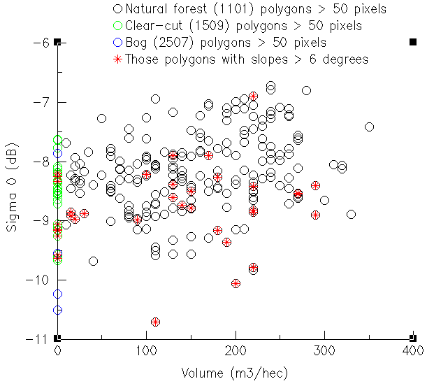

Figure 2 shows the same forest volume data against coherence (20 pixel) estimates. The influence of slope on coherence estimates has yet to be fully established and the data shown here displays mixed results. In Figure 2 all polygons greater than 50 pixels represented in the database are displayed. For natural forest polygons (black circles) the spread of data is quite significant. Analyses of these outlying points are made in the working note, ‘Analysis & interpretation of ‘strange’ outliers at the northern Irbeiskii test site’ by K. Tansey (UWS). Interesting points to note in Figure 2 are that stars (∗), indicating average slopes greater than 6°, are distributed within the data, even when estimates of coherence are high. Also, note that there is no significant clustering of coherence values for clear-cut regions (subject to further investigation presented in the working note mentioned above) or bog regions (no surprise with this latter landuse class).

Figure 2. Coherence against volume for all landuse classes. Those shown as red stars have estimated slope values > 6° (InSAR DEM)

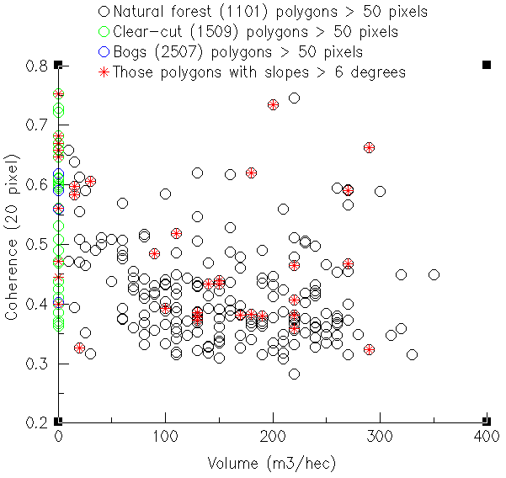

If slope degrades coherence, then the results shown here indicate that the reduction may not be a large or significant, more analysis is required to clarify the situation.

GTOPO’30 DEM analysis
The most important observation discovered is that when the same 6° threshold was applied to the average slope map derived from the GTOPO’30 no polygons were highlighted. All estimates were actually less than 5°. In fact to obtain the same representative number of polygons, the threshold was set at 3°. Another interesting observation is that the same polygons that were highlighted from the InSAR DEM analysis were in most cases different from the GTOPO’30 DEM analysis. It is obvious that the high frequency relief changes detected in the InSAR DEM are being averaged out or missed by the GTOPO’30 height estimates.

In Figure 3, the relationship between backscatter and volume for the Irbeiskii test site is shown. All of the landuse classes represented in the test site database are shown. Those polygons with average slope values greater than 3° are shown as stars (∗). The distribution of stars in the data seems to be random, but this may be because the GIM correction is accounting for the changes in incidence angle caused by the topography. Figure 4 shows the same slope threshold applied to the relationship between coherence and volume. Comparing Figure 2 with Figure 4 we do not see much similarity between those polygons having steep slopes, estimated from the InSAR DEM, and those polygons having steep slopes, estimated from the GTOPO’30 DEM.

The results show that estimates of slope derived from the global GTOPO’30 DEM originally resampled to 500 by 500m resolution do not compare, in the slightest, with estimates of slope made from the InSAR derived median filtered DEM. The values of slope derived from the GTOPO’30 DEM are less than those derived from the InSAR DEM for the same polygon. Furthermore polygons displaying high slope values from the InSAR DEM do not have relatively large slopes when estimated from the GTOPO’30 DEM.

Figure 3. Intensity against volume for all landuse classes. Those shown as red stars have estimated slope values > 3° (GTOPO’30)

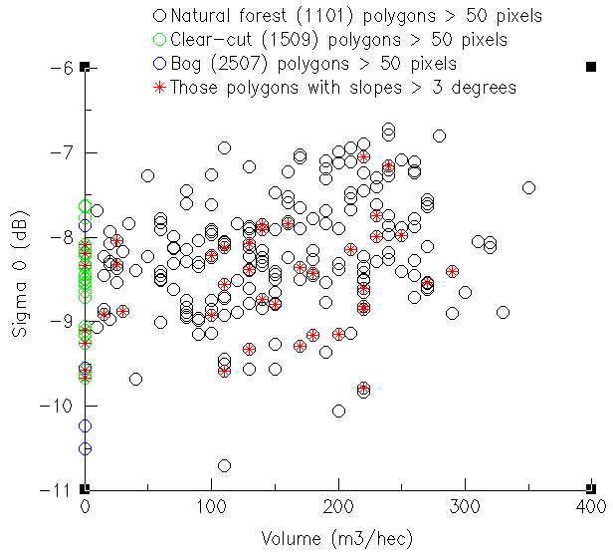
Figure 4. Coherence against volume for all landuse classes. Those shown as red stars have estimated slope values > 3° (GTOPO’30)

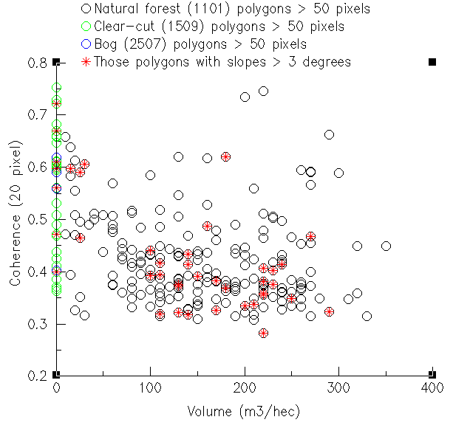

Simulating results for a GTC (no GIM correction) product
To get an approximate idea of the usefulness of the GTOPO’30 derived slope estimates to define polygons that are influenced by high relief I undertook the following experiment. (The results of the experiment would indicate whether outliers in the intensity data could be attributed to high relief as indicated by the GTOPO’30 DEM). I calibrated the Irbeiskii GTC product without using a GIM so there was no correction in the radiometry for the relief. I then extracted average slope values for the same polygons as those chosen in the analysis outlined above. Figure 5 shows the relationships obtained between intensity and volume. This can be approximated to undertaking a similar experiment with a GEC product, which will not be corrected for the influence of topography on the radiometry.

Figure 5. Intensity against volume for all landuse classes. Those shown as red stars have estimated slope values > 3° (GTOPO’30), no GIM correction applied

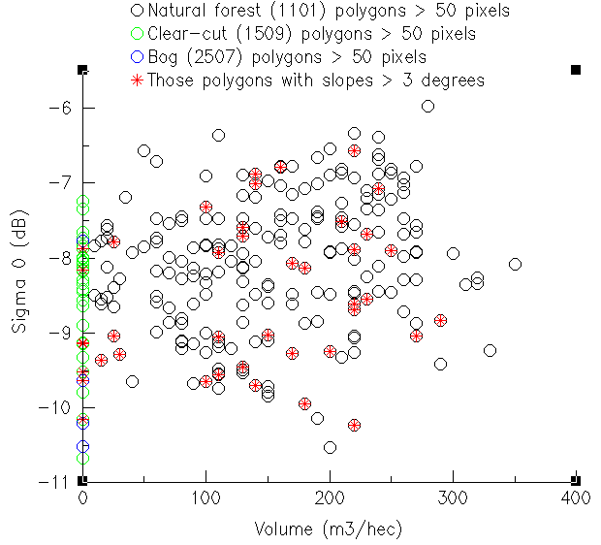

Obviously the coherence product under this processing step will be identical to Figure 4. Those polygons shown as having average slopes greater than 3° are well distributed in the data observations. Only a few of the extreme outlying points are flagged as having large slopes. Furthermore, by comparing Figures 3 and 5 we can see the influence of the GIM on the calibration of the imagery, in Figure 3 the distribution of values is much reduced. These results again emphasise the limited usefulness of GTOPO’30 derived slope estimates.

Conclusions

For concluding remarks see the main conclusion section of page 1 of this document.

