

Working note on Analysis of ERS SAR Information Content of the Ulkanskii (Lake Baikal) Test Territory
Kevin Tansey and Adrian Luckman
6th May 1999

Site Description:
32657_2493_0 ERS (GEC) frame was used that corresponded to the southern test area in the Ulkanskii test territory. The area can be described as mountainous by the shores of Lake Baikal in the east and flatter plateaus and river channels to the west. The area covered by the field data is not mountainous apart from the eastern extremities and is flat enough to be able to identify field polygon boundaries.
Methodology:
The field data was converted to a raster image, on a 50 by 50m pixel spacing and expanded in size to match the size of the image data.
Each field polygon is identified by a number (corresponding to the polygon number in the attribute database.
Field polygons are eroded to reduce contamination from surrounding polygons.
ERS amplitude data are converted to intensity (linear scale) using Calit g option (no GIM available).
Image and field rasters are overlaid and intensity values are extracted from polygons with > 150 pixels to increase the equivalent number of looks.
Values are converted to intensity (log. scale) and standard errors of estimation calculated.
Polygons that are influenced by terrain (areas in shadow, very bright regions in the mountains) have been removed from the analysis, approximately 8 polygons.
Values are compared to various forest attributes (Growth stock volume [m3/ha], tree type and age and stocking %).
(See also Powerpoint presentation, slides 1-8)
Results:
These are displayed in the PowerPoint presentation (slides 9-23) and are also summarised here:
Backscatter and Tree Age:
1. The sensitivity of the backscatter coefficient with tree age is not significant for any of the images observed (ERS1/2 tandem and ERS-2 spring/summer) (Fig. 1).
2. A large (1.3 dB) difference is observed between tandem images. This has been shown to not be due to calibration of the imagery but can be explained by changes in the physical properties of the scatterers in the scene (Fig. 1).
3. The mean standard error is large for young, immature and mature trees, small for overmature trees (Fig. 1).
Coherence and Tree Age:
4. Differences in the estimate of coherence using 20 and 80 pixels can be as much as 0.12 (the 20 pixel estimate is greater) supporting findings by SCEOS (Fig. 2).
5. Considering all forest types (coniferous (con) and deciduous (dec)) the coherence is not sensitive to dominant species age until the forest is dominantly mature. A reduction in the coherence is then observed (Fig. 2).
6. The standard error of estimation for coherence is small for overmature (in this case coniferous) forest (Fig. 2).
7. The estimates of coherence for deciduous dominated forest are more distributed than for coniferous woodland. A wide spread of values is also observed for young coniferous woodland (Fig. 3).
8. There seems to be a large difference (> 0.1) between immature deciduous and coniferous forest (Fig. 3).
9. If forest types are segregated, then the reduction in coherence is observed for coniferous forest between classes, middle-aged (class 2) and immature (class 3), and not between classes mature (class 4) and overmature (class 5) as the data suggests would happen if tree type is not accounted for (Fig. 2 & Fig. 4a)
10. Coherence increases with deciduous forest age class (this data set is limited by the number of samples) although more data are needed to confirm this observation (Fig. 4b).
Backscatter and Stock Volume:
11. There appears to be no relationship between this parameter and ERS backscatter (see the IIASA Web Site for further information about this parameter) (Fig. 5).
Coherence and Stock Volume:
12. The relationship between these two parameters is stronger than that for backscatter, there are no coherence values greater than 0.4 (20 pixel estimate) for a growing stock volume greater than 200 m3/ha. Below this value of stock volume estimates of coherence increase up to 0.55, however the spread of values for areas with low stock volumes (between 30 and 200 m3/ha) the range of coherence estimates is large (Fig. 6).
Backscatter and Stocking %:
13. There appears to be relationship at all between ERS backscatter and Stocking % (Fig. 7).
Coherence and Stocking %:
14. Again there appears to be no sensitivity of the coherence estimate to stocking % (Fig. 8).

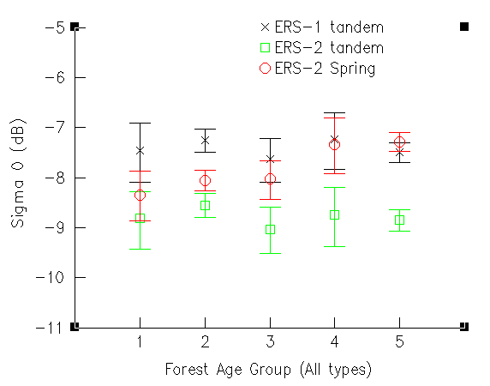  Figure 1 - Backscatter versus Tree Age | 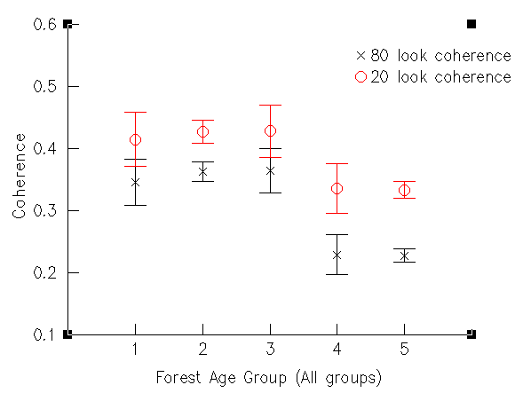  Figure 2 - Coherence versus Tree Age
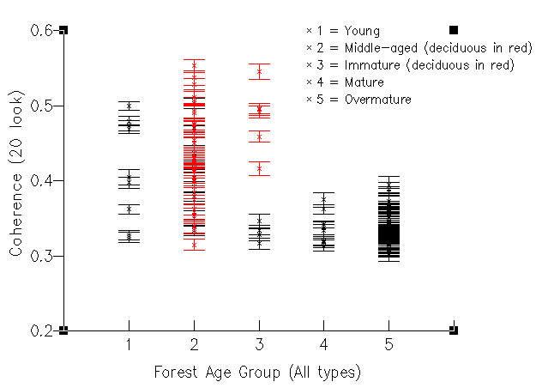  Figure 3 - Forest Type versus Coherence | 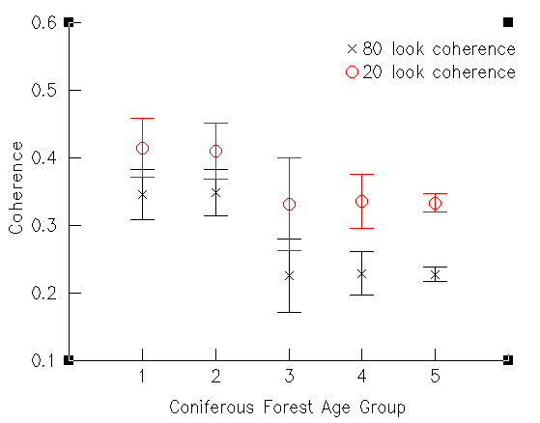  Figure 4a - Mean Coherence versus Coniferous Forest
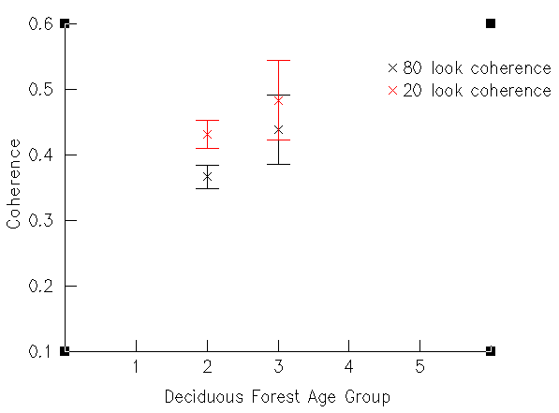  Figure 4b - Mean Coherence versus Deciduous Forest | 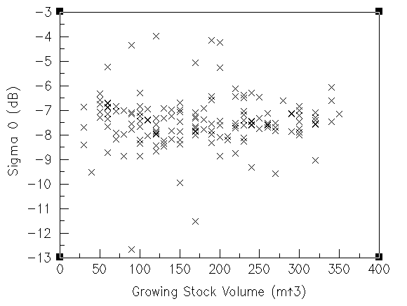  Figure 5 - Backscatter versus Growing Stock Volume
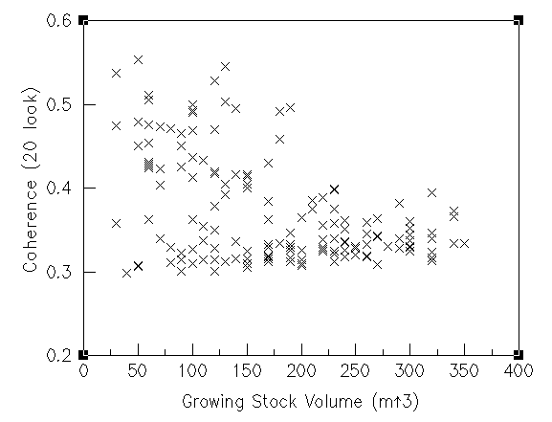  Figure 6 - Coherence versus Growing Stock Volume | 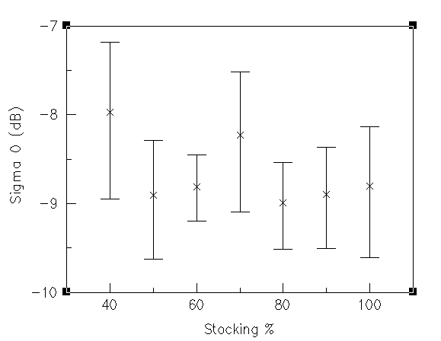  Figure 7 - Backscatter versus Stocking %
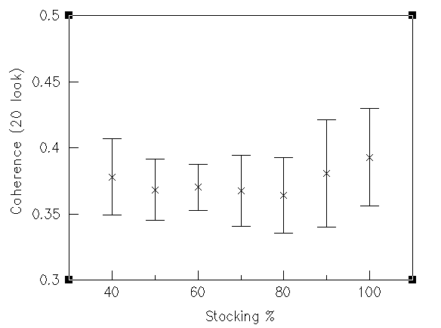
Figure 8 - Coherence versus Stocking %

