 | Working Note | 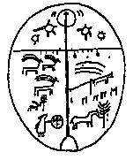
Report on Co-registration using GAMMA Software
Kevin Tansey, UWS, 31st January 2000

Abstract
This working note presents results and details the process of coregistration of JERS-1 imagery to ERS imagery using the GAMMA software.

The advantages of using this software are:
(1) The process is very quick (maximum of three minutes per scene including conversion to floats and reversal of this command). (2) JERS can be co-registered to ERS GEC and GTC products. (3) Images with very little area of overlap can be coregistered. (4) The output JERS image is in the same map geometry as the ERS image frame. (5) Output statistics are reported and can be saved. (6) The process can be scripted (just input file names are required) and is fully hands off.

The disadvantages of using the software are:
(2) Some errors of co-registration exist – especially in high relief regions. (2) The software has to be purchased. (3) In some cases, the refinement of the initial offset derived from the map coordinates does not work decreasing the likelihood of very fine registration (where overlap is not sufficient enough, registration still occurs however based on the map offset values).

Details
The co-registration software was tested for three scenes (2 x GEC, 1 x GTC) each with varying regions of overlap. The software was modified by Tazio Strozzi (Gamma, UWS) to read in the ERS dmp file and the JERS dem_par file. UWS developed a script that performs the coregistration without any prompting. The process (conversion to floats included) the process took under three minutes per image scene.

Processing Chain
Without compromising the method of coregistration used in the GAMMA software, an initial registration offset is automatically calculated from the map offsets provided in the header files. This is then refined to a good offset estimation. Further analysis produces an offset field for the coregistration and then a polynomial equation is written to perform the transformation. Bilinear resampling is then carried out from this equation. The bilinear transformation is the best method of resampling (details from Urs and Tazio). As the source code or binaries are not available to non-GAMMA licensed institutions the programs cannot be made available for testing.

Results

The images shown below have been co-registered. The intensity images are in a linear format with different scaling that accounts for the strong JERS intensity values. The RGB channels are: RED = ERS coherence, GREEN = ERS intensity, BLUE = JERS intensity. The full scene is shown followed by a zoom in of a region of the overlap. The final set of images (Fig 4.) shows a mosaic of 4 JERS scenes overlying the ERS frame. Image properties are discussed below.
Fig. 1: ERS = 32414_2493_GTC, JERS = 138_n62
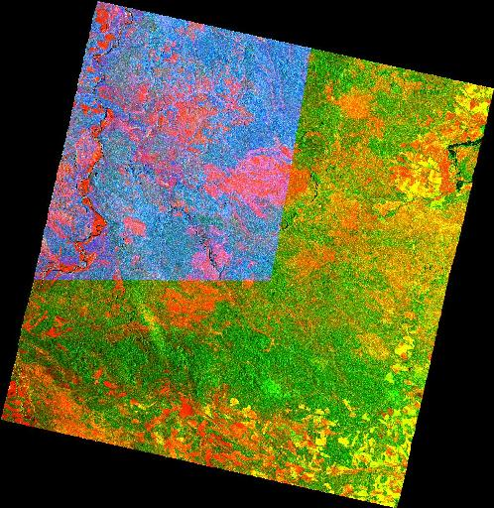
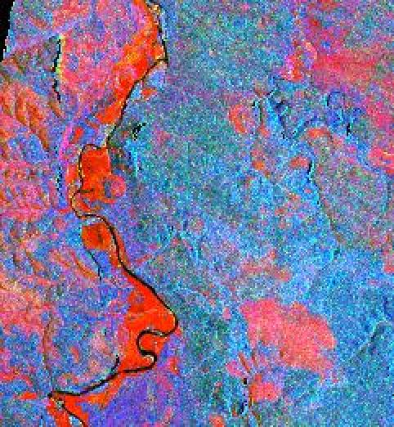
Fig. 2: ERS = 32657_2493_GEC, JERS = 122_n62
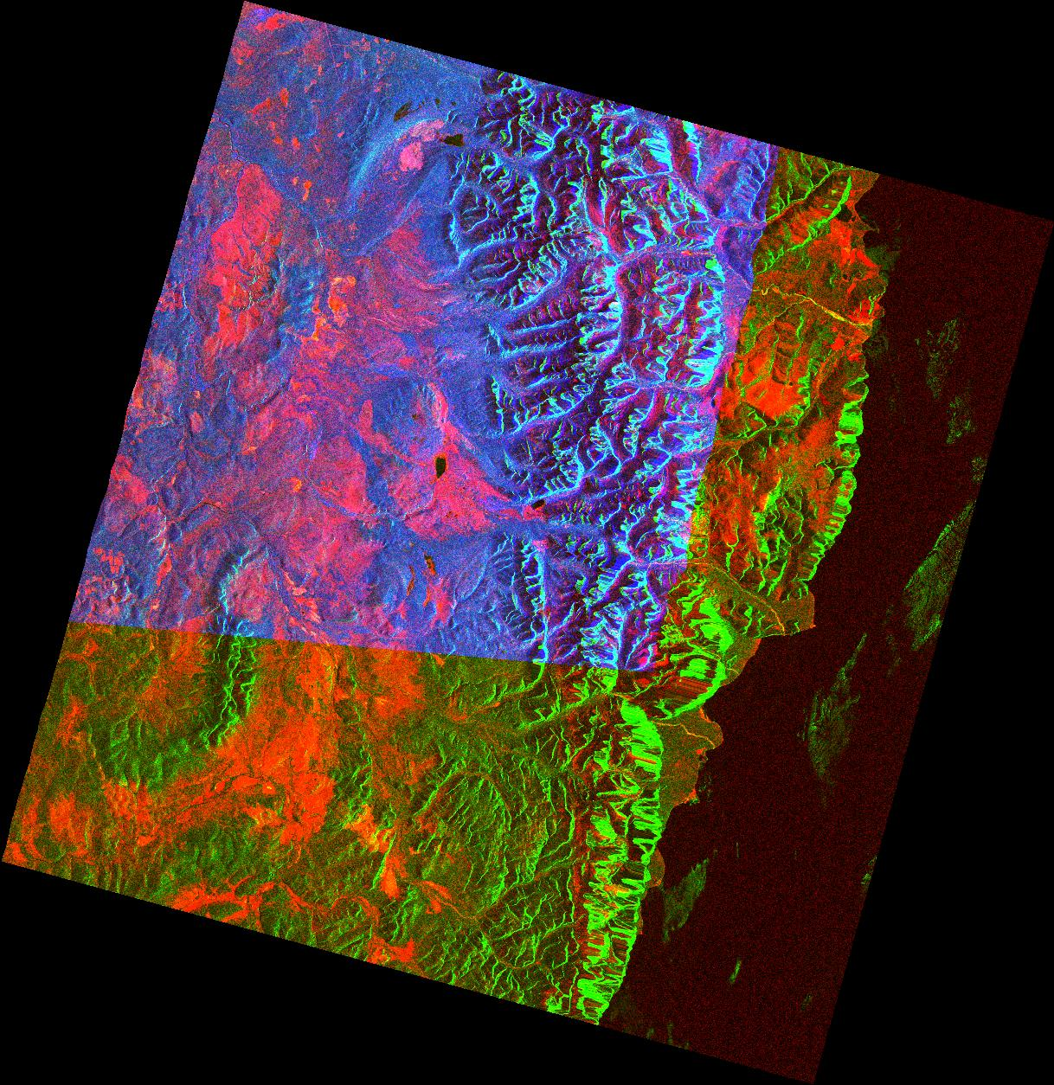
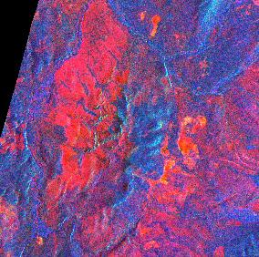
Fig. 3: ERS = 32700_2475_GEC, JERS = 122_n62
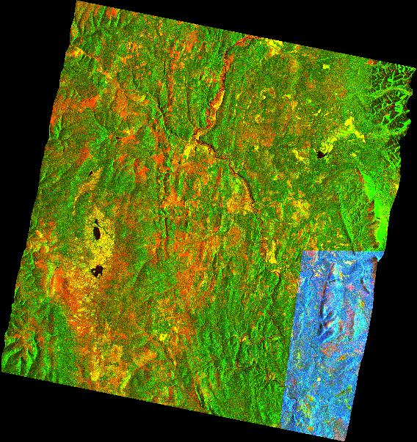
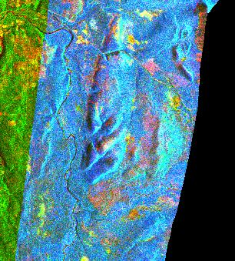
Fig. 4: ERS = 32414_2493_GTC, JERS = 138_n62, 138_n61, 136_n62 & 136_n61

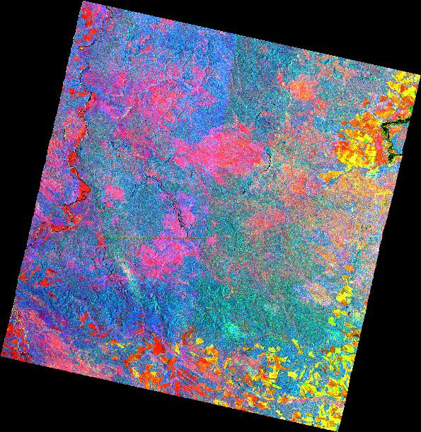
Please Note: Vertical join down the centre of the image, reflecting JERS intensity differences from orbits 2 days apart.
Horizontal join at the middle of the left half of the image. This is due to registration artifacts between scenes on the same orbit (3 pixels wide)
The ERS and JERS intensity are in a linear scale with different scale values so are not comparable (hence the dominance of blue = JERS intensity)
Images created using Gamma (co-registration) and ENVI (mosaic) software.
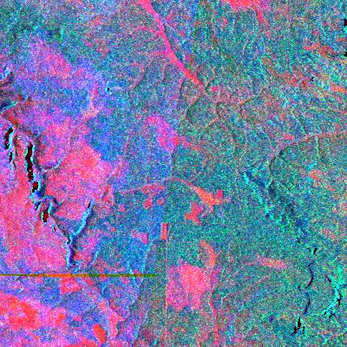

Please Note: Zoom in of the boundary between tracks (left-right) and frames (north-south).
The vertical line in the bottom middle of the image is in fact a ground feature (probably a road or power line) and it has probably stopped that forest fire in the low centre part of the image).

Conclusion
The GAMMA software coregistration option offers a quick, reliable and accurate method for registering JERS imagery to ERS imagery. The advantages of using this software certainly outweigh the disadvantages. The method seems suitable for both ERS GEC and GTC products. Although some small errors have been observed the method seems very suitable for the SIBERIA project.

Appendix A – Co-registration statistical output:

Example of coregistration information from the GAMMA software:
--------------------------------------------------------------

number of range samples: 24 number of azimuth samples: 24
number of samples in offset map: 576
range sample spacing: 63 azimuth sample spacing: 47
read offset and snr data...
number of accepted offsets: 310

range_singular values: 5.7275e+01 2.8027e+05 8.1431e+04
azimuth_singular values: 5.7275e+01 2.8027e+05 8.1431e+04

range_offset_polynomial: 2.8599e+02 2.5385e-03 -2.7161e-05
azimuth_offset_polynomial: 6.5883e+02 -6.7765e-03 -1.6445e-03

range parameter errors: 1.7460e-02 1.5155e-05 1.3030e-05
azimuth parameter errors: 1.7460e-02 1.5155e-05 1.3030e-05

standard deviation for range, azimuth fits: 1.0152 2.7113
range, azimuth error thresholds: 2.0305 5.4226

SNR threshold: 6.5000

************** rejected offsets *************
1577 175 287.834 660.084 289.984 647.858 11.952
1451 974 304.957 603.241 289.642 647.398 18.831
947 1162 286.325 651.550 288.358 650.505 6.979

range_singular values: 5.6245e+01 2.7765e+05 8.0850e+04
azimuth_singular values: 5.6245e+01 2.7765e+05 8.0850e+04

********* final least-squares parameters *********
range_offset_polynomial: 2.8689e+02 1.7550e-03 -5.0077e-04
azimuth_offset_polynomial: 6.5629e+02 -4.6357e-03 -2.1631e-04

range parameter errors: 1.7779e-02 1.5512e-05 1.3156e-05
azimuth parameter errors: 1.7779e-02 1.5512e-05 1.3156e-05
number of valid offset measurements after culling: 307

standard deviation for range, azimuth fits: 4.318e-01 1.855e-01

writing culled offsets: 138_980608_utm47_n62_to_32414_2493.coffsets

writing offset parameter file: 138_980608_utm47_n62_to_32414_2493.par

user time (s): 0.010
system time (s): 0.000
elapsed time (s): 0.040

