Investigation on input channels, filter choice and water initialisation in ISODATA classification
J J Yu 16/3/2000 (SCEOS)

experiment 1: investigation on filter choice and input images

part-a

Input images to ISODATA: ERS-1 23/5/97, ERS-2 24/5/97, ERS-2 27/5/98, JERS-1 4/5/97 and ERS 80-pixel coherence (23/5/97 & 24/5/97);

Intensity filtering: comprehensive multi-channel filter, 5x5, using 3 ERS, 2 JERS and 1 ERS coherence images;

Coherence filtering: box filter 3x3;

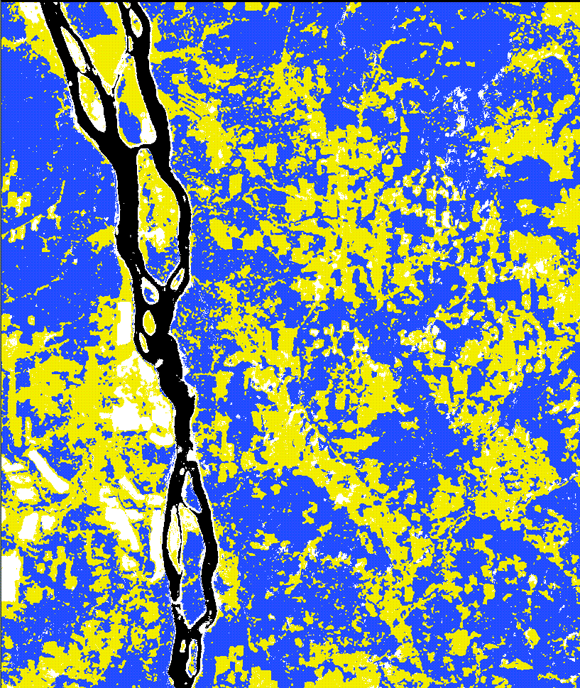
Water class initialised: No
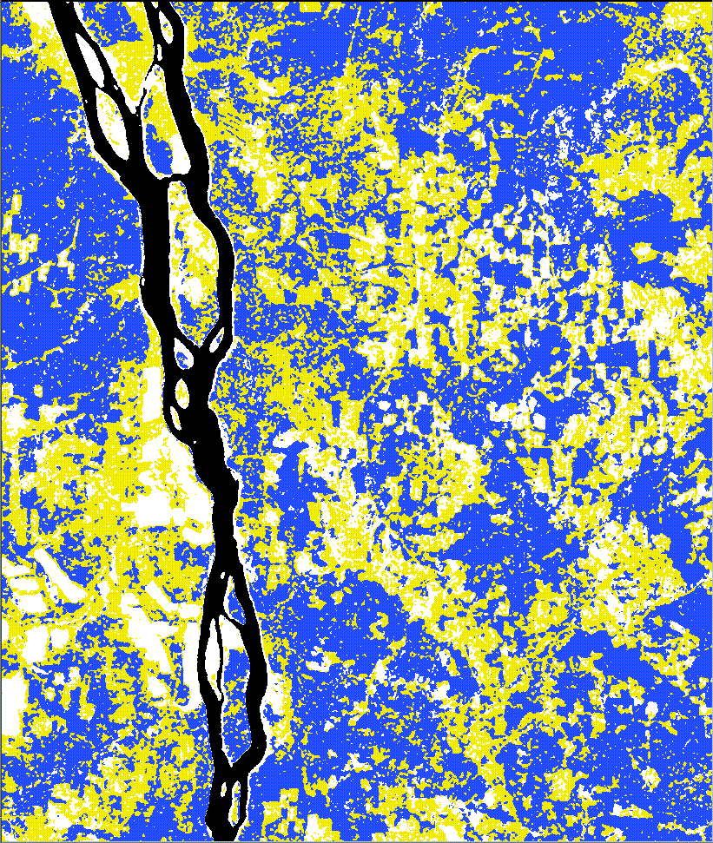
(a) (b)
Figure 1: 4-cluster classifications using 3 ERS, 1 JERS and 1 ERS coherence images; intensity images were filtered using (a) a 3x3 box filter and (b) multi-channel filter with window size 5x5. Coherence image was smoothed using a 3x3 box filter.
- Figure 1 (b) shows better separation between clearcut (yellow) and smooth soil (white) than Figure 1(a). The 3x3 box filter does not provide sufficient speckle reduction in the intensity images, especially in JERS.
- The 3x3 box filter results in slightly better water classification than the multi-channel filter.

Experiment 1 (cont.): investigation on choice of filter and input images

part-b

Input images: ERS-1 23/5/97, JERS-1 4/5/97 and ERS 80-pixel coherence (23/5/97 & 24/5/97)

Intensity Filtering: comprehensive multi-channel filter, 5x5, using 3 ERS, 2 JERS and 1 ERS coherence images;

Coherence filtering: box filter 3x3;

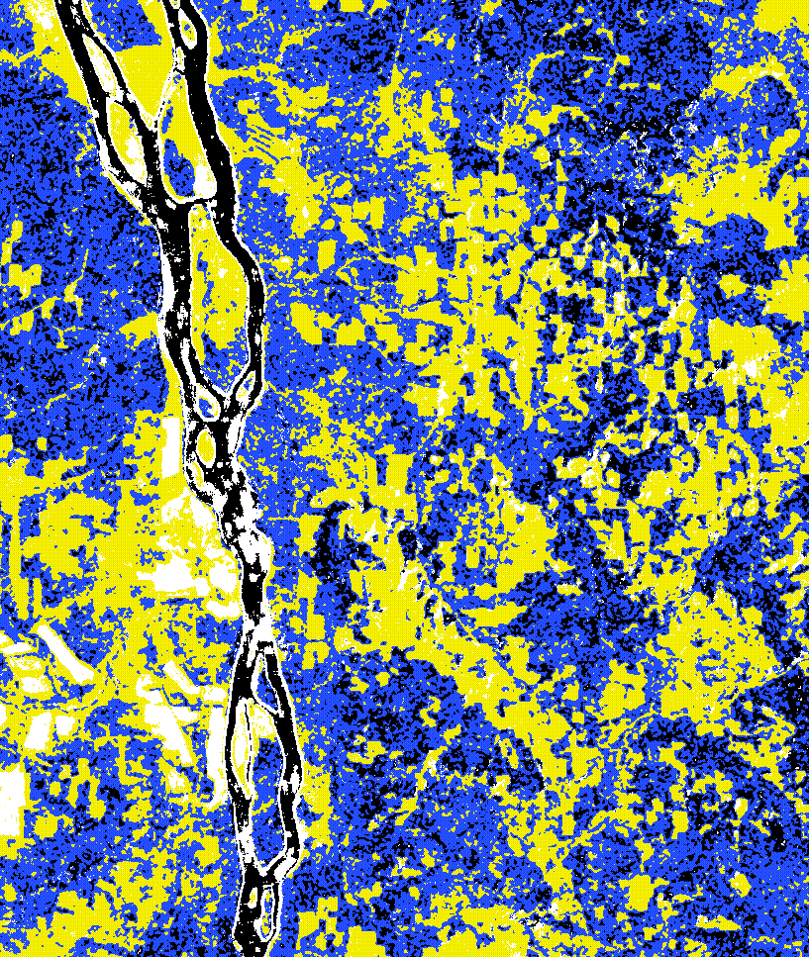
Water class initialised: No
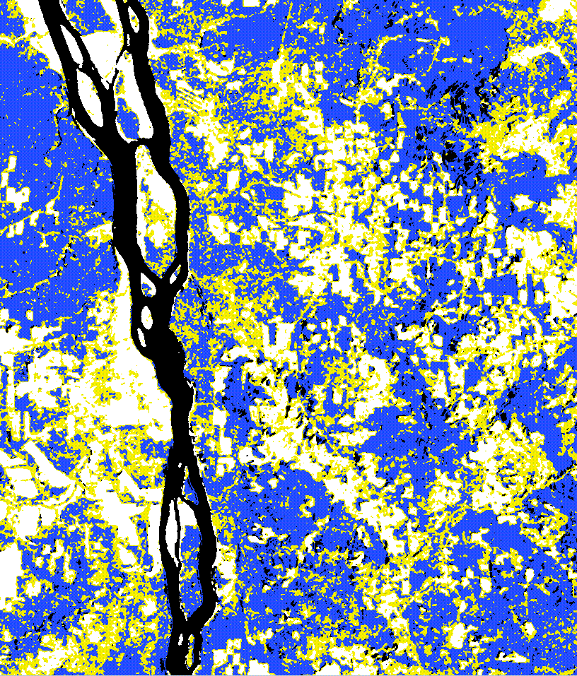
(a) (b)
Figure 2: 4-cluster classifications using 1 ERS, 1 JERS and 1 ERS coherence images; intensity images were filtered using (a) a 3x3 box filter and (b) multi-channel filter with window size 5x5. Coherence image was smoothed using a 3x3 box filter.
- The classifications using 1 ERS and 1 JERS are clearly much worse than the ones using 3 ERS and 1 JERS intensity images as shown in Figure 1. There are quite a few forest pixels misclassified as water in Figure 2 (b).
- The 3x3 filter gives better water classification than the multi-channel one. However, clearcut and bare soil cannot be separated using the 3x3 filter.

experiment 2: investigation on choice of input images and water class initialisation

part-A

Input images: Same as Figure 2 (b), ERS-1 23/5/97, JERS-1 4/5/97 and ERS 80-pixel coherence (23/5/97 & 24/5/97);

Intensity filtering: comprehensive multi-channel filter, 5x5, using 3 ERS, 2 JERS and 1 ERS coherence images;

Coherence filtering: box filter 3x3;

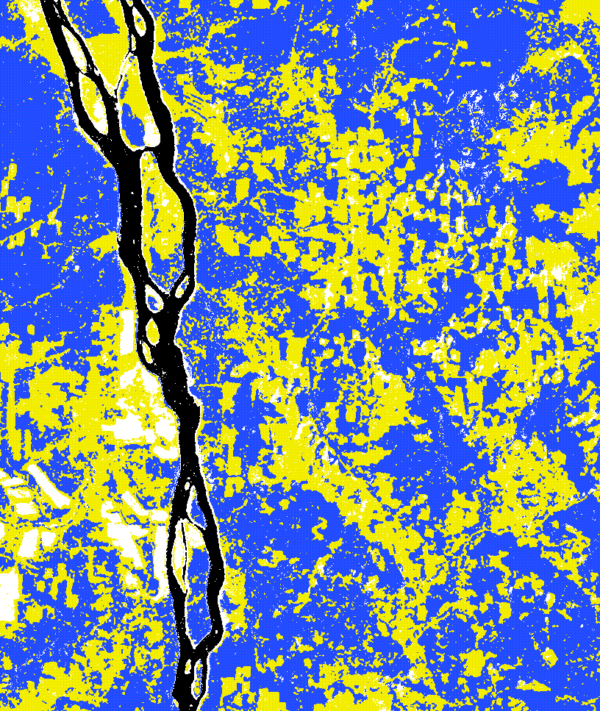
Water class initialised: Yes
Figure 3: 4-cluster classifications using 1 ERS, 1 JERS and 1 ERS coherence images, with water class initialised. Intensity images were filtered using a multi-channel filter 5x5.
- The ISODATA classification with water class initialised (Figure 3) is much clearer than the one without (Figure 2 (b)). The river is very well classified in Figure 3, whilst in Figure 2 (b), parts of the river are misclassified into the same class as bare soil. Visually, none of the forest class is misclassified as water in Figure 3, unlike in Figure 2 (b). The water class definition for the Ust_Illimsk area is given in Appendix.

experiment 2 (cont.): investigation on choice of input images and water class initialisation

part-b

Input images: Use same input images as in PART-A, but replace ERS-1 23/5/97 by ERS-2 27/5/98;

Intensity filtering: comprehensive multi-channel filter, 5x5, using 3 ERS, 2 JERS and 1 ERS coherence images;

Coherence filtering: box filter 3x3;

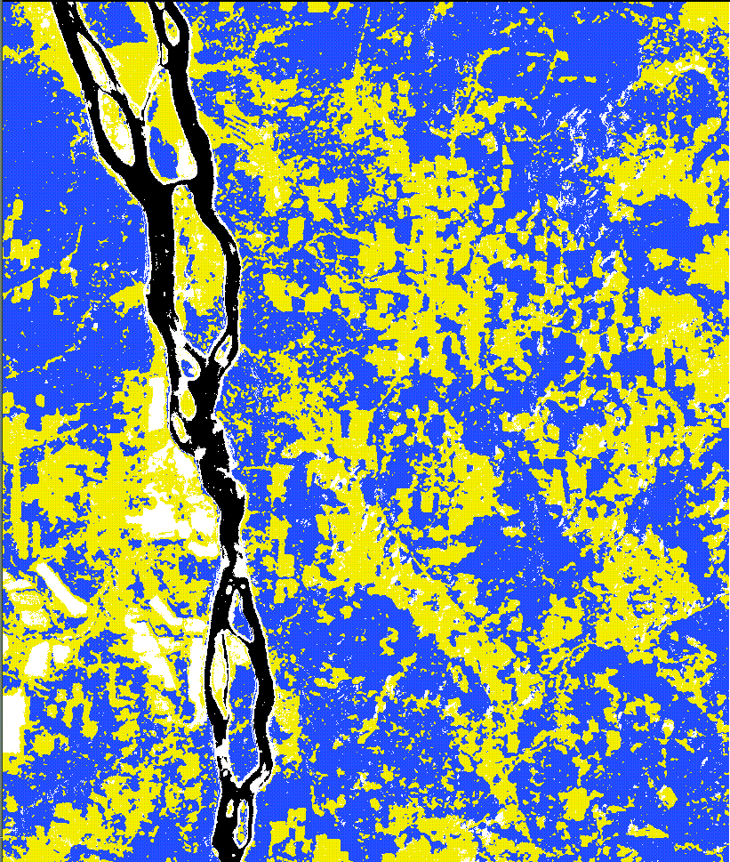
Water class initialised: Yes
Figure 4: 4-cluster classifications using 1 ERS-2, 1 JERS and 1 ERS coherence images, with water class initialised. Intensity images were filtered using a multi-channel filter 5x5.
- The use of ERS-2 27/5/98 image instead of ERS-1 23/5/97 causes small parts of the river to be misclassified as bare soil. Otherwise, the classification shown in Figure 4 is very similar to Figure 3.

Experiment 2 (cont): investigation on choice of input images and water class initialisation

Part–c

Input images: Use only two input images, ERS coherence and JERS 4/5/97;

Intensity filtering: comprehensive multi-channel filter, 5x5, using 3 ERS, 2 JERS and 1 ERS coherence images;

Coherence filtering: box filter 3x3;

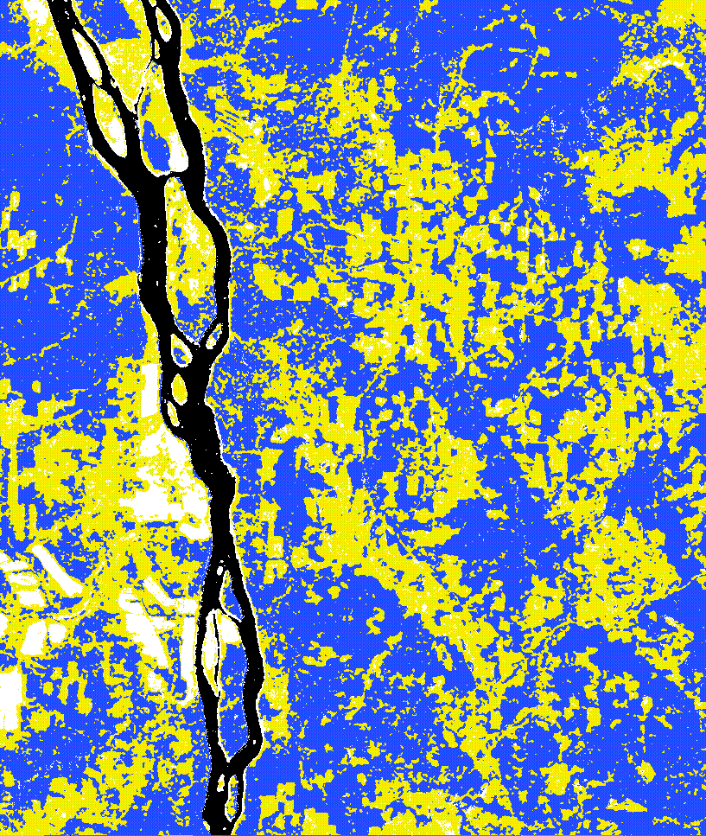
Water class initialised: Yes
Figure 5: 4-cluster classifications using 1 JERS and 1 ERS coherence images, with water class initialised. Intensity images were filtered using a multi-channel filter 5x5.
- Figure 5 is very similar to Figures 1 (b), 3 and 4, but with the following differences:
  - Figure 5 shows the best water classification;
  - The area indicated by the white rectangle is classified as clearcut (yellow) in Figure 5, but as bare soil in Figures 1 (b), 3 and 4;
  - Note that most of the features found in Figure 5 in the rectangle are also in Figures 3 and 4. However, there are other features in Figures 3 and 4, some stable between the 2 ERS acquisitions, some not, i.e. ERS brings information but much of it is not stable.

Experiment 3: ISODATA classification using coherence only

Input image: ERS 80-pixel coherence

Coherence filtering: box filter 3x3;

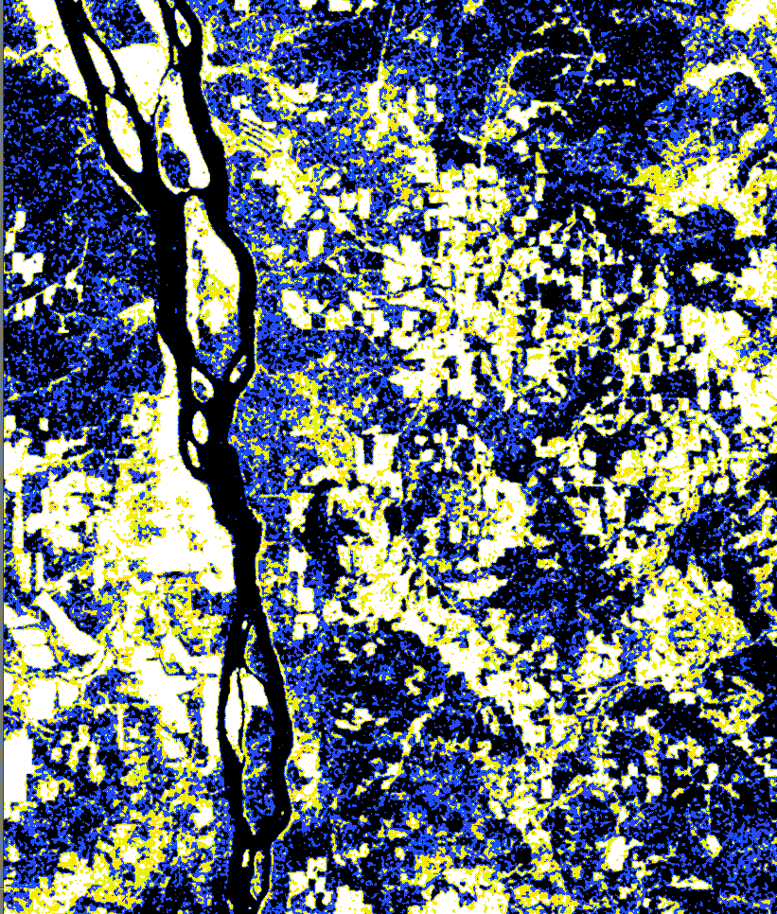
Water class initialised: No

Figure 6: 4-cluster classifications using only ERS coherence (3x3 filtered)
- As we would expect ISODATA classification using only ERS coherence cannot separate water from forest areas (partly because water is not initialised as JERS not used); clearcut and bare soil are classified as a single class.

Experiment 4: investigation on the effect of correlation between ERS Tandem pair in multi-channel filtering

Part-A

Input images to ISODATA: ERS-1 23/5/97, ERS-2 24/5/97, ERS-2 27/5/98, JERS-1 4/5/97 and ERS 80-pixel coherence (23/5/97 & 24/5/97);

Intensity filtering: Simple version of multi-channel filter (neglect correlation between the ERS Tandem pair), 5x5, using 3 ERS, 2 JERS;

Coherence filtering: box filter 3x3;

Water class initialised: No
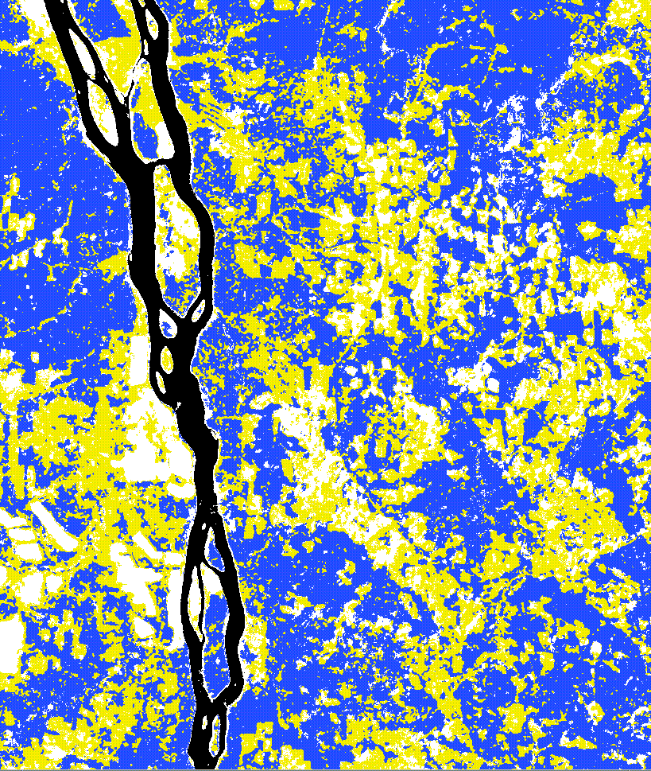
Figure 7: Same as Figure 1 (b), but intensity images were filtered using a multi-channel filter that neglects the correlation between ERS Tandem pair
- Figure 7 is to be compared with Figure 1 (b) in Experiment 1, Part A. Unlike in Figure 1 (b), some of the clearcut areas are misclassified as smoothed soil in Figure 7, which makes Figure 7 similar to the result using a box filter 3x3 shown in Figure 1 (a). Clearly, by neglecting the correlation between ERS Tandem pair, a simple version of multi-channel filter does not suppress speckle as much as a comprehensive one.

Experiment 4: investigation on the effect of correlation between ERS Tandem pair in multi-channel filtering

Part-b

Input images to ISODATA: JERS-1 4/5/97 and ERS 80-pixel coherence (23/5/97 & 24/5/97);

Intensity filtering: Simple version of multi-channel filter (neglect correlation between the ERS Tandem pair), 5x5, using 3 ERS, 2 JERS;

Coherence filtering: box filter 3x3;

Water class initialised: Yes
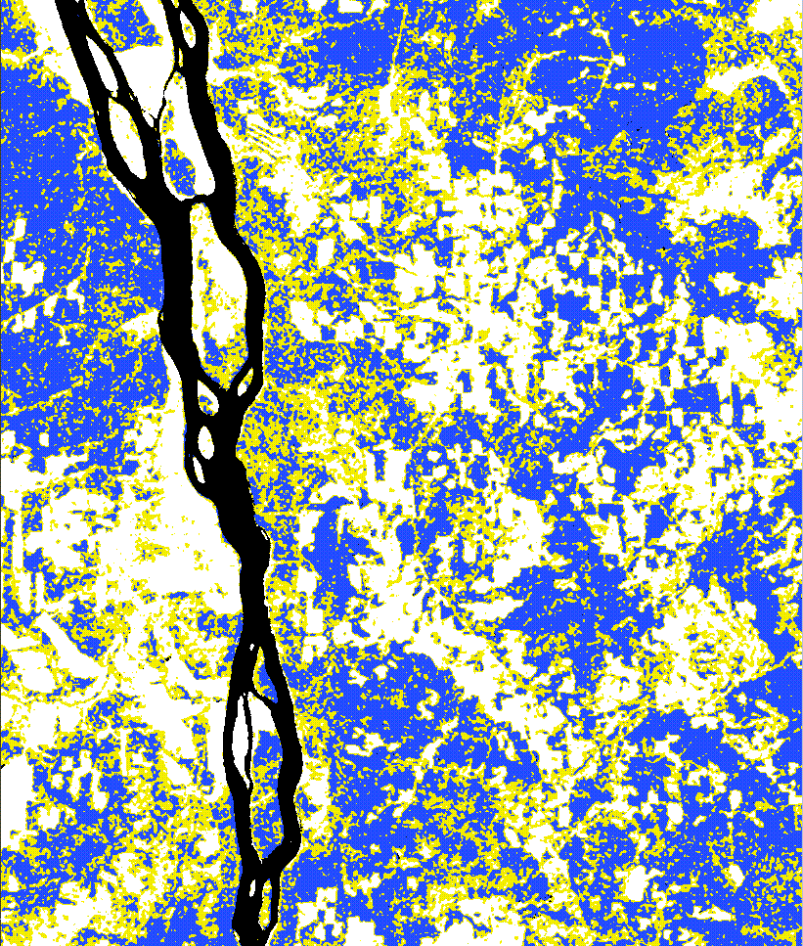
Figure 8: Same as Figure 5, but intensity images were filtered using a multi-channel filter that neglects the correlation between ERS Tandem pair
- There is a drastic difference between Figures 5 and 8. The clearcut and bare soil are inseparable in Figure 8, just like results generated using an ordinary box filter. This is because of insufficient speckle reduction in the JERS data.

conlcusions and recommendations
- Initialising the water class in ISODATA gives much better classification, as forest and water pixels with similar coherence values (see scatter plot in Appendix) can now be separated;
- Classification using only one JERS and coherence gives clearer classification than if an ERS image is added.
- As expected, the information in the coherence channel alone is not enough to produce a good classified image using ISODATA;
- In scenes where ERS is needed to separate bogs from the rest of the classes, ERS will introduce confusion in some areas. Using ERS data will also result in slightly different classifications;
- An ordinary box filter or a multi-channel filter that neglects correlation between images seems unable to reduce speckle to sufficient levels (especially in the JERS data) for further ISODATA classification. The extra noise causes increased classification error. For more accurate results, a comprehensive multi-channel filter with window size 5x5 is recommended.

appendix-- water class initialization at the Ust-Illimsk area

scatter plot of JERS backscatter vs. ERS coherence
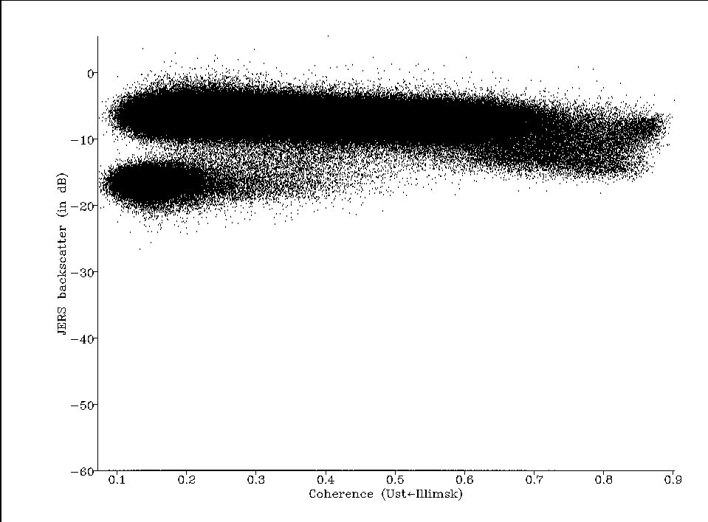
water
Bare soil ?
Figure 9: Scatter plot of JERS backscatter vs. ERS coherence using Ust-Illimsk data
- The water class is indicated by the red circle in the above scatter plot, with coherence less than 0.4 and JERS backscatter lower than –13 dB approximately. For the Ust_Illimsk test site, a pixel is initialised as water if the following two conditions are both satisfied at the same time:
JERS σ º < -13dB
ERS

Where ρ_min and ρ_max are the minimum and maximum coherence values in the ERS coherence image; and C is the expected number of classes.
- There is also evidence of bare soil, indicated by the blue circle, with characteristics of low JERS backscatter and high coherence. There is no clear separation between the bare soil and other classes in the elongated oval in Figure 9.
Note that for a given set of images, it is important to check the presence of water (and bog) and examine the number of pixels that fit the water “definition” in terms of JERS backscatter and ERS coherence. If the number found is too small, initialisation at these pixels will cause error in the output classification.

