Irbeski 1
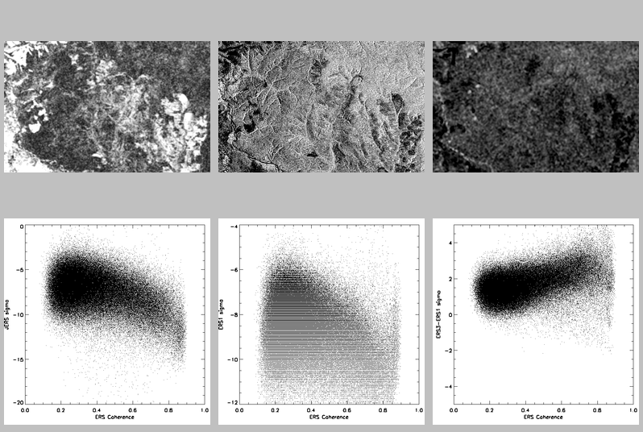
- water class ( JERS σº < -13 dB, ERS ρ < 0.16) not found, no class initialised
- input data: ERS ρ, JERS σº and ERS-3 – ERS-1

4-cluster classification:
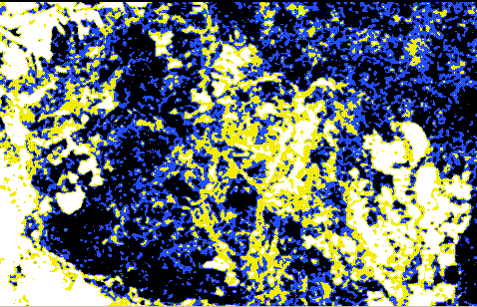

5-cluster classification:
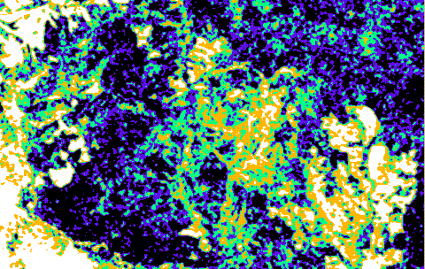
Ulkanski 1
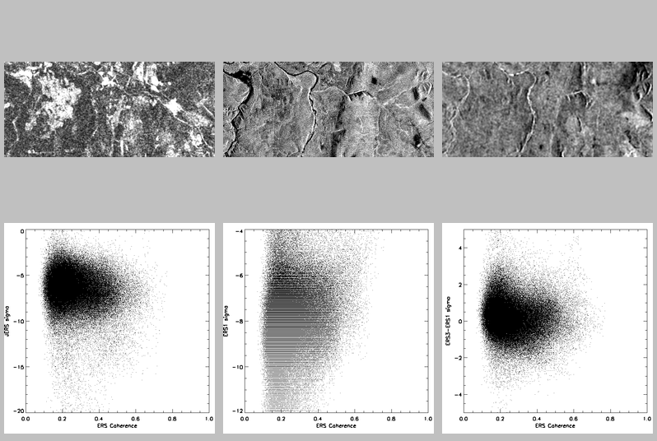

4-cluster classification using input data: ERS ρ, JERS σº and ERS-3 – ERS-1, water class initialised with JERS σº < -13 dB, ERS ρ < 0.16:
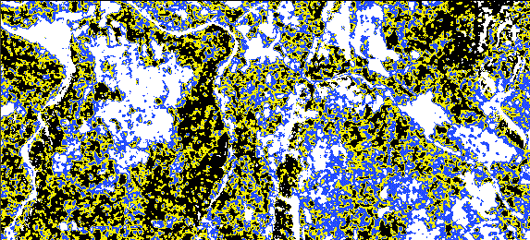

4-cluster classification using input data: ERS ρ, JERS σº and ERS-3 – ERS-1, water class initialised with JERS σº < -13 dB, ERS ρ < 0.24:
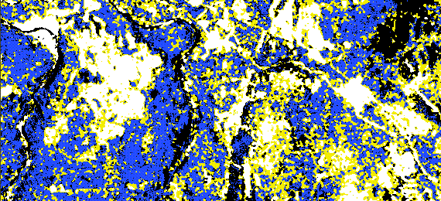

4-cluster classification using input data: ERS ρ, JERS σº and ERS-3 – ERS-1, no water initialised
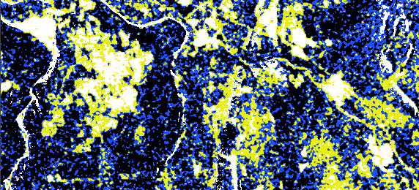

5-cluster classification using input data: ERS ρ, JERS σº and ERS-3 – ERS-1, water class initialised with JERS σº < -13 dB, ERS ρ < 0.16:
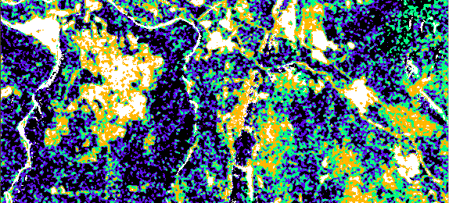

5-cluster classification using input data: ERS ρ, JERS σº and ERS-3 – ERS-1, no water initialised
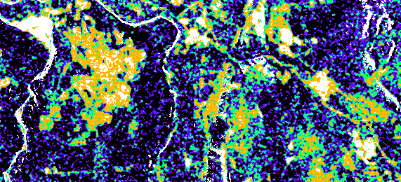

Nishni 2
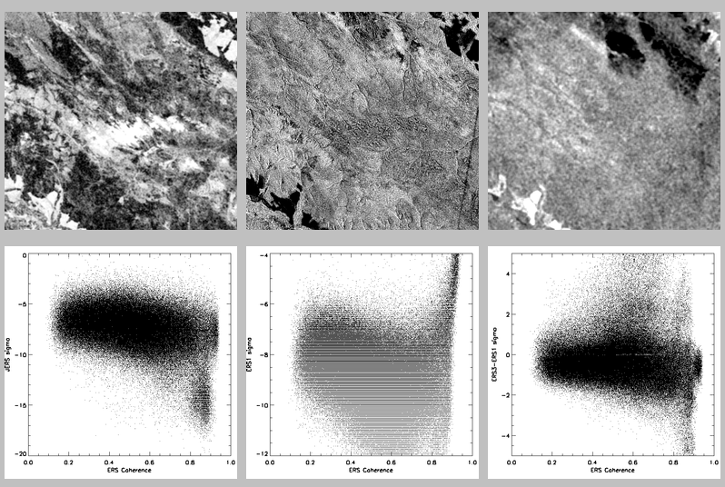

4-cluster classification using input data: ERS ρ, JERS σº , ERS-1 σº , and ERS-3 – ERS-1, bog class initialised with ERS σº > -5 dB, ERS ρ > 0.8 (no water class found):
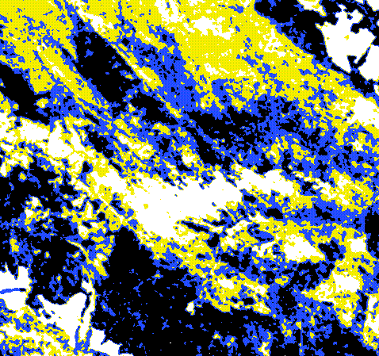

4-cluster classification using input data: ERS ρ, JERS σº , ERS-1 σº , and ERS-3 – ERS-1, no class initialised
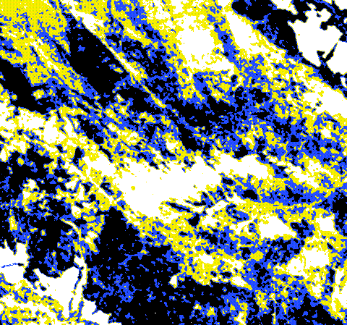

5-cluster classification using input data: ERS ρ, JERS σº , ERS-1 σº , and ERS-3 – ERS-1, bog class initialised with ERS σº > -5 dB, ERS ρ > 0.8 (no water class found):
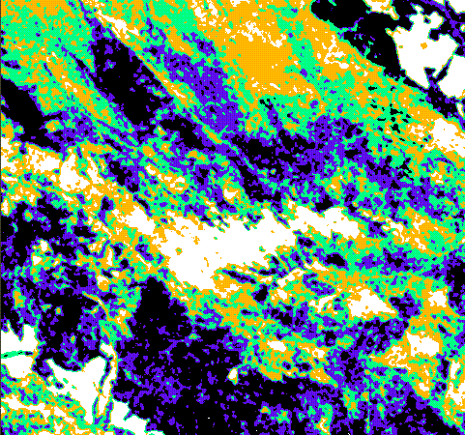

5-cluster classification using input data: ERS ρ, JERS σº , ERS-1 σº , and ERS-3 – ERS-1, no class initialised

