Working note on analysis of backscatter and coherence as functions of age
of the Bratsk/Ust-Illimsk test area

Jiong Jiong Yu and Shaun Quegan (SCEOS)
23/March/1999
- Introduction
One of the important steps in classification, especially in supervised classification, is developing sufficient knowledge to define representative signatures for each class in the SAR images. In the cases where thresholds or limits are used, it is necessary to identify homogeneous areas for all classes in the image to be analysed. Because of the lack of the ground truth data while this analysis was carried out (Feb 99), a hardcopy of an age map of the Bratsk/Ust-Illimsk area distributed on the KO meeting was used as a stopgap. It was scanned and registered to the ERS1/2 and JERS images, see Figure 1. Polygons of homogeneous areas were taken from the map and superimposed over the image data, which enabled the backscatter and the coherence generated from ERS Tandem pair to be analysed as functions of age. The analyzed SAR data are listed in Table 1. The two coherence images supplied by DFD were generated using windows of either 80 pixels or 20 pixels. This working note reports the preliminary results of the analysis. Because GEC, not GTC data, were used, the related geometrical and topographical effects may have larger influence on backscatter than the vegetation biomass, which has been noted during the analysis and is discussed here.

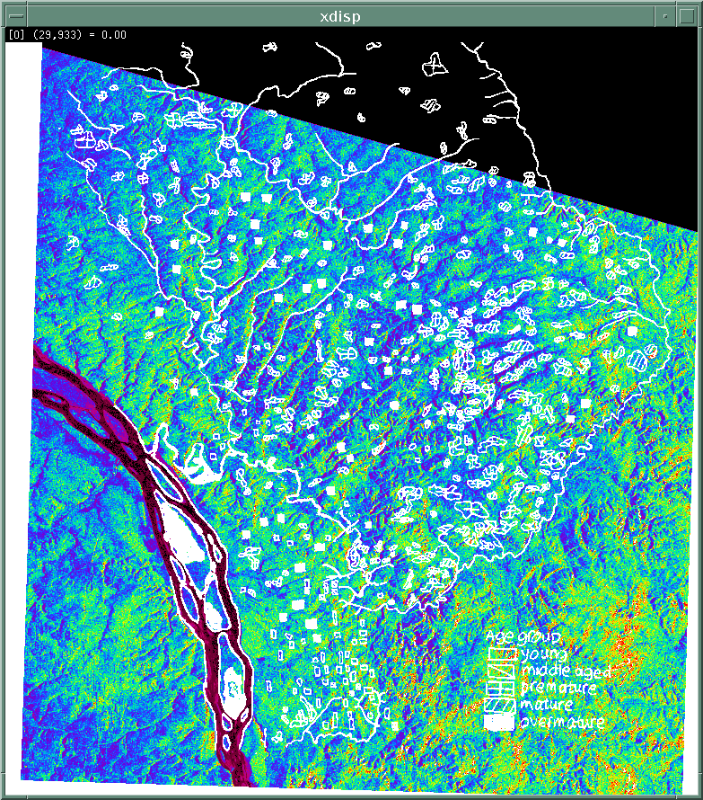  (a) | 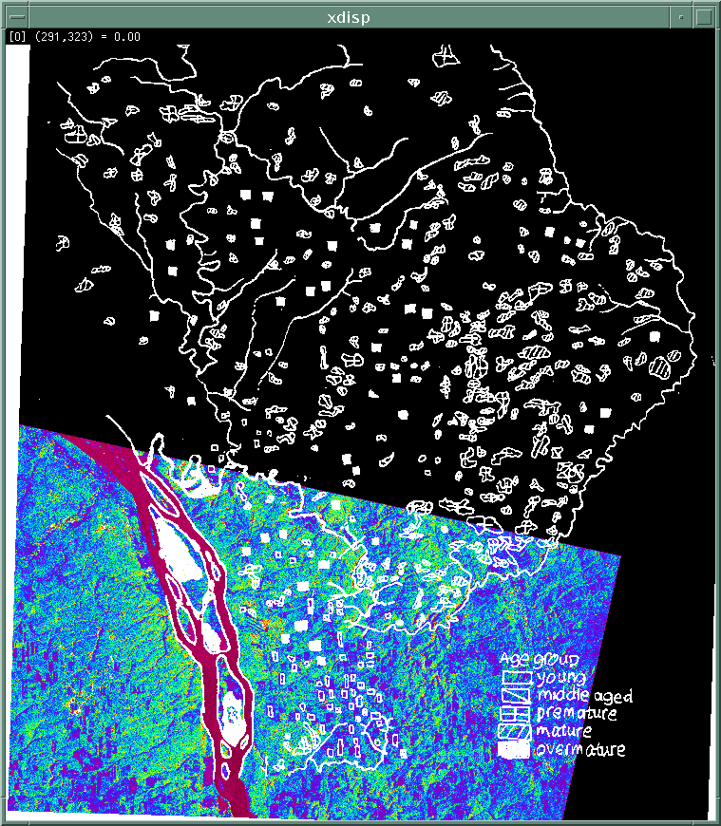  (b)
Figure 1 Scanned age map registered to (a) ERS data, frame 2421,
and (b) JERS data, row 202.

- Coherence vs. age
In the age map of the Bratsk/Ust-Illimsk area, five age groups are distinguishable, namely young, middle aged, premature, mature and overmature. For the purpose of comprehensive representation, as many polygons as possible were extracted for each group. In the cases of premature and mature, the number of polygons exceeds seventy, whilst the overmature group has the least number of polygons, around forty. For the purpose of measurement, the polygons were shrunk to avoid edge corruption of the measured values. The number of pixels in the polygons is in the range 150 - 1500. The polygons are numbered arbitrarily from the South to the North and from the East to the West in the map, possibly causing systematic effects that will be discussed later.

 | Sensor | Format | Data Type | Acquisition date | ERS Frame/  JERS Row | Orbit
1 | ERS-1 | Intensity | GEC | 23/9/97 | 2421 | 32371
2 | ERS-2 | Intensity | GEC | 24/9/97 | 2421 | 12698
3 | ERS-2 | intensity | GEC | 27/5/98 | 2421 | 16205
4 | ERS-1/2 | Coherence  (20-pixels) | Generated from (1) and (2)
5 | ERS-1/2 | Coherence  (80-pixels) | Same as above
6 | JERS-1 | Intensity | GEC | 4/5/97 | 202 | 28593
7 | JERS-1 | Intensity | GEC | 31/7/97 | 202 | 29911
Table 1: List of SAR data analysed as functions of age.

Based on the assumption that these polygons correspond to homogeneous areas in the SAR images, the pixel values inside each sample were averaged to give the local mean coherence. These local means are represented by points in Figure 2 (a) and (b), for coherence images of 80 pixels and 20 pixels, respectively. The x-axes in both figures are the arbitrary polygon numbers. The points belonging to the same age groups are linked by lines to aid the interpretation. It is important when interpreting these graphs to remember that while each age group is measured in an approximately systematic way (N to S, E to W), the numbering between age convey no geographic information. The remarks which follow must be interpreted in this light. Both Figure 2 (a) and (b) have the following common features:
(a) The young and middle aged forest stands are separated from the rest of the stands in the sample range of No. 1 to 12;
(b) In the range No.12 to 25, all classes are mixed together with no separation;
(c) The middle aged, premature, mature and overmature stands No. 15 to 20 have similar coherence behaviour in both graphs, with almost identical increasing and decreasing patterns. The same behaviour is observed for premature and mature stands No.20 - 25. In fact, these stands are all concentrated on the right hand side of the map, lying inside the rectangle in Figure 1 (a). This phenomenon could be caused by terrain effects, which dominate the age effect on the coherence. The map information, such as DEM of this area, has not yet been used for interpretation, but will be checked upon in further investigation;
(d) The young stands can be discriminated from other classes for stands No. 25 - 43;
(e) From stand number 43 onwards, the middle aged, premature, mature and overmature tend to be separated from each other.
A clear difference between Figure 2 (a) and (b) lies in the dynamic range of coherence. The coherence resulting from a window of 80 pixels (Figure 2(a)) has larger dispersion than that from a window of 20 pixels (Figure 2(b)). Coherence are within the range 0.15 to 0.65 in (a), and 0.3 to 0.65 in (b). In addition, the coherence values of middle aged, premature, mature and overmature stands are higher in Figure 2 (b) than in Figure 2 (a), whilst the young stands are fairly similar in both graphs.
In order to illustrate further the different coherence levels between Figure 2 (a) and (b), the average and standard deviation (SD) of all the points of the same age group are calculated, and represented by diamonds and error bars as a function of age in Figure 3. The two data sets in Figure 3, black diamonds for 80 pixels coherence and red for 20 pixels, show that the coherence declines with age. The previously observed coherence sensitivity between age classes, especially between young, middle aged and premature, is confirmed; whilst there is little separation between mature and overmature stands. Notice that only the young forests can be well separated from the premature and older ages, as indicated by the non-overlapping 1 SD intervals. This separation is slightly better for the 80 pixel coherence. From Figure 3, it is obvious that the difference between coherence values resulting from different processing windows is smallest for young stands, and increases when the stands get older. This is caused by the positive bias in the coherence estimator, which increases as coherence and the window size decrease. Hence, bias increases with age and the processing window of 80 pixels gives less bias.

(a) (b)
Figure 2. Plots of coherence values of different age groups, estimated from coherence images generated using windows of (a) 80 pixels and (b) 20 pixels.
Figure 3. Averaged coherence vs age from the Bratsk test area.

- Backscatter vs. age
The set of polygons used in Figure 2 and 3 was also used to retrieve backscatter signatures of age classes in the available SAR images, and the results are illustrated in Figure 4 (a) – (e). Again, each point in the plots represents a local mean (averaged in intensity before conversion to dB). The ERS plots, Figure 4 (a) – (c), indicate that the chance of separating the age classes using ERS data is small, since the curves overlap severely. There are several cases where unusual behaviour is observed in all ERS images. For example, from the three graphs ((a) – (c)), it can be seen that for middle aged stands, the backscatter is the lowest at sample No. 27, and highest at No. 56; while for mature stands, the highest is at No. 30. The topography possibly plays a significant role in these sampled backscatter values. In addition, there is a slightly decreasing trend in all three graphs. This systematic trend is related to the way the polygons are numbered. Terrain, elevation or calibration effects are all possible causes, requiring further investigation.
In the case of JERS ((d) – (e)), the number of samples is smaller than in the ERS images because many samples are outside the JERS images (see Fig. 1(b)), but the discrimination between age classes is more feasible. The data used to form Figure 4 were averaged and plotted against age, as shown in Figure 5 (a). The ERS data samples in this figure show that age discrimination based purely on ERS σº data will be impossible. This is because the separation between classes is small in ERS images, and mean backscatter of forest stands of all age classes lies within a small dynamic range of –8.7dB to –7.5 dB. Note that the ERS data acquired on 27/5/98 are generally higher than the Tandem pair acquired in September.

( a ) ( b )

( c ) ( d )
(e)
Figure 4. Plots of σº values of different age groups retrieved from: (a,b) ERS Tandem, (c) ERS-2 spring, and (d, e) two JERS images.

(a) (b)
Figure 5. The plots of (a) mean log σº vs. age. (b) mean intensity vs age, with SD error bars of JERS data.

When compared with ERS, the JERS data lies within a much bigger and higher dynamic range of -6.8dB to –3.8 dB. The sensitivity of JERS to biomass is also obvious in Figure 5(a). The backscatter increases as the stands get older, reaching a peak at the age of “mature”, then decreasing a little at “overmature”. The young stands exhibit the biggest backscatter difference between the two JERS data sets, one acquired on 4/5/97 and another on 31/7/97, and this difference gets smaller as the trees get older. In order to investigate the overlapping between classes, the error bars of SD are added to the JERS data in (a) and shown on Figure 5 (b). Note that the y-axis in Figure 5 (b) is in intensity rather than in dB as in (a), because the dB dynamic range of SD is too large for displaying. These error bars indicate that, in JERS images, the premature stands have the largest SD that overlaps with all other age classes. The young and middle aged can be clearly separated from mature stands, and the young and overmature classes can be well discriminated from each other, because their error bars do not overlap.

- Summary
The backscatter of available ERS and JERS images, as well as the coherence images generated using windows of different sizes, have been analysed against age. The main results are:
The backscattering coefficient from the same forest stands is higher in JERS images than in ERS.
(a) The JERS data show much more sensitivity than ERS in terms of age discrimination at the Bratsk site. The young stands can be separated from mature and overmature stands using JERS data; the middle aged can be separated from the mature; whilst the premature has large SD and cannot be reliably distinguished from other age classes.
(b) Coherence is a potential data source for age classification. In terms of separability, the young stands can be well separated from the premature and older ages. The coherence values are clearly influenced by the processing window sizes; a window of 80 pixels results in lower coherence than that of 20 pixels, due to the bias introduced by the smaller window.
(c) The measured coherence and backscatter values are possibly affected by topographic factors in the GEC data, and may not truly reflect the age related vegetation biomass. This needs to be investigated further.

