HELD BACK TEST AREAS

Ulkanski
Test area 1 (UTM 49)
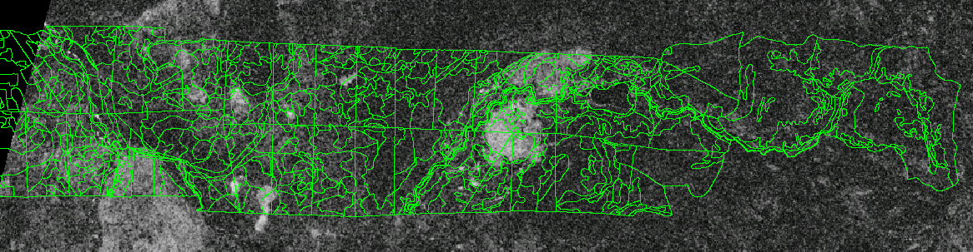
Frame 2493 orbit 32657 -- this is available as a GEC (shown below)
Test area 2
Frame 2475 orbit 32657 -- is this available?

Manski
Three test areas (UTM 46)
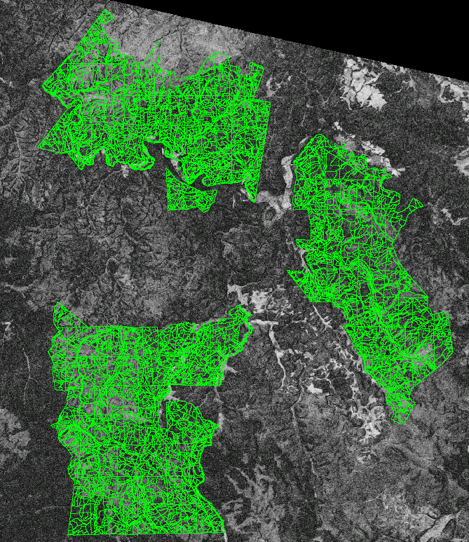
Frame 2493 orbit 32357 -- this is available as a GEC (shown below)
The northern area has some areas burned and should be masked.

Irbeiski
Three test areas (UTM 46)
Frame 2493 orbit 32543 -- this is available as a GEC _GLOBE (shown below)
And frame 2493 orbit 32500 -- is this available? -- I do not have this.
This area may have changed since the 1992 inventory! See the Q&A page of the IIASA web page.
http://www.iiasa.ac.at/Research/FOR/siberia/qa.htm#Question 13. 00/01/25
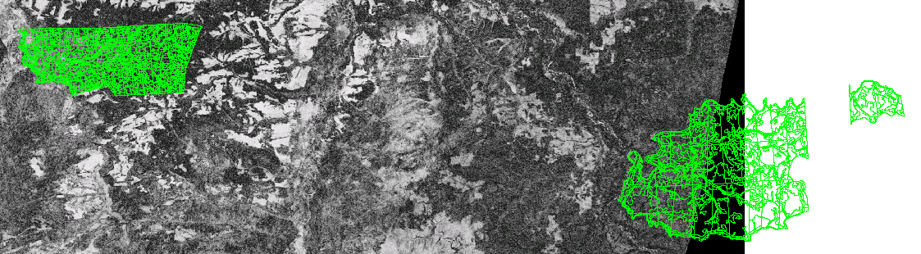
Sayano
Four test areas (UTM 46) -- although we may not have radar data for all of them.
Frame 2529 orbit 32400 -- this is available as a GTC (shown below)
And frame 2529 orbit 32357 -- this is available -- but I do not have this.
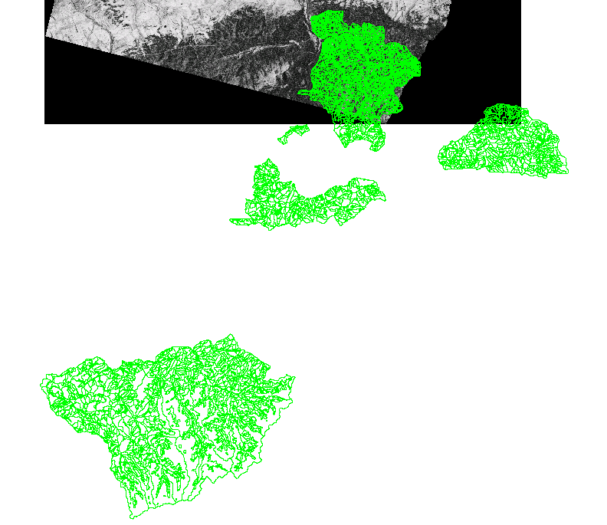
And frame 2547 orbit 32400 -- is this available? -- I do not have this.

