Appendix A



SIBERIA Project Ground Truth Data Workbook
May 1999

Introduction
This document is a guide to the ground truth data provided to the SIBERIA Project and can be thought of as a workbook for our Siberian Field Trip. It is not, however, a definitive report regarding Russian Forest Inventory standards or measurements. Finally, thanks to everyone who contributed questions to our Question & Answer page.

Forest Inventory
This is a brief description of forest inventory -- a complete review of remote sensing methods used in Russian Forest Inventory is forthcoming. Two types of inventory are completed for Russian forests depending on forest management requirements: on-ground (so called lesourtroistvo) Forest Inventory and Planning (FIP) for intensively managed forests and survey of remote unmanaged forests, basically in Siberia and the Far East. The SIBERIA project forests are located in areas inventoried by the first method.
FIP is completed in each Russian Forest Enterprise every 10 to 20 years. Approximately 70 percent of Russian forests are inventoried by FIP. Boundaries of primary inventory units (SKNR) (stands for forested areas although they may be other land classes) are, as a rule, interpreted from 1:10,000 or 1:20,000 scale aerial photos. SKNRs are basically resolved from air photos on the basis of dominant species composition, age, relative stocking, site index, origin, vertical structure, quality of growing stock and forest homogeneity. On ground measurements are used to provide final estimates of variable and verify photo interpretation. Most of the ground truth data in the SIBERIA project area is based on 1:25,000 scale photos. There are three categories of FIP that define details and accuracy of the forest inventory results.
The survey of remote forests is accomplished for the rest of Russia's forested area using a "photo-statistic" or multi-stage sample design. The first stage uses RESURS or COSMOS-based images (1:275,000 scale) to stratify the forest into forest groups (e.g. recently burned forest, mainly larch forest, etc.). Lower stages of the sample design use large-scale (1:2000-1:7000) air photo transects to estimate forest variables. The bottom stage of the sample design involves ground sample plots in which exact measurements of forest variables are made.

Forest Variable Definitions
Unique
In our attribute data, we have combined forest district (GIR), kvartal (KV), and stand (SKNR) into a Russia-wide unique (UNIQUE) identifier that we use to relate forest data polygons to our databases.
Kvartal (KV)
A kvartal is an administrative area ranging from 50 to 4000 ha. Kvartal boundaries can be natural (e.g. rivers or mountains) or artificial. For example, if you look at the Ust Ilimsk area on the right you see what look like boxes across the forest. These follow an old German system of creating forest compartments as part of the management of the forest. You may see the effect of these administrative units in the cutting patterns in the forest -- harvested areas as a rule follow kvartal boundaries.
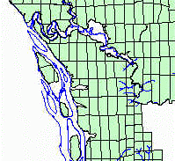

Primary Inventory Unit (SKNR)
Each kvatal is divided into primary inventory units (SKNR) (in forested areas these are sometimes called stands). A SKNR is a relatively homogenous area in terms of tree species composition, age, height origin, site index and relative stocking. Some SKNR boundaries have an ecological origin, etc. (e.g. the edge of an area once burned by fire) and others are kvartal boundaries. The SKNR boundaries are constant but, when we look at the forest according to different attributes (e.g. age or species composition), they may become more or less pronounced. We see this if we, for example, look at a section of the Ermakovsky test area. The image on the left shows the forest displayed according to age (AMZ) whereas the right image shows the proportion of birch (BIRCH_KF). We see that the contrast among the SKNRs is very different.
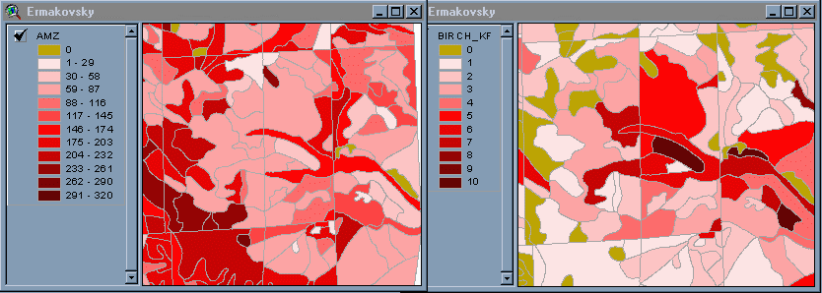
It is important to recognise that SKNR boundaries are based on subjective, human interpretation, usually of aerial photos, and that they are not always visible in small-scale satellite-based remotely sensed images, but can often be recognised on large-scale images.
Area (AREA_HA)
This is the vertical projection of the area of the SKNR as reported in the forest inventory. You may notice that the GIS files also contain an "AREA" item. This is the area as measured by the GIS in square meters. The GIS area is sensitive to shifting caused by georeferencing, therefore we advise that the forest inventory area (AREA_HA) be used for analysis purposes.
Land Category (ZK)
These are the basic categories of land for which the entire landscape is classified.
1101 - natural stand
A stand of growing trees resulting from natural regeneration following a forest disturbance. By definition, these stands have relative stocking greater or equal to 10 for young age groups and greater than or equal to 30 for all other age groups.
1102 - unclosed natural forest
Forests with relative stocking of 10 to 40 for young age groups and 10 to 30 for all other age groups if this condition is a result of climatic conditions (i.e. altitude or climate), otherwise they are classes as sparse forests (1400)
1104 - low productivity forest
According to "All-Russia Manual", these are mature and overmature exploitable forests of site index Va and V, and forests of higher productivity if growing stock is less than 40 m³/ha in European Russia and less than 50 m³/ha in Siberia. These criteria can be regionally adjusted.
1108 - forest plantation
A stand of growing trees, raised artificially, either by sowing (seeds) or (most commonly) planting. A forest plantation must have at least a relative stocking of 30 for young trees and 20 for mature (less than this it is an unclosed forest plantation). In some plantations, if they have been intensively managed, one may be able to see the trees in rows.
1201 - unclosed forest plantation
This is basically a younger stage of the forest plantation. If you imagine looking down from above on a young forest in which you can still see the forest floor then the canopy is considered "unclosed" (and relative stocking is less than 30 for young trees and 20 for all others). In terms of forest management this means that there is still the possibility of competing vegetation (shrubs, grasses, etc.) to outgrow the planted trees and compete for sunlight and water resources.
1400 - sparse forest
The same relative stocking as in 1102, however, this state is the result of natural (e.g. fire) or human-induced disturbances.
1503 - burned forest
The full name of this category is burned and dead forest. This is a land category that describes areas that have experienced a "stand replacing" fire. This means that the "surviving" trees have a relative stocking of less than or equal to 10. If between 10 and 30 percent (relative stocking) survive the fire then it is classed as a sparse forest (category 1400)
1507 - stand marked for cutting
Stands planned to be cut during the year of forest inventory.
1509 - clear-cut areas
These are areas that are harvested under the clear-cut silvicultural system. They have a relative stocking of less than 10. This is a system of regenerating even-aged forest stands in which new seedlings become established in fully exposed micro-environments after most (some individual trees may remain standing) of the existing trees have been removed. Regeneration can originate naturally or artificially. Clear-cutting may be done in blocks, strips or patches. Once regrowth occurs the area could be classed into unclosed forest plantation (1201). Check the inventory update date of the test territory (this information is located on each test territory page) to verify before what date this harvest occurred.
Other - non-defined.
2102 - agriculture, hay
2103 - agriculture, pasture
2110 - stream
2308 - lake
2507 - bogs
2505 - exposed rock
2512 - talus
2540 - quarry or gravel pit
Other (to be provided on field trip):
1103 - __________________________________________________________________
1504 - __________________________________________________________________
2101 - __________________________________________________________________
2109 - __________________________________________________________________
2116 - __________________________________________________________________
2305 - __________________________________________________________________
2310 - __________________________________________________________________
2404 - __________________________________________________________________
2548 - __________________________________________________________________

Relative Stocking (SKAL)
Let's break relative stocking down into two parts -- "relative" and "stocking". Stocking is an expression of the adequacy of tree cover on an area in terms of basal area. Basal area is the area of the cross section of a tree trunk near its base, usually 1.3m above the ground (also called breast height). Basal area is a way to measure how much of a site is occupied by trees. The term basal area is used to describe the collective basal area of trees per hectare. Relative stocking is a comparison of the stocking of a particular stand to what the ideal stocking would be under perfect management conditions. The ideal conditions are a function of site quality and can vary according to the species composition and age of the stand. There are yield tables developed for Russia that would describe fully stocked stands.
Growing Stock Volume (TUR1H)
In general, growing stock volume (TUR1H) is the STEM volume for all living species in a stand. Specifically, however, only in young stands are all stems considered. In all other stands trees must be greater or equal to 6 cm at "breast height" (1.3 m) to be included in the growing stock. The trees that are excluded from this measurement only represent about 1 percent of the volume -- so it OK to say that this variable considers all trees. It is expressed in cubic meters per hectare.
NOTE: The Ust Ilimsk database has volume in 10m3/ha units!!
Age of Dominant Species (AMZ)
This can be considered as the age of the stand expressed in years. Age groups are region-specific calculations that take into account forest site quality, dominant species and legislative requirements. In general, however, the age groups for the SIBERIA project area can be defined using simply the age of the dominant species. The table below shows the age thresholds for the age groups in our project area.
Species | Young | Middle-aged | Immature | Mature | Overmature
Pine, spruce, fir & larch | 1-40 years | 41-80 years | 81-100 years | 101-140 years | >140 years
Cedar | 1-80 years | 81 - 160 years | 161 - 200 years | 201 - 240 years | >240 years
Aspen & birch | 1-20 years | 21-50 years | 51-60 years | 61-70 years | >70 years

Composition (KF)
Composition is the proportion of a species in a stand on a scale of 1 to 10 (e.g. PINE_KS = 1 means 10 percent of the growing stock of the trees in the main canopy layer of the stand are pine)
Height (H)
An estimate of the average tree height of the dominant species in the stand. Expressed in meters.
Diameter (D)
An estimate of the average tree diameter of the dominant species in the stand based on a quadratic average. The diameter is measured at 1.3m or "Breast height". Expressed in decimetres.

Forest Variable Relationships
In this section we discuss the relationships among the variables with particular attention to how these relationships affect remotely sensed measurements.
Age, volume and stocking
In general, stand volume increases with age until maturity is reached after which the stand starts to loose volume through death and decay. When examining stand volume it is important to also look at the relative stocking of the stand. For example, we can consider three stands with the same volumes:
Stand | Age | Age Group | Relative Stocking | Composition | Volume
1 | 200 | Overmature | 40% | 60% pine, 40%larch | 150
2 | 60 | Immature | 70% | 10%pine, 30%larch, 60% birch | 150
3 | 50 | Middle age | 90% | 100% birch | 150

This does not follow the pattern we would expect until we consider stocking. These stands have different ages (and are in different age groups) but the general pattern is that the older stands have lower relative stocking. This affects the expected relationship between age and volume, however, if we calculate what the volumes would be if these stands were fully stocked (i.e. SKAL = 10) then stand one would have 375 m³/ha, stand two 214 m³/ha and stand three 167 m³/ha. We can plot the forested stands from the Ust-Ilimsk test territory this way to also see this relationship.
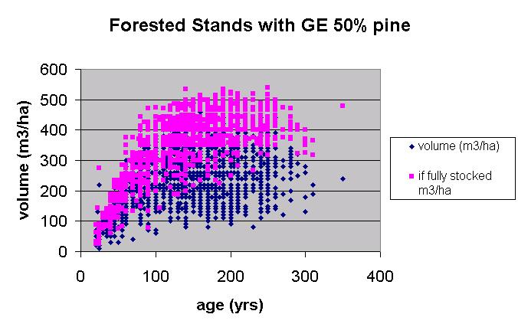

Species and Canopy Characteristics
The canopy structure of forests varies according to species composition, age, relative stocking and height. Radar-based measurements can also be affected by season and weather conditions. The following figure shows the basic form for individual trees (from Racey et al. 1996).
PINE 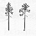 ASPEN 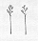

SPRUCE 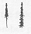 BIRCH 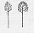
FIR CEDAR 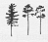
LARCH 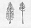

Here are some hypothetical cross-sections of forest stands (from Racey et al. 1996)
PINE with some spruce
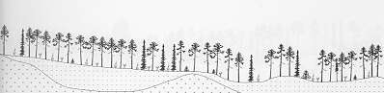

LARCH with some spruce
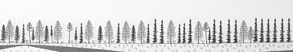

ASPEN and BIRCH
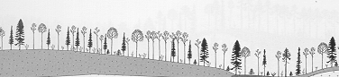
Disturbed Areas
One of the most important information requirements is to know the extent and type of forest disturbance. Forest can be disturbed naturally by biotic (e.g. fires or wind) or biotic (e.g. insects and disease) sources and through human-caused activities (e.g. harvesting, pollution). Probably the most easily detected disturbances in the SIBERIA study area are clear-cut harvesting and forest fires. The forest data must be carefully queried, however, to these areas. For example, to find recently disturbed areas in the Ust Ilimsk test territory, we should use the select clear cut stands (ZK = 1503), unclosed forest or plantations (ZK = 1102 or 1201), burned and sparse forest (ZK = 1509 and 1400) and forest stands with a young age (e.g. AMZ < 10). The figure below shows this selection and compares it to SPOT XS4 and ERS data for the same area.
Some notes:
- Some clear-cut areas still have standing trees.
- Burned areas generally have many standing dead trees.
- There may only be undetectable (remotely sensed) differences between clear-cut, plantation and young forests.
- Some clear-cut areas are not indicated in the ground truth due to the age of the data.
- Wetlands may have similar physiognomic features to recently disturbed areas and may actually have "dry surfaces" during the summer months.
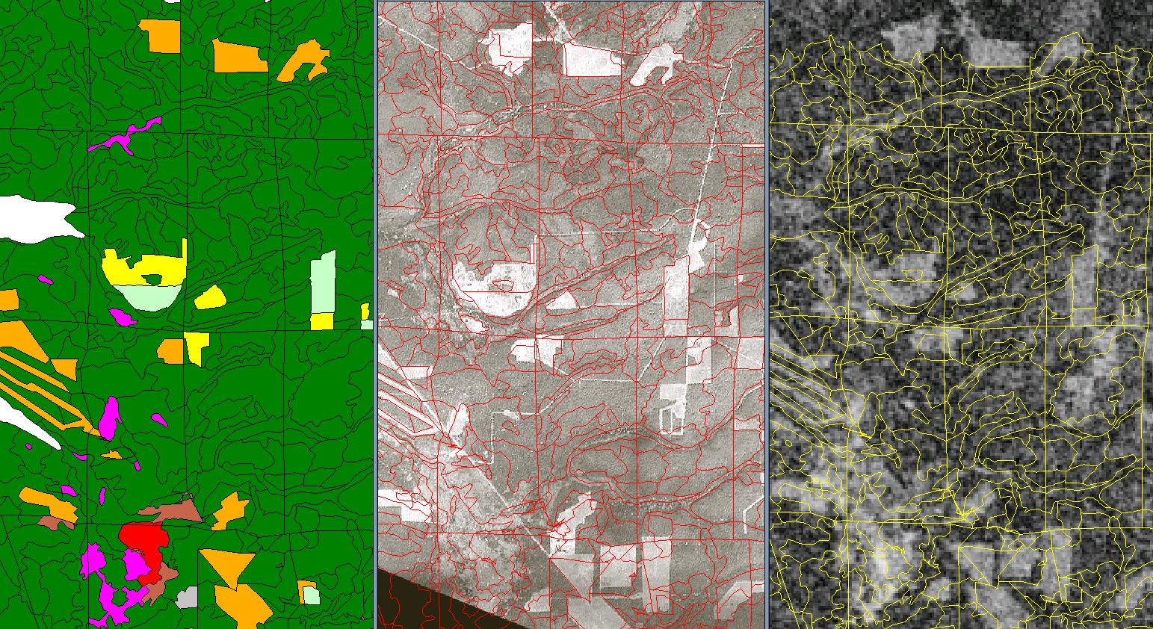
Left to right, forest map (mustard = clear cut areas, pale green = plantation, yellow = forest < 10 years, red = burned areas, pink = bogs and brown = not classed), SPOT XS4 and ERS1 coherence images with forest map polygons.

Forest Variable Estimate Accuracy
Here are the required inventory standards as described in the Russian Forest Inventory handbook. As the table below shows, the required inventory accuracy increases, as stands become ready to harvest. In general, however, one can see that the required accuracy is between 10 and 20 percent.
WHEN? | Growing stock - within XX percent | basal area (used for stocking) within XX percent | height within XX percent | composition within X percent (1 = 10 %) | diameter within XX percent
Stands to harvested | 15 | 12 | 8 | 1 | 10
Stands to be thinned (pre-commercial) | 20 | 16 | 10 | 1.5 | 10
All other stands | 20 | 16 | 10 | 1.5 | 12

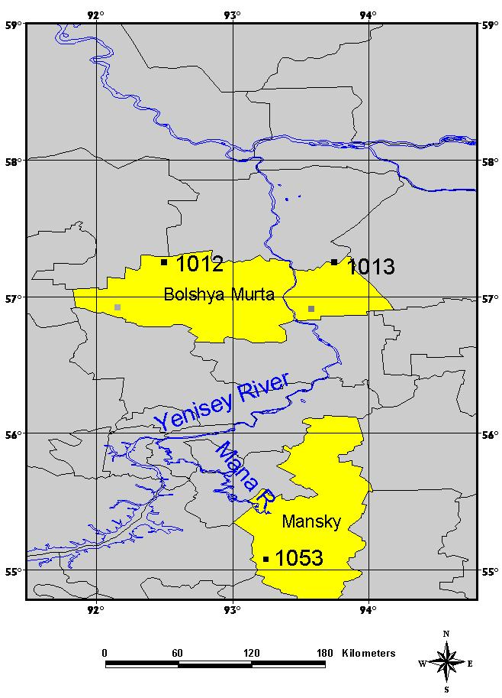
Krasnoyarsk Field Trip Sites
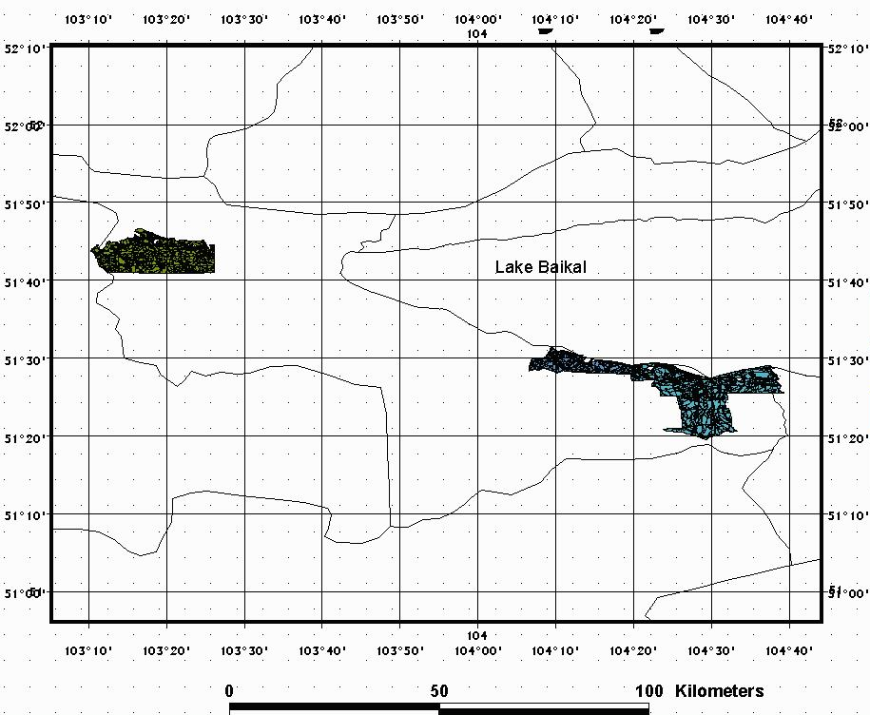
Baikal Field Trip Sites

