Working Note on the order and processing of JERS SAR Data within the SIBERIA project

Andreas Wiesmann, Urs Wegmüller, Tazio Strozzi

Gamma Remote Sensing AG, Switzerland
7/Mai/1999

Introduction
SIBERIA’s scope is the production of a large forest map database for South Siberia using images from the operational SAR satellites JERS-1 and ERS-1/2 including the application of new radar interferometry techniques. The main product envisaged is a landcover database containing forest information derived from geocoded SAR classification results. JERS-1 SAR is operating at L-Band where the dynamic range of the vegetation response is higher than at C-band, so that discrimination between forest and non forest on the basis of backscatter contrast is easier. JERS interferometric coherence offers a good potential for forest applications because the critical baseline increases with wavelength and compared with C-band longer acquisition time intervals can be used at L-band. JERS is a satellite operated by the National Space Development Agency of Japan NASDA.

Data availability
On one hand SAR data is available from NASDA’s data archive, on the other hand the mobile receiving station of DLR was deployed in Ulaanbataar, Mongolia, in autumn 1997 and spring 1998. There is a possibility to check the NASDA archive via telnet. For that purpose one has to telnet to eustty.eoc.nasda.go.jp (133.56.85.1) and login as “nasdadir”, user name is “guest”. For JERS data acquired by DLR no data catalog is available. On the website of NASDA baseline tables are available (http://www.eorc.nasda.go.jp/JERS-1/Result/). Though it has to be stated that not all referenced data exist! PATH and ROW characterize the data frames. PATH is the y-coordinate from east to west while ROW indicates the x-coordinate from north to south (see Figure 1). RSP indicates the track number. For the investigated area it can be said that even or odd RSP are sufficient for a complete coverage, succeeding RSP’s overlap 50% (see Figure 2).

Figure 1: JERS Frame characterization geometry.

Data Orders
As explained in the Introduction data is needed a) for global coverage (see Figure 3 for a map of the coverage geometry), b) for INSAR coverage of selected test sites, c) for multi temporal coverage of selected test sites. Archived data is ordered via NASDA (Osamu Isoguchi, isoguchi@restec.or.jp). The order has to fit the rules as outlined in Table 1. Data from the DLR receiving station must be ordered via DLR specifying Date, RSP and ROW range. It is synchronized by DLR and later processed and delivered by NASDA. The list of the data orders and their status is given in the Appendix A.

Table 1: NASDA JERS SAR data order form

Sensor: | JERS-1 SAR
Media: | 8 mm tape (5 Gbyte) multi-volume
Media code: | E211
Proc. Level: | RAW
Scene shift: | 0
No. looks: | 1
Asc./Desc. | Descending
Path | Row | Acq. Day | Ground stn. |  | (Ground station is listed in the EUSTTY browser)
296 | 293 | 960313 | HEOC |  | (HOEC = NASDA Hatoyama)
298 | 292 | 960315 | FAIS |  | (FAIS = Alaska SAR Facility)
(Note that Path indicates the GRS number, not the RSP. Row number does not change)

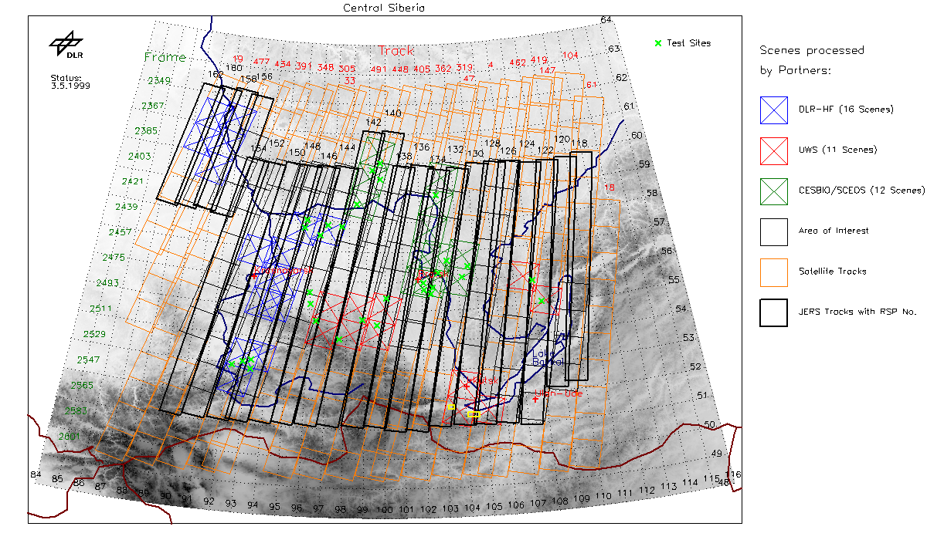
Figure 2: Map of the test area, with ERS and JERS SAR coverage.

Data Format
Data were either delivered with a CEOS Leaderfile and data-file header or instead with a special state vector file and the required auxiliary information were extracted from raw data line headers and an auxiliary ASCII file.

Data Processing
SAR processing was done with Gamma's Modular SAR Processor (MSP). A special effort is made to ascertain good radiometric calibration of the JERS processing. The MSP processor accounts for JERS sensitivity gain control (STC), and automatic gain control (AGC). In addition it corrects for JERS range antenna pattern and applies radio frequency interference (RFI) filtering. Gain saturation correction is not applied.
To determine the calibration factor required for the absolute radiometric calibration of JERS SAR processing with the MSP Masanobu Shimada (NASDA) kindly made JERS RAW data and information on 2 active calibrators available. Once the MSP JERS calibration factor was determined it was validated with NASDA processed and calibrated data over a tropical forest site. Good agreement was found.
To facilitate the SAR processing of large data sets as required in the Siberia experiment the MSP offers the option to concatenate JERS raw data of consecutive frames of an orbit.
Within the SIBERIA project a terrain corrected geocoding using a coarse resolution global DEM was applied. The status list of processed data and products is given in the Appendix A and B.

Registration with ERS SAR data
Mainly because of the limited accuracy of the JERS orbit data the registration between geocoded ERS and geocoded JERS data with offsets up to hundreds of meters is far from being perfect. This accuracy is not sufficient for the interpretation of the combined data at a local scale. Therefore, a fine registration step is required. Registration based on backscatter intensity cross-correlation is operationally used for the automatic fine registration of multiple images of the same sensor. Here we tried the same methodology for the registration of the geocoded JERS data to the geometry of the geocoded ERS data. In spite of the evident large differences in the backscattering at C-band V-polarization, 23° incidence angle and L-band, H-polarization, 35° incidence angle, the technique worked well. About half of the 128 pixel x 128 pixel sized image chips used to determine the bi-linear registration function resulted in a reliable local registration offset estimate. A flow chart for the JERS / ERS registration technique is shown in Figure 3.

Post-processing and interpretation
To reduce speckle noise, filtering is performed on the registered JERS and ERS σ° images. In the case of multiple registered images "multi-temporal" filtering as described by Quegan et al. [3] is an efficient and effective method. As mentioned by Quegan the "multi-temporal" filtering methodology should also be applicable to a combined ERS / JERS data set.

Figure 3: Flow chart of the JERS / ERS registration technique.

Appendix A Data Orders, delivery and processing status
# | RSP ROW | Date | Area | Ordered | Delivered | Processed
1 | 134 200-204 | 970504 |  |  | 1.9.98 | 16.11.98
2 | 134 205-209 | 970504 |  |  | 21.9.98 | 16.11.98
3 | 134 202-209 | 970731 |  |  | 13.10.98 | 16.11.98
4 | 148 200-210  150 200-210 | 961123  970404  961125  970406 | Krasnoyarsk | 5.2.99 | 23.3.99 | 13.4.99
5 | 120 200-210  122  124  128  130  132  134 | 970717  970719  970721  970725  970727  970729  970731 | Baikal See | 25.2.99
6 | 148 211-213  150 211-213 | 961123  970404  961125  970406 | Krasnoyarsk | 7.4.99 | 20.4.99 | 21.4.99
7 | 118 200-214  …138  140 198-214  …142  144 200-214  …154  156 196-202  …162 | 9807/08 | Global coverage (see Figure 2) | 21.5.99  Priorities set by W. Wagner
8 | 118 200-214  …138  140 198-214  …142  144 200-214  …154  156 196-202  …162 | 9805/06 | Global coverage (see Figure 2) | 21.5.99  Priorities set by W. Wagner

Appendix B Products
# | RSP ROW | Product | Processed | Distributed
1,2,3 | 134 200 | SAR, baseline to large for INSAR | 16.11.98
4,6 | 148 200-213 | SAR, INSAR | 21.4.99 | 21.4.99
4,6 | 150 200-213 | SAR, INSAR | 21.4.99 | 21.4.99

