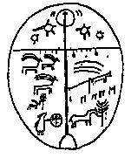 | Working Note
Clue to Problems using GTC Amplitude Images
Jan Vietmeier, DLR, 24th September 1999

Problem
I just want to point out that there are still problems using GTC amplitude images. Although it is possible to consider the local incidence angle doing the calibration there are residual regions inside GTCs which are not usable for further analysis (figure 1).
figure 1: Calibrated intensity image of the Krasnoyarsk scene (32586_2493) using GIM. There are still regions of ‘bright’ intensity, mainly around layover areas.

These residuals are connected with areas for which the InSAR DEM is not accurate enough to remove topopgrapical effects. This seems to be mainly the case for slopes which are near the layover (e.g. x: 700,000, y: 6,205,000 in figures 1-4) or where the topography varies strong (e.g. around x: 705,000 ,y: 6,210,000).
figure 2: GIM for the Krasnoyarsk image.

Conclusion
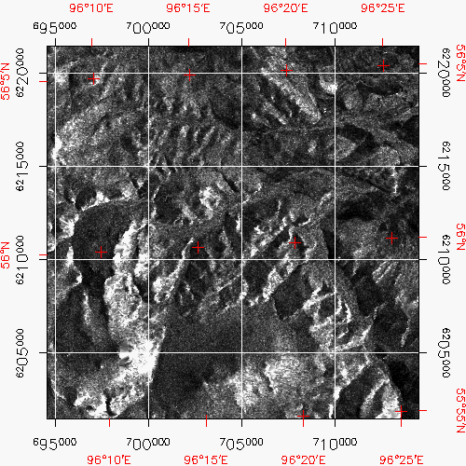
figure 3: Calibrated intensity image of the Krasnoyarsk scene (32586_2493) using NO GIM.
From the images it is obvious that an analysis of calibrated amplitude images using GIM is also not possible. It is necessary to mask out unsuable areas for further analysis as to be done with GEC images. Therefore I would suggest to have also a eye on GTCs developing a method for masking out areas inside GECs. At the DFD we also try to develop a methodology for the masking for GTCs. It should be much easier to mask unusable regions inside a GTC than in a GEC because additionally topographical information is available. For example we could mask out areas where the gradient in height is too strong over an area of a few square kilometers.
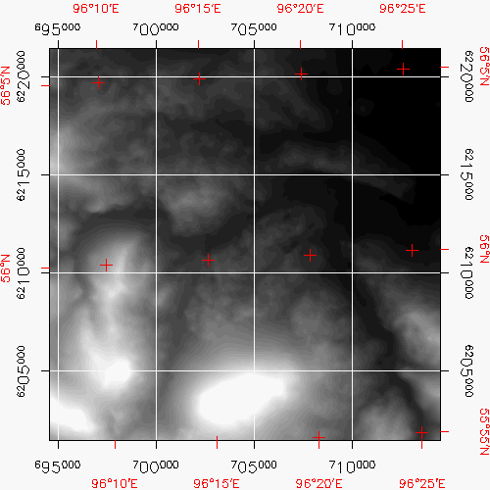
figure 4: InSAR DEM of the Krasnoyarsk scene.

