

Working note on calibration using calit

Jan Vietmeier
<jan.vietmeier@dlr.de>

March 25, 1999

Contents

- Problem
- Comparison of calibration using GIM (only "flat earth") and calibration using no GIM
- Comparison of calibration of GTC and SLC using one overall value for the input-file
- Calit: Results of modifications
- Decisions regarding the modifications of calit
- About this document ...

Problem
This is a note on tests carried out to evaluate the "calit" software by DFD. During the tests several unclarities appeared. Therefore it seemed to be necessary to write a working note. It is written in the order the tests have been carried out.

Comparison of calibration using GIM (only "flat earth") and calibration using no GIM
The main ulterior motive of this test was the assumption, that calibration using the command
"calit <in-file> g 1 -l -o 1000 -s 10"
should lead to the same result as
"calit <in-file> g 1 -l -o 1000 -s 10 -i <GIM-file>"
if the GIM-file contains only the satellite and pixel position dependent incidence-angle (ellipsoid).

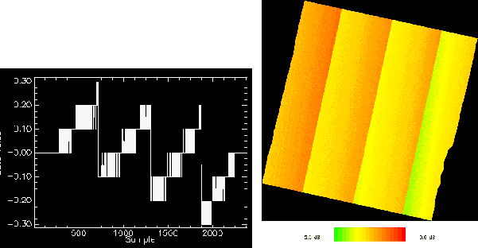
Figure 1: sigma0-images of 32586 2493-Ampl1 generated using no GIM and using GIM ("only flat earth"). Left: Difference between the x-profiles in dB. Right: Image showing the differences between both images.

The input-file is the first amplitude image of the Krasnoyarsk data set (32586 2493).
There are no visible differences between the results but the difference between two x-profiles show a strange course.

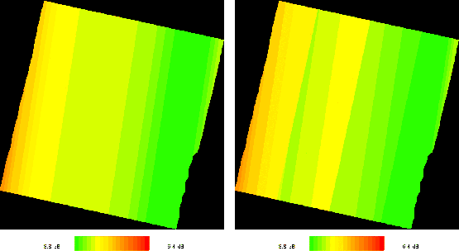
Figure 2: sigma0-images generated using input-file with overall value of 100. Left: Amplitude generated using no GIM. Right: Amplitude generated using GIM (only "flat earth").

Also the image showing the differences between the results of both calibrations is looking curious (Fig. 1). The differences ranges from -0.5 dB in the north west to +0.6 dB in the south east of the image in Fig. 1. In the most cases they are between -0.3 dB and +0.3 dB. The "separation" of the image into four areas is related to the GIM-format, as the incidence angles are stored in 2 deg. steps.
After this it was tested how the calibrated image looks like if the input-file has one overall intensity value. For this test an input-amplitude image with one overall intensity value of 100 was generated. The calculations were made the same way as above mentioned. The pixel values of the images ranges between -8.8 dB and -7.2 dB (using GIM: -9.0 dB to -7.2 dB, see fig. 2). In the image which is calculated using no GIM the lines are not parallel to the range-distance. It seems that calit does not consider the image rotation for geocoded products correctly.

Comparison of calibration of GTC and SLC using one overall value for the input-file
The values in the image at the left side in fig. 2 are not only range dependent, as has to be expected but there is also a dependence in azimuth direction.
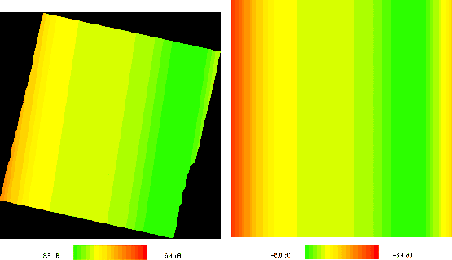
Figure 3: sigma0-images of the e1 32586 2493 image generated using input-file with one overall value of 100. Left: sigma0-image of the GTC. Right: sigma0-image of the SLC.
To see if the calibration of a SLC also show azimuth dependent properties one SLC of the same frame with an overall value of 100 was generated and calibrated using the commands
"getit /dev/nrmt0l r"
for reading the ceos-formated tape and
"calit <in file> g 2 -n 5 -l -o 1000 -s 10"
for calibration. The flag "-n 5" means that 5 pixel in azimuth are condensed to one pixel.
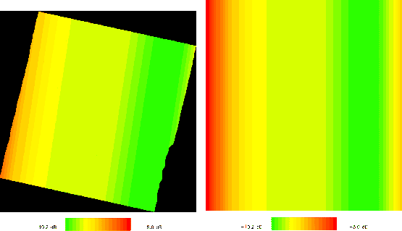
Figure 4: sigma0-images of the e2 12913 2493 image generated using input-file with one overall value of 100. Left: sigma0-image of the GTC. Right: sigma0-image of the SLC.
The out-image shows, in opposite to the GTC, a strict range dependence (fig. 3, right). The output values of the SLC ranges from -8.8 dB to -6.6 dB. The same calculation were made using the ampl2.ras of the e1 32586 2493-package.
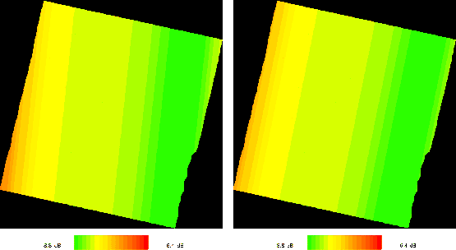
Figure 5: sigma0-images of the e1 32586 2493 image generated using input-file with one overall value of 100. Left: sigma0-image of the GTC with "g sens edir" angle of 192. Right: sigma0-image of the GTC with "g sens edir" angle of 202.
The results are comparable with the results of the ERS-1 image (fig. 4). The GTC sigma0-values ranges between -10.2 dB and -8.6 dB (SLC: -10.2 dB to -8.0 dB). Comparing the GTC and the SLC images there are three main points that are striking:
- Calibrating the GTC calit does not consider enough the rotation of the image.
- Even if the image would be rotated enough, the area of the correction would not fit the area of the image inside the GTC-frame.
- For the ERS-1 GTC image the error due to the insufficient consideration of the image rotation is in far-range of about 0.5 dB (far range north minus far range south).
While discussing about the problems using calit, the DFD stated:
- The error with the rotation is caused by an incorrect rotation angle in the dmp-file.
- If the rotation angle is considered in the right way, the problem with the "fit" of the corrected area to the GTC image area disappears.
Therefore the dmp-file variable "g sens edir" with the value of about 197 (corresponding to a image rotation angle of about 17 deg) was corrected to 192 (rot-angle: 12 deg).
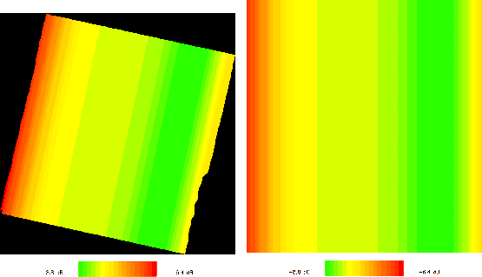
Figure 6: Calit after correction: sigma0-images of the e1 32586 2493 image generated using input-file with one overall value of 100. Left: sigma0-image of the GTC. Right: sigma0-image of the SLC.
12 deg is the angle between the "north" border of the SAR-scene inside the GTC and the "north" border of the GTC. Additionally a angle of 202 deg was tested (see fig. 5). The angle of 12 deg leads to a stronger error than the original angle, while the angle of 22 deg leads to a better result. Therefore the error must be inside the calit-program!

Calit: Results of modifications
Walter Knöpfle from DFD checked the program-code of calit and found an error regarding the calibration of GECs' and GTCs''. The consideration of the different pixel-spacing in azimuth and range for multi-looked SLCs' and GTCs was not correct. He removed the mistakes in the program and also took measures to change the rotation angles in the dmp-files for all new and all delivered products. The minimum of the calibrated GTC is now -8.8 dB and the maximum -6.4 dB 0.2 dB more than the maximum of the calibrated SLC (see fig. 6). In far range the maximum difference between GTC and SLC is 0.1 dB, the maximum difference in near range is 0.2 dB. We think this "error" is acceptable for our purposes.

Decisions regarding the modifications of calit
To remove the problems with calit we and the DFD came to the agreement, that
- The DFD re-processed the dmp-files for all frames delivered before 10/03/99 to take the right rotation angle into account. The dmp-files delivered after 10/03/99 consist right rotation angles. On 16/03/99 Ursula uploaded all zip-archives of the images including the new dmp-files.
- Walter Knöpfle will deliver a new calit version before Ester, which takes the different pixel-spacing of SLCs and GTCs or GECs into account.
- In addition to that I would suggest to make calit by ourselves capable to read incidence angles from the GIM-files in 0.5 deg steps. This is a very simple modification of calit that I will carry out, so everyone could use it.

About this document ...
Working note on calibration using calit
This document was generated using the LaTeX2HTML translator Version 96.1-h (September 30, 1996) Copyright © 1993, 1994, 1995, 1996, Nikos Drakos, Computer Based Learning Unit, University of Leeds.
The command line arguments were:
latex2html -split 0 working_note_on_calit.
The translation was initiated by viet als user on Thu Mar 25 14:57:35 CET 1999

viet als user
Thu Mar 25 14:57:35 CET 1999

