Working Note on Histogram Generation

V1.0 – January 18, 2000

Background:
As a consequence of the Kiruna meeting in December 1999 one of the conclusions reached was that, the analysis of radar measurements against forest databases provided by IIASA for each testsite does not provide all the necessary information for classification purposes. Specifically
- Many land-use classes which exist in image and need to be included in the final classification algorithm are not covered by the database which is oriented towards forest categories.
- Numerous sources of error - including the relative misregistration of database polygons with respect to image data as well as changes in land cover status (e.g. forest fire, cutting activities) between the time of the database compilation and that of the image acquisition exist and obscure the underlying relationships between radar data and both land cover type and status.
In order to address these issues a hybrid database-image based approach to the analysis of radar information content was agreed to in order (1) to cover other land use classes inexistent in the IIASA databases and (2) to reduce the influence of other sources of errors affecting the database-radar data relationships.

Approach:
The overall approach is to generate histograms for selected land-use categories selected from the images. The land-use categories for which radar signatures should be extracted include the following:
- Water (lakes, rivers etc…)
- Agricultural fields
- Urban areas
- Bogs
- Forest divided into the IIASA growing stock volume (TUR1H) categories (<20, 20-50, 50-80 and > 80)
- Burnt forest
- Clear cut
The areas need to be selected using a combined image and database approach. To save time we recommend using only the two major sources of land-cover information in the generation of the histograms, to whit
- ERS coherence product
- A single JERS image.
For some land-use categories such as water, database information does not exist so that the selection of regions of interest is made using image interpretation only. For other categories such as Forest, Bogs and so on, database information is available but should be checked against the image data before being selected. This can be done for instance by superposing the polygons for a given land-use or forest category with image data and either defining regions of interest by hand using the database information as a background or eliminating suspicious polygons from the database and then running the usual SIBERIA analysis programs.
In should be pointed out that not all categories are likely to be present in all sites. However at CESBIO we will try to synthesise the results from each team which will then hopefully cover all categories and give us a better idea as to how to proceed.
Points to keep in mind are:
- Histograms should be based on a minimum of 200 pixels of image data in order to have some validity.
- While the format of the histograms is up to the individual SIBERIAn is would be useful that the histograms include a legend containing the following information on the areas from which the histogram was drawn
- Title indicating site name
- Mean value (in dB for sigma0 values)
- Standard deviation about the mean (in dB for sigma0 values)

Example:
Some example plots for the Shestak site are given below

Class | ERS coherence | JERS σ₀
Water | 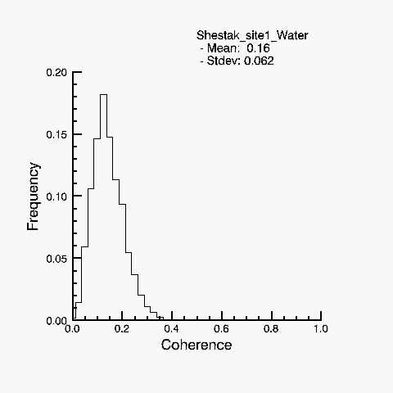 | 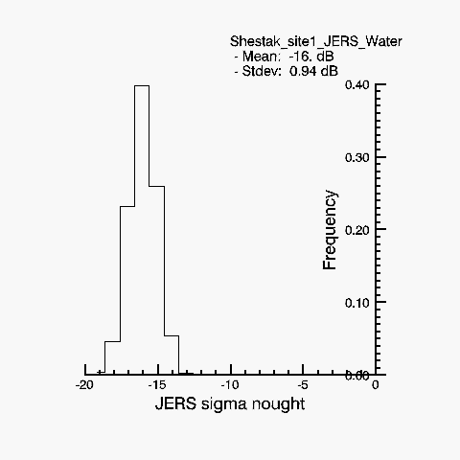
Tur1h_>80 | 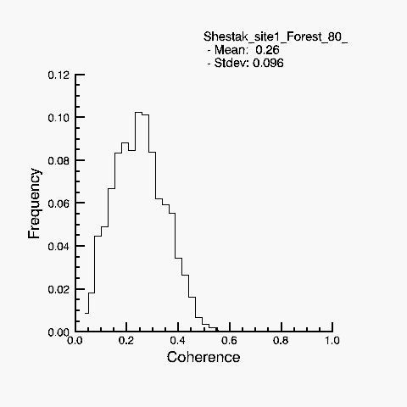 | 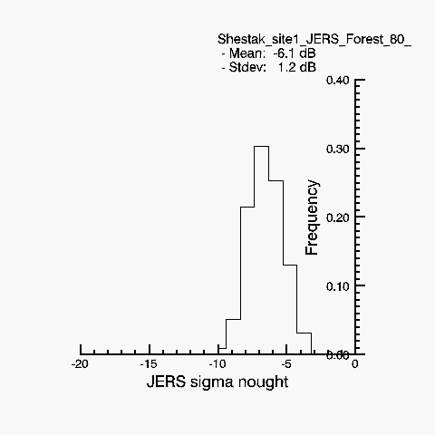
Tur1h_50-80 | 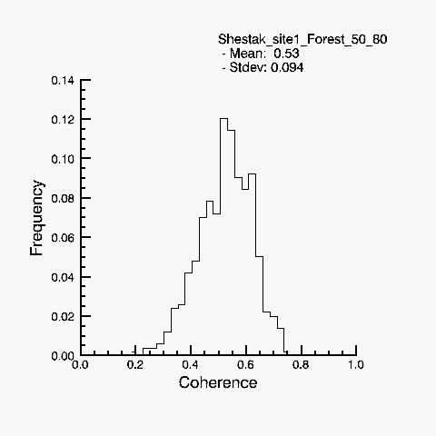 | 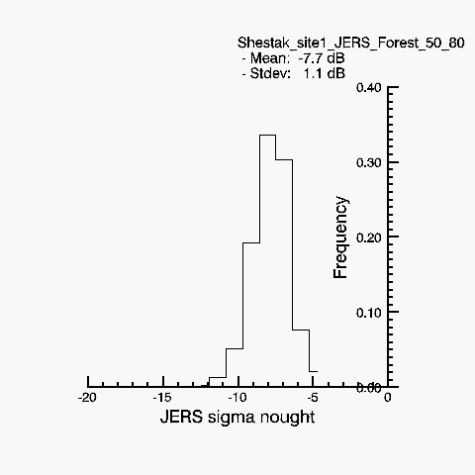
Tur1h_20_50 | 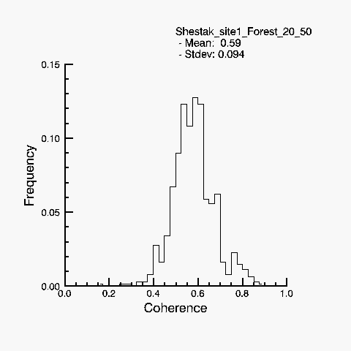 | 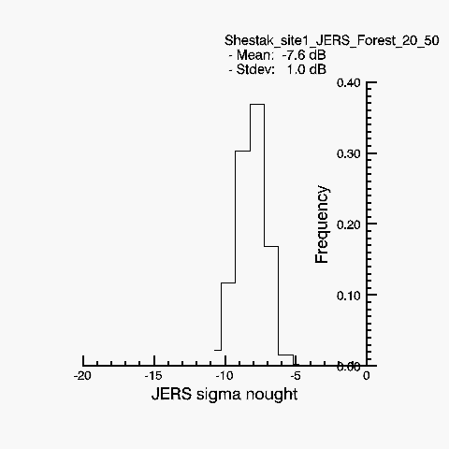
Tur1h_0_20 | 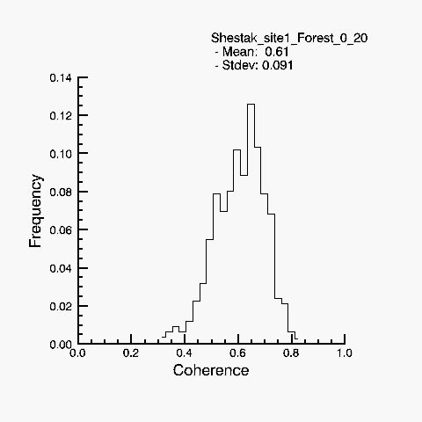 | 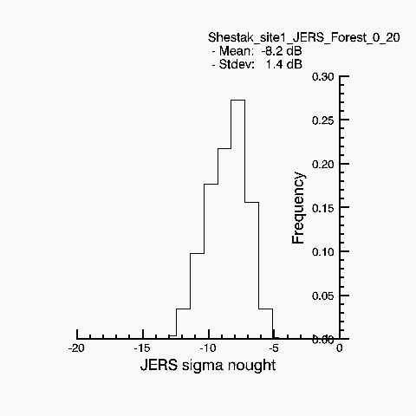
Bogs | 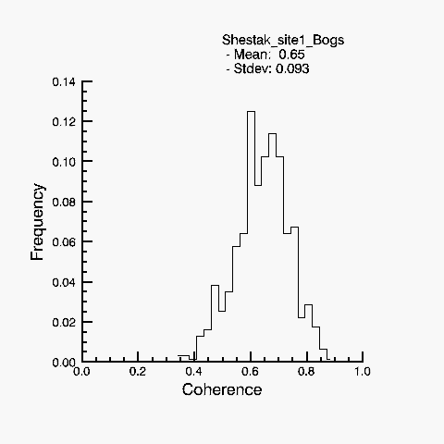 | 