

Working Note on Coherence:
(Produced by Malcolm Davidson, CESBIO, February 1999)

First of all the good news is that the DLR coherence products are much improved with respect to those presented at the Toulouse meeting. The transitions from high-coherence to low coherence areas (e.g. recently cut stands) are sharp not fuzzy as was previously the case, contrast is good and the visual appearance of the images are similar to those of DIAPASON when similar estimation window sizes are used. Furthermore, and more importantly, the actual mean coherence values for different land-use classes are approximately equal as the following table indicates (mean+stdev):

Class | DIAP 10x2 | DIAP 15x3 | DLR16x4
Water | 0.2+-.1 | 0.15+-.07 | 0.13+-.07
Mature Forest | 0.3+-.1 | 0.26+-.1 | 0.26+-.1
Young Forest > 6 years | 0.59+-.1 | 0.57+-.08 | 0.57+-.08
Young Forest < 6 years | 0.71+-.09 | 0.69+-.09 | 0.67+-.09

Unlike the comparison presented at the Toulouse meeting, exactly the same regions were used in each image. N.B. for those of you wondering where I got the "Young Forest < 6 years" class, I assumed that all field-like high coherence regions not appearing on the original map represented forest stands cut after 1992, the year the map was compiled (IIASA to confirm ?). The small variations between DIAPASON and DLR results seen in the table are likely due to the different window sizes + geometric resampling to ground coordinate strategies.
A much more difficult task has been to provide some feedback on the optimal coherence estimation window size and the amount of topography smoothing to apply to the coherence images. Nico Adam has done some good work in this respect and summarised his results in a technical note of impressive size (35 Mbytes +). The main issues addressed are (1) The influence of the estimation window size and related bias using real data (water surfaces in India!) (2) The influence of the topography phase as a function of phase smoothing window (unclear where test images come from and a visual comparison only is made) The study, as the above comments indicate, does not address the impact of these processing parameters on actual "Siberian" data which is unfortunate since appropriate processing parameters are always function of land-cover characteristics and do not represent "absolute" parameters in themselves. The study, as the above comments indicate, does not address the impact of these processing parameters on actual "Siberian" data which is unfortunate since appropriate processing parameters are always function of land-cover characteristics and do not represent "absolute" parameters in themselves.
At CESBIO we have therefore concentrated on identifying the information content as a function of processing parameters. "Histogram" (below) presents the histograms for different estimation window sizes and for 4 land-use categories (blue=water, green=mature forest, yellow=young forest > 6y, red=young forest < 6y).

HISTOGRAM
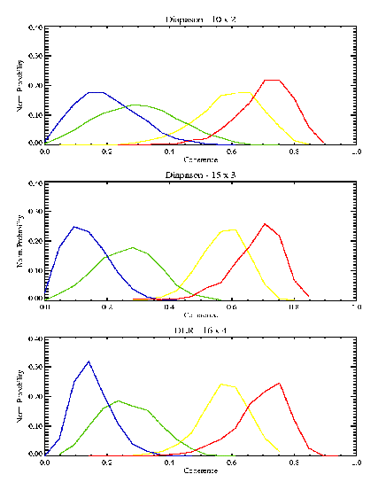

My comments are the following: - as expected the histograms narrow and the tails are less pronounced for increasing window size - the information content however does not change much:
(1) water and mature forest overlap considerably even for larger window sizes which implies other information (e.g. intensity) must be used to separate these two categories. This also implies that we don't care too much about the expected biases for low coherence values (sorry DLR !) and these aspects should not enter into discussion unless the plan is to enlarge the estimation window well past 80 looks.
(2) the is a good distinction between mature forest and young forest types for all window sizes although the probability of false alarms is less for window sizes greater than or equal 15 x 3.
(3) the separability of recently and not-so-recently cut areas does not depend much on the precision of the estimation but rather on the scale of the phenomenon we are trying to map. The classification images using simple threshholds determined from the histograms (class diap 10*2) and (class diap 16*4) illustrate this point. The colour scheme is the same used for the histograms. We see that the recently cut areas which are quite small (small red parcells) are better identified using the 10x2 window (class diap 10*2 vyf) then using the 16x4 window (class diap 16*4 vyf). On the other hand areas of regeneration over 6 years old, which can be very inhomogeneous in character, are better mapped using larger windows (class diap 16*4 yf) than smaller windows (class diap 10*2 yf) because of the smoothing and integrating properties of the former.

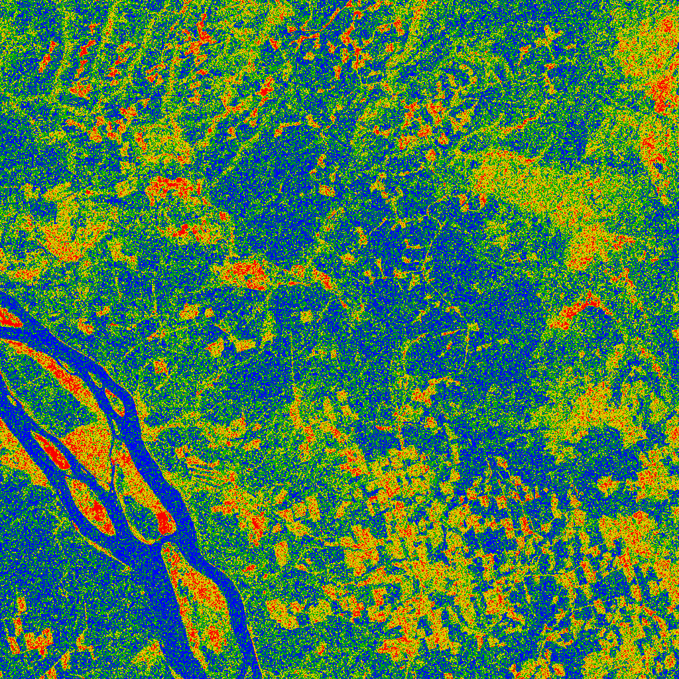  Class Diap 10 * 2 | 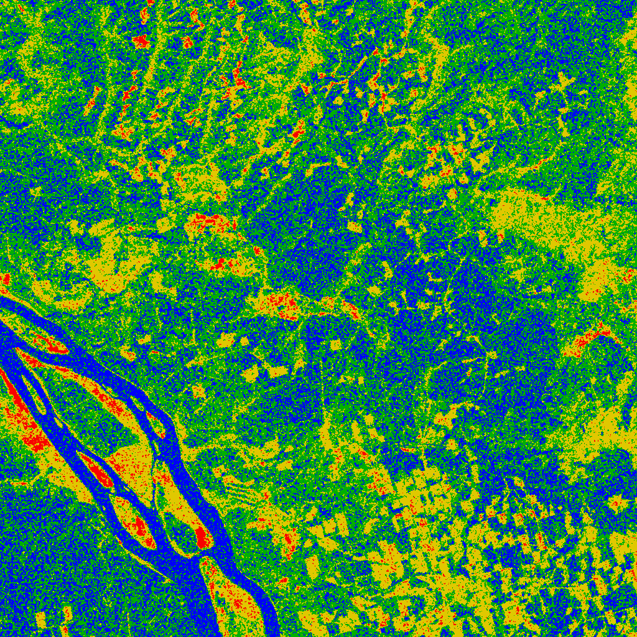  Class Diap 16 * 4
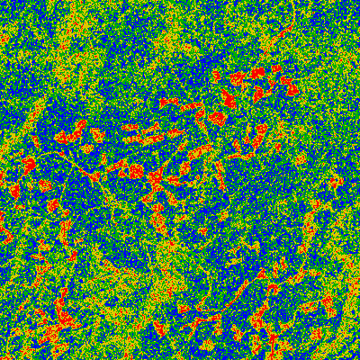  Class Diap 10 * 2 vyf | 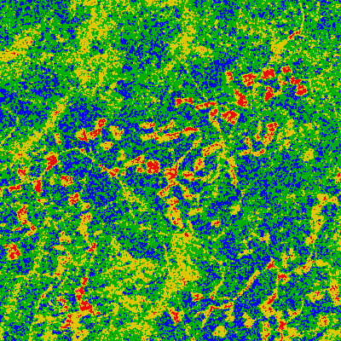  Class Diap 16 * 4 vyf
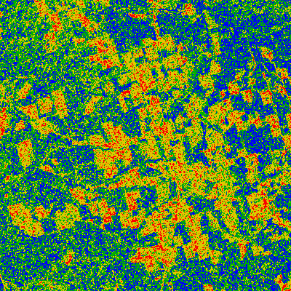  Class Diap 10 * 2 yf | 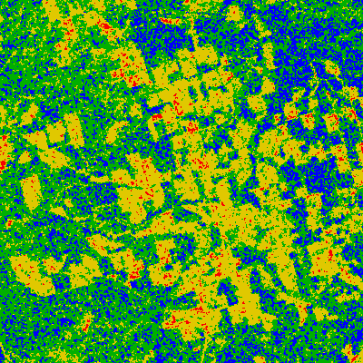  Class Diap 16 * 4 yf

To summarise the above results I would suggest the following:
(1) for a general and robust map of vast areas in Siberia a larger estimation window (64 or 80 looks proposed by DLR) is preferable because of its smoothing properties. However only a limited number of classes should be considered (water, mature forest, young or cut forest, urban areas, perhaps agriculture) and fine distinctions such as between recently-cut and young forest lumped together. Coherence information can then be used to distinguish between mature forests, young or cut forests and urban areas. Intensity + contextual info should help in separating water and mature forests.
(2) for the test-site areas where ground-truth covers at least part of the area I would recommend to continue with generation of BOTH 20 and 80 look coherence maps in order to develop locally-applicable classification methodologies permitting a finer distinction between forest classes/status. In so doing we would also be addressing the wishes of IIASA for more detailed information , which are in contradiction with the overall aim of mapping (is this still our aim ?) vast tracts of land in Siberia.

