
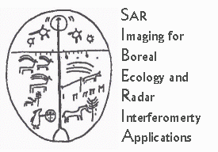


Working Note

Ground offsets during coregistration of JERS-1 and ERS images
Heiko Balzter (CEH-ITE) and Kevin Tansey (UWS)

14/01/00

Problem and approach
ERS images are processed to GTC (geocoded terrain corrected) products by DLR whenever the quality of the interferometric coherence permits it. The digital elevation model (DEM) from the interferometry is used for geometric terrain correction and radiometric calibration. For JERS-1 several reasons are making it impossible to use the same GTC production. The ERS InSAR DEM can not be used for JERS-1 terrain correction because images / orbits overlap only partially. The adopted solution Gamma Remote Sensing uses for JERS-1 geometric correction and geocoding is based on the public domain DEM GTOPO30. One pixel of this DEM is 30 arc seconds. It is not used for radiometric calibration. The different DEMs for terrain correction of JERS-1 and ERS imagery will create a geometric error in the coregistration step of JERS-1 onto ERS-1. The amount of this ground offset is the subject of this working note.

For a GTC product to be produced there must be significant areas of high coherence to enable the interferometric phase to be unwrapped and the DEM extracted. Areas of high coherence, in the Siberia project, are normally associated with development (or natural/non-natural forest clearance). A GTC is also more likely to be produced in the lower lying regions that have less topography than mountainous regions. In mountainous regions the terrain is likely to be forested resulting in low coherence. Therefore, the problems and errors outlined in this example (in an area with some topographic variation) are possibly the worst-case scenario for a GTC scene in the Siberia region. If the topography becomes more significant, there will be reduced opportunity for development and the area is likely to be forested. This results in low coherence and no INSAR DEM, therefore the GTOPO30 DEM is used and registration should be better with the JERS with also uses the GTOPO30 DEM). If topography is less or development is increased (higher coherent areas), there is an increased chance of obtaining a more accurate DEM and registration problems should be less important. Therefore, the errors involved in co-registering other ERS-JERS images should be of the same order or smaller than those errors estimated in the analysis presented below.

Test site
One test site has been selected to examine the ground offset of JERS-1 pixels relative to ERS-1. The test site is located within the Nishni-Udinskii test territory. The test site (Ukarsk) and is located in the north-east of the territory covered by ERS frame 32414_2493 (track 362) (a small part of the test site is not covered by the ERS frame of interest here). The product 32414_2493 is geocoded and terrain corrected (GTC). The ERS frame is characterised by extensive regions of high coherence (look like large forest fire scars) and development in the south and east of the frame (Figure 1). The forest inventory database for Nishni was updated in 1997.

Results
Figure 2 and 3 show ERS-1 and JERS-1 intensity images of the test site. The ratio of the two gives a first impression of geometric displacements (Figure 4), but is influenced by different scattering mechanisms for L- and C-band and different viewing geometries of the two sensors as well.

Figure 5 and 6 show the two different DEMs used for terrain correction. GTOPO30 is much coarser than the InSAR DEM, which results in large differences in height for small-scale features such as little rivers and valleys. Figure 7 gives a visual impression of the differences between the two DEMs. The histograms of height values in Figures 8 and 9 confirm this visual impression. The InSAR DEM has smaller values than GTOPO30, which is likely to be caused by the little valleys that are only being picked up by the InSAR DEM. The InSAR DEM has a smaller mean height than GTOPO30 (Figures 8 and 9).
The histogram of differences between the two DEMs in Figure 10 confirms the observations made above. The InSAR DEM at this test site is on average 47 m lower than GTOPO30. Given approximately normal distribution, 95% of the difference values are included in the interval between -114 m and 20 m.

The ground offset Δg can be estimated from the elevation height h and the incidence angle θ (Schreier 1993, p. 120):

$Δg=\frac{h}{\text{tan}θ}$

The height difference between GTOPO30 and the InSAR DEM is regarded as h in the equation above, assuming an equivalence of the coregistration problem with different DEMs to the distortions during geocoding of a SAR image without any DEM.
tanθ in the equation equals 0.781 for the 38° incidence angle of JERS-1. Table 1 gives the estimated ground offsets for the boundaries of the 95% interval of the height differences. The estimated pixel displacements are valid for 95% of the pixels in the image (Figure 3).

Table 1: Height difference, ground offset and pixel displacement (pixel spacing 50 m) for the coregistration of JERS-1 to ERS-1 GTC products. The height differences of 20 m and 114 m are including 95% of the pixels of the examined test image.

h | Δg | Pixel displacement
20 m | 25 m | 0
114 m | 146 m | 3

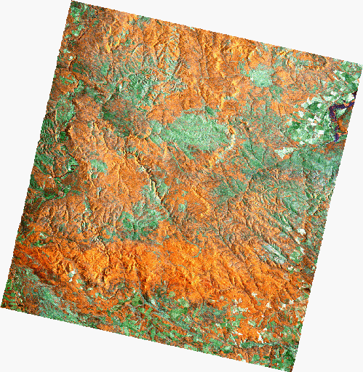
Figure 1: False colour composite of frame 32414_2493 (GTC) covering the Ukarsk region of the Nishni-Udinskii test territory.

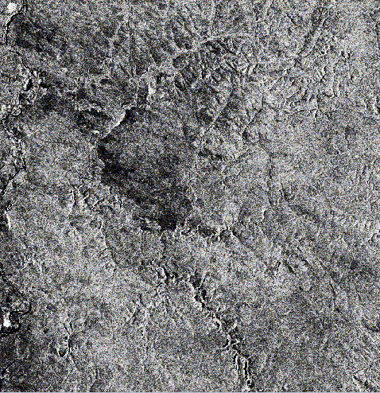
Figure 2: ERS-1 intensity subset of the image (enhanced). Upper left: pixel 436, line 356. Lower right: pixel 889, line 913.

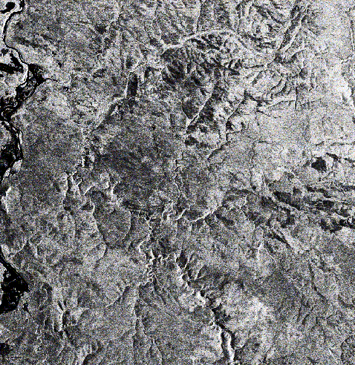
Figure 3: JERS-1 intensity image (enhanced).

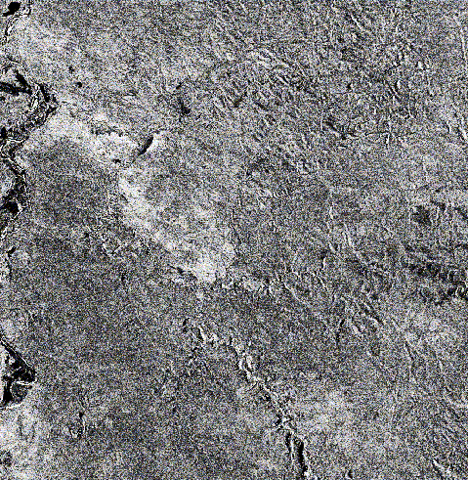
Figure 4: JERS-1 intensity divided by ERS-1 intensity (enhanced).

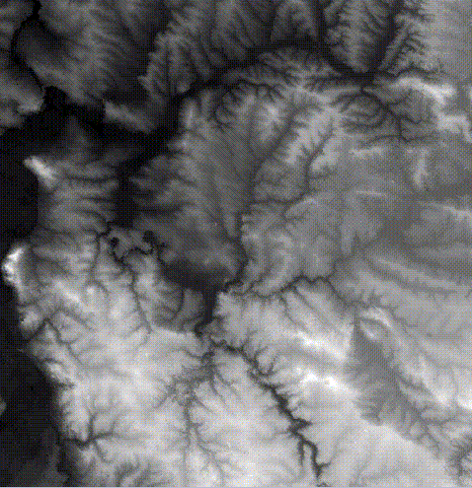
Figure 5: GTC InSAR DEM used for geometric correction and radiometric calibration of ERS-1 image

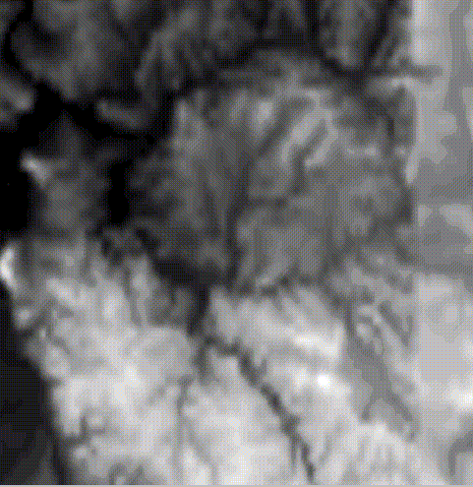
Figure 6: GTOPO30 DEM used for geometric correction of JERS-1 image

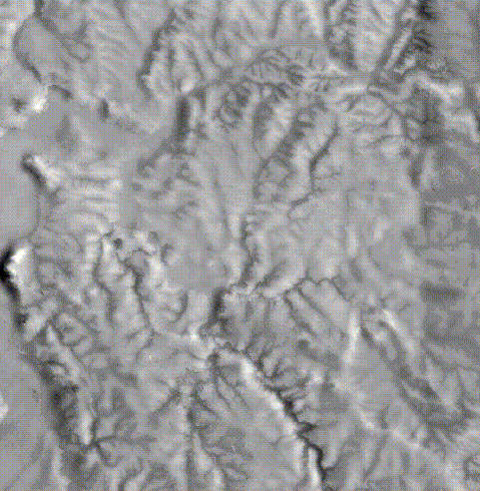
Figure 7: Height difference between GTOPO30 DEM and InSAR DEM.

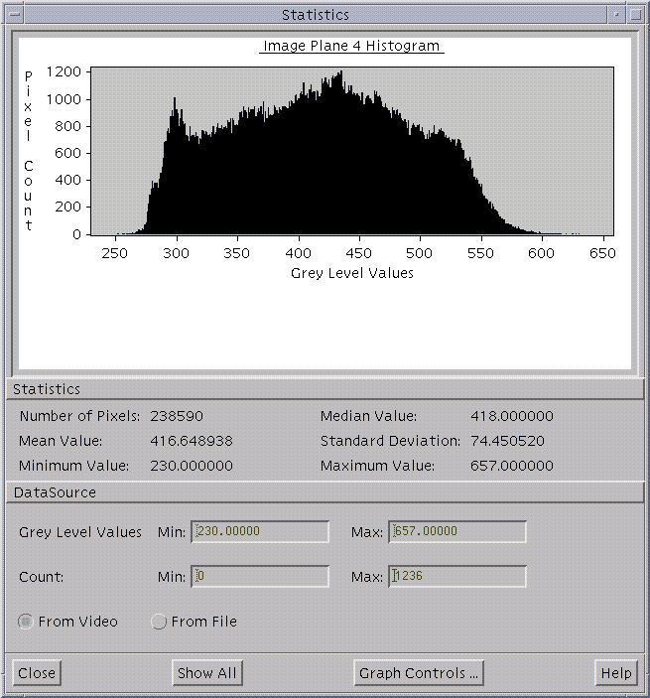
Figure 8: Histogram of height values from InSAR DEM.

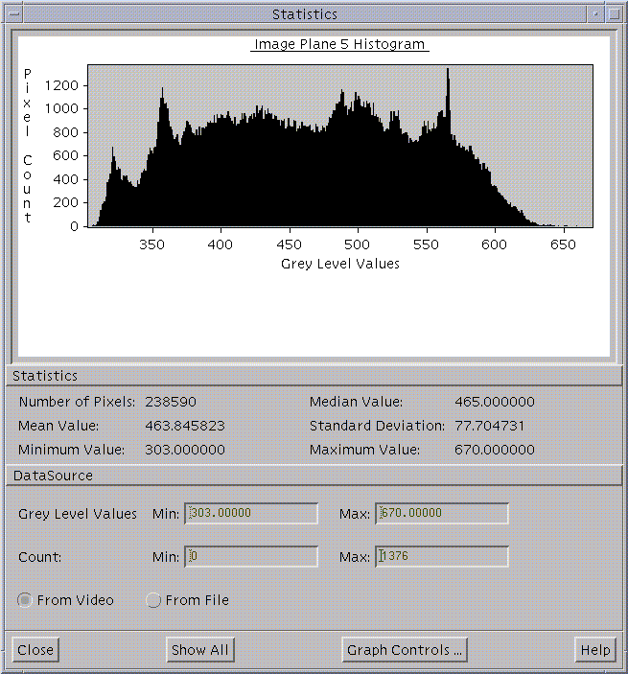
Figure 9: Histogram of height values from GTOPO30 DEM.

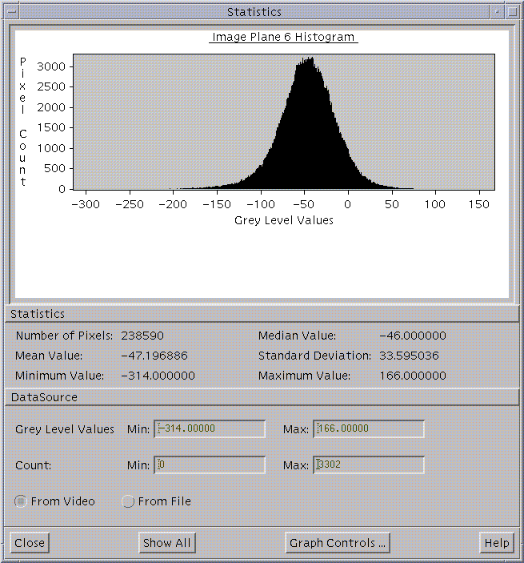
Figure 10: Histogram of differences between GTOPO30 DEM and InSAR DEM.

Conclusions

- The coregistration of JERS-1 to ERS-1 creates pixel displacements caused by the different DEMs.
- The expected pixel displacements of 95% of the image will vary between 0 and 3 pixels, and will be 1 or 2 pixels on average.
- A polygon erosion of 2 pixels will be able to reduce the problem significantly.
- The final classification faces a significant problem at the boundaries between different land use classes.
- Intelligent contextual classification methods need to be applied to correct the classified map for the ground offsets between JERS-1 and ERS-1.

References:

Schreier, G. (1993): Geometrical properties of SAR images. In: Schreier, G. (Editor): SAR Geocoding: Data and Systems, Wichmann, Karlsruhe, 103-134.

