Working note

Treatment of extreme topography in GEC and GEC_GLOBE images

Heiko Balzter, NERC / ITE Monks Wood 9/9/99

Email: Heiko.Balzter@ite.ac.uk

The problem

When creating the polygon database, the influence of topography can be quite strong. This is certainly true for our test site at the southern shore of Lake Baikal, as the ERS intensity image 32514_2565 below shows. Shadow and layover will inevitable create artefacts in the polygon database if we are not careful.

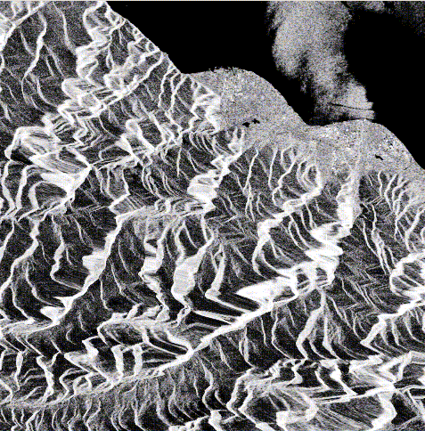
Part of ERS intensity image 32514_2565 of the southern shore of Lake Baikal.

Possible solutions:

Analysis of the polygon values

The first idea is to look at extreme intensity values in the polygon database and mask high and low values as layover and shadow. This is not possible in practice, as we get mixed polygons in the database.

GTOPO30

GTOPO30 is a global DEM, part of which was created by the former Defense Mapping Agency, with a pixel spacing of 30’ in Northing and Easting. The accuracy depends on the different sources of the DEM and is for the area at Lake Baikal a RMSE of ca. 18 m. The DEM is public domain and can be downloaded free of charge from the EROS Data Center in Sioux Falls.
The DEM tile for Lake Baikal has been reprojected to UTM WGS84 geometry using PCI’s procedure REGPRO. From the reprojected DEM, I created a slope map. Slope and height were then co-registered to the ERS frame with a few ground control points, bilinear resampling and a first order model. It’s resolution is coarse compared to the ERS pixel spacing.

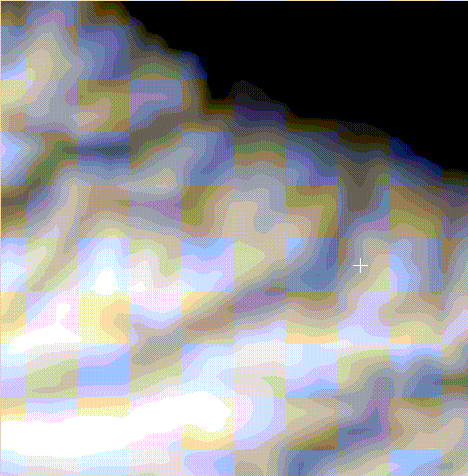
GTOPO30 for the area shown above.
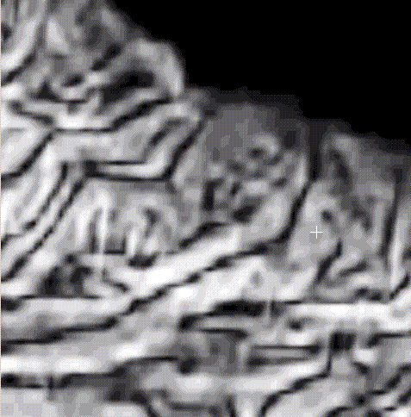
Slope derived from GTOPO30 for the area of interest.

From the slope image, one can derive a mask of steep slopes (>12 degrees, say), shown in the next image. This mask can be extracted with the p_av program like an 8 bit image channel. The mean number of pixels with slopes greater than 12 degrees might give a useful indicator of difficult terrain, and define a ‘strangeness flag’ for the polygon.
This procedure assumes, however, that the slope map is accurate enough to mask out the polygons we want.

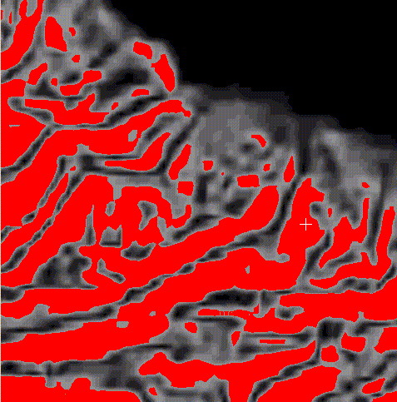
Mask of steep slopes > 12 degrees derived from GTOPO30

Layover and shadow masks from intensity thresholds

Another strategy is to create a mask of layover and shadow from the intensity image itself. This can be done by defining a low threshold for shadow areas and a high threshold for layover areas. In the two ERS frames 32514_2565 and 35978_2565, I found thresholds of <70 and >700 gave satisfying results. If any of the three intensities was lower than 70 or higher than 700, the pixel was masked. The mask has been 5x5 median filtered to remove effects of speckle.
These thresholds will be different for other images though. Creating a topography mask will have to be done manually on screen to assure the quality of the mask.

The ERS intensity image

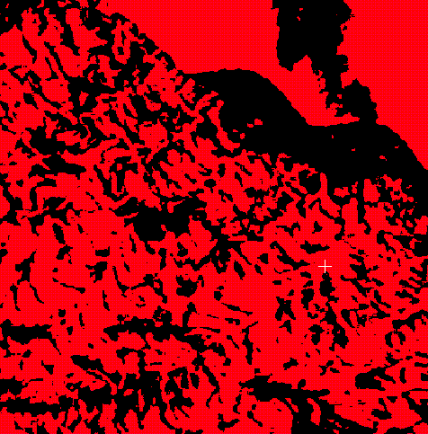
Shadow and layover mask derived from intensity thresholds and median filtering

As becomes clear from the images, this mask provides good results for the study site, as it masks out most of the high topography in the lower left part of the area, but includes the flat ‘m’ shaped area at the shore in the analysis (shown in black). Part of the lake is masked, too, but this does not affect the polygon database.

Conclusions

Although I have not performed a thorough analysis of the different approaches, I tend to use the intensity thresholding, as it shows the best agreement with the actual image (which is not surprising). Use of the slope from GTOPO30 may introduce unknown errors and flaw the polygon analysis.

I would greatly appreciate your comments on this approach, and whether you all agree to proceed in the way I suggested. We will need to find common ground for production of the polygon database as soon as possible.

