

Working Note

Analysis of the information content of three texture measures of ERS amplitude and coherence
26/10/99
Heiko Balzter, David Gaveau, Stephen Plummer
NERC Institute of Terrestrial Ecology Monks Wood

Aims

- To investigate the information content of different texture statistics of the ERS amplitude and coherence images.
- To give a recommendation on whether to include texture in the classification procedure or not.

Material and methods

Study site: Lake Baikal South, ERS frame 35978_2565 (Figure 1)

Input channels:
- ERS-1 calibrated amplitude
- ERS-2 (1) calibrated amplitude
- ERS-2 (2) calibrated amplitude
- coherence (window size 80)

Texture statistics:
- standard deviation over a 7x7 window for ERS-1, ERS-2 (2) and coherence80
- entropy over a 7x7 window for ERS-1, ERS-2 (2) and coherence80
- contrast over a 7x7 window for ERS-1, ERS-2 (2) and coherence80
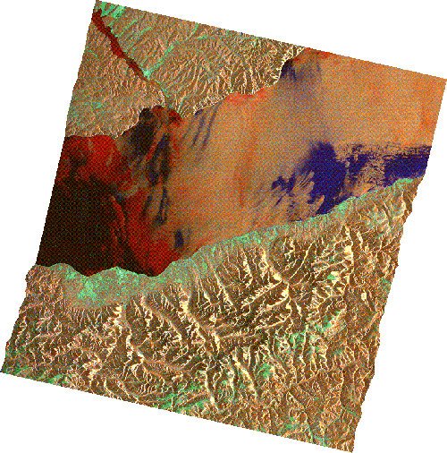
Figure 1: Overview of ERS frame 35978_2565 (.wbb file from DLR).

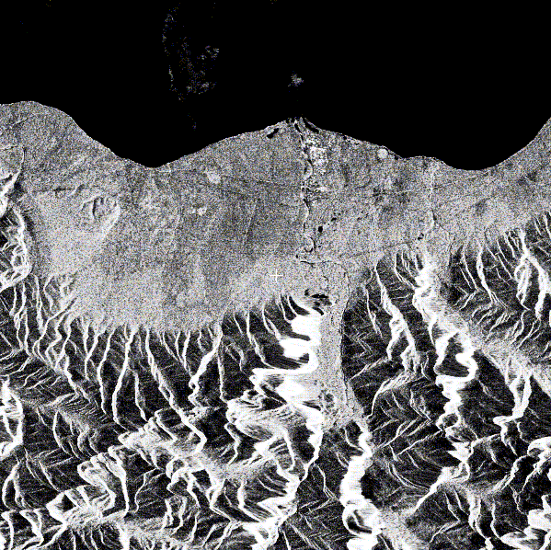
Figure 2: Amplitude of the second ERS-2 pass for the area of interest.

Approach

The assessment of ERS texture statistics was undertaken using Principal Component Analyses (PCA). A PCA reduces a multidimensional feature space to orthogonal principal components which are derived from linear combinations of the input variables. The principal components are ordered according to the proportion of the variation in the data they can explain. Here, the criterion for considering a principal component (PC) as not negligible is that it explains more than 5% of the overall variance. Four principal component analyses were undertaken using the above input channels as variables. A random sample of 10,000 pixels was taken from the area covered by the polygon ground database (Figure 2), masking out mountainous areas.

PCA1: 4 input channels and all 9 texture statistics
PCA2: 4 input channels and the 3 standard deviation channels
PCA3: 4 input channels and the 3 entropy channels
PCA4: 4 input channels and the 3 contrast channels

PCA1 was used to evaluate the joint use of several texture measures. PCA2 to PCA4 were used to compare the information content of each single texture statistic.

Results

Figure 3 shows an example of the entropy for the area of interest.
A summary of the explained proportions of variance by the four PCAs is given in Annex A.
PCA1 reduced the 13 input variables to 5 PCs (5% criterion, see Annex A). The most important PC (i.e. component 1) is determined mainly by different texture statistics from amplitude 1 and coherence80.
PCA2 yielded five, PCA3 six, and PCA4 five PCs. Irrespective of the texture statistic used, roughly the same number of PCs was found to be significant. In all cases, the most important PC explaining more than 40% of the variation in the data was determined mainly by the texture statistics, and only secondarily by the amplitude and coherence.
Figure 4 shows an image based on the three most important principal components from PCA2 (with the standard deviations as texture information) as red, green and blue. Visually, there seems to be a large potential for classification.

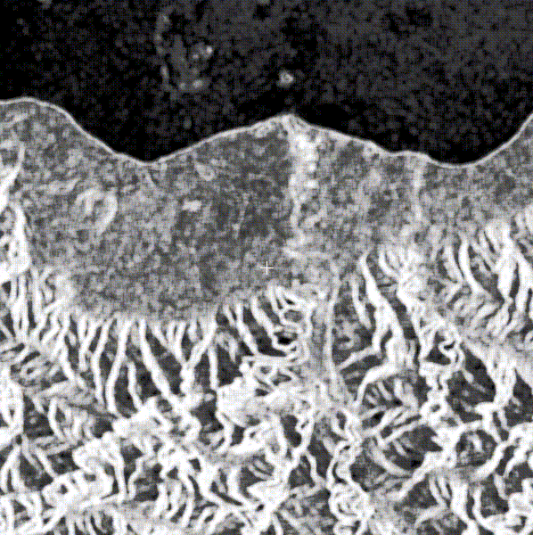
Figure 3: Entropy of the amplitude of the second ERS-2 pass over a 7x7 window.

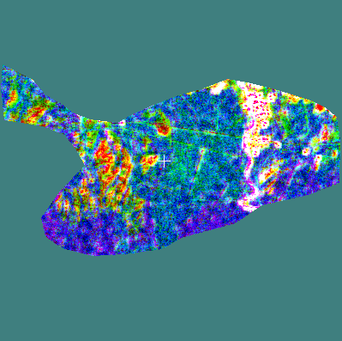
Figure 4: RGB colour composite of the first three principal components from PCA2. The coloured background is caused by the linear enhancement.

Conclusions

The high contributions of the texture statistics to all most important principal components for PCA1 to PCA4 is evidence for the importance of including at least one texture measure for the amplitudes and one for the coherence in the development of the classification methodology.

The information content in relation to the land cover classes and forest parameters and the temporal stability of these observations are yet to be assessed.

Annex A: Short summary of PCA results

PCA1

Importance of components:
Comp. 1 Comp. 2 Comp. 3 Comp. 4
Proportion of Variance 0.6013169 0.1192481 0.07677425 0.06587221
Cumulative Proportion 0.6013169 0.7205650 0.79733924 0.86321145
Comp. 5 Comp. 6 Comp. 7 Comp. 8
Proportion of Variance 0.05806851 0.03314189 0.02987786 0.007595942
Cumulative Proportion 0.92127997 0.95442185 0.98429971 0.991895652
Comp. 9 Comp. 10 Comp. 11
Proportion of Variance 0.006291074 0.001813274 5.212534e-017
Cumulative Proportion 0.998186726 1 1
Comp. 12 Comp. 13
Proportion of Variance 6.065358e-018 0
Cumulative Proportion 1 1

PCA2

Importance of components:
Comp. 1 Comp. 2 Comp. 3 Comp. 4
Proportion of Variance 0.4599091 0.2065788 0.1267871 0.1115800
Cumulative Proportion 0.4599091 0.6664879 0.7932750 0.9048550
Comp. 5 Comp. 6 Comp. 7
Proportion of Variance 0.05822768 0.03691732 8.939945e-017
Cumulative Proportion 0.96308268 1 1

PCA3

Importance of components:
Comp. 1 Comp. 2 Comp. 3 Comp. 4
Proportion of Variance 0.435100 0.2061996 0.1276848 0.1070339
Cumulative Proportion 0.435100 0.6412995 0.7689843 0.8760182
Comp. 5 Comp. 6 Comp. 7
Proportion of Variance 0.06823821 0.05574359 1.079715e-016
Cumulative Proportion 0.94425641 1 1

PCA4

Importance of components:
Comp. 1 Comp. 2 Comp. 3 Comp. 4
Proportion of Variance 0.4722757 0.1928094 0.1321372 0.1134369
Cumulative Proportion 0.4722757 0.6650850 0.7972222 0.9106591
Comp. 5 Comp. 6 Comp. 7
Proportion of Variance 0.05807849 0.0312624 0
Cumulative Proportion 0.96873760 1 1

