Classification of boreal forest (Ust-Illimsk) with Maximum Likelihood Classification

Working note, SIBERIA project

David Gaveau,

Institute of Terrestrial Ecology, Monks Wood
Natural Environment Research Council

October 1999

PART I- THEORY

Introduction

Coherence is a parameter capable of discriminating between forest and non-forest. It is therefore a valuable discrimination tool. However when it comes to dividing the forest into several classes, or to discriminate between the non-forest classes (bogs, burnt area, grassland, arable land, clear-cuts etc..) coherence is difficult to interpret. The coherence retrieval procedure involves several complex processing steps. As a result several artefacts will show up on the way. Therefore quantitative analysis of coherence may not be very reliable. Theoretically coherence is linked indirectly to forest biomass because it is controlled by the first order interaction of radiation with soil. The more the radiation sees the ground component the higher is the temporal correlation because soil is more inert than vegetation. As a result the lower the biomass the higher is the coherence and vice versa. If we use use coherence as a quantitative input for forest classification it is important to remember that some artefacts, which we cannot correct, might distort the above indirect relationship. Will the database help us establish stable threshold values for coherence? The key objective of this working note is assess whether it is possible to produce more classes than simply forest non-forest by means of L- and C-band intensity and ERS coherence images.

In the following, we study carefully the behaviour of the intensity backscatter at L- and C-band as the radiation hits different land and soil types. The different intensity backscatter signatures lead us to the development of a method for boreal forest classification within the framework of the SIBERIA Project.

The goals we set ourselves in this working note are:

- To detect 5 stable land cover classes:

- river
- bog (possibly permafrost)
- low/little vegetation area (arable land, bare soil, low grassland or very low biomass clear-cut)
- clear-cut
- forest

- To detect 3 and 2 subclasses within the primary clear-cut and forest classes respectively:

4) clear-cut → 4) low biomass clear-cut (very young birch or conifer regrowth)
→ 5) higher biomass clear-cut (young tree regrowth)

5) forest → 6) low biomass forest (possibly fire scar)
→ 7) mature and healthy forest

The analysis looks for variations in the intensity difference for two different scenes since it is not sensible to compare the intensities, at one pixel, of two different scenes. Indeed detection systems are not stable over time (Intensity difference variations over time should be less prone to instrumental decay unless the detector fails differently along the image). As an example, within the same scene, backscatter difference [frozen bog – mature forest] ≠ backscatter difference [thawed bog –mature forest].
However, in defining the training sites for the classification, we did not apply any threshold to the intensity difference. We will see for example that JERS backscatter for bare soil is very low compared to the surrounding forest. The eye sees it very clearly so that we chose our training sites for bare soil fairly intuitively and did not use any intensity difference threshold.
The database we’ve all created may allow us to put values to such intensity differences. For example we may find that a certain dB difference (with surrounding forest) is bound to be a low/little vegetation area. However such threshold values may vary according to the weather conditions during the time of acquisition. For instance, will the intensity difference threshold for bare soil from surrounding forest discrimination be the same when the ground is wet or dry? We will try to answer such questions qualitatively. We hope that the database will give us quantitative results.
It should be made clear from the start that we did not run CALIT to correct the scenes for the antenna pattern. However since, we are only interested in intensity differences from two land types boundaries close to one another it should not be a problem.
Analysis

L-Band (JERS) backscatter behaves differently from C-Band (ERS) backscatter. We will use this difference as an analysis tool.

L-band ($λ=\text{23} \text{cm}$) is less affected by surface roughness than C-band ($λ=5\text{.}6 \text{cm}$). In other words an experiment comparing L-band and C-band scattering behaviour from the same rough surface will show that L-band will be more specularly reflected whereas C-band will be more diffusely reflected.

- in the case of ERS satellites for which $λ=5\text{.}6 \text{cm}$ and the incidence angle $α≈{\text{23}}^{∘}$ the surface roughness maximum height$Δh$must be smaller than 0.77 cm to have perfect specular reflection.
- In the case of the JERS satellite for which $λ=\text{23} \text{cm}$ and the incidence angle $α≈{\text{37}}^{∘}$ $Δh$ must be smaller than 3.60 cm to have perfect specular reflection.

Practically, less backscatter should be seen from land types such as clear-cuts, bare soil, arable land and grassland in the JERS case.

We have reasons to believe that the dry land surfaces we will analyse had relatively low soil moisture at the time of acquisition. In other words it wasn’t raining too much in the Ust-Illimsk area. The meteorological data (station 30117) give no precipitation for Sept. the 23rd and 24th as well as for July 31st and possibly May 27th (to be verified).

By looking at the two ERS intensity scenes below, one sees that arable land backscatters more radiation when the soil moisture is high1. Therefore as we found that most clear-cuts and low/little vegetation areas appear darker compared to the surrounding forest in the Ust-Illimsk area we reached the above conclusion that the soil was fairly dry.

Siggefora city (southern Sweden) surrounded by fields seen By ERS

12 March 1994 Ascending 20 August 1995 descending
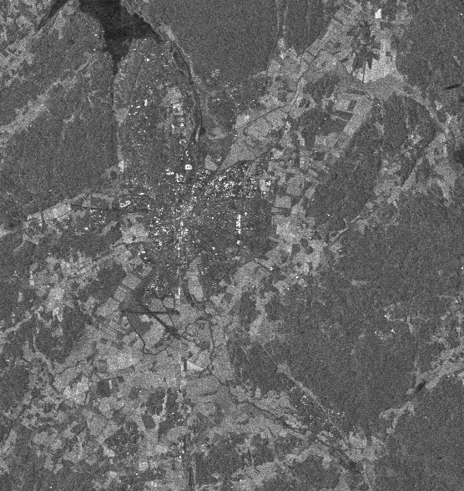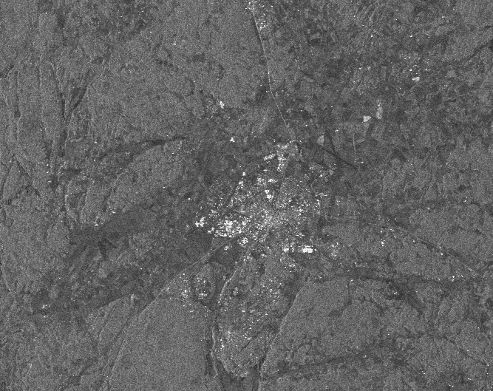
Snow started to thaw just after March 03, No rain
precipitation 0.2 mm
- Low/little vegetation areas, clear-cuts and fertile land

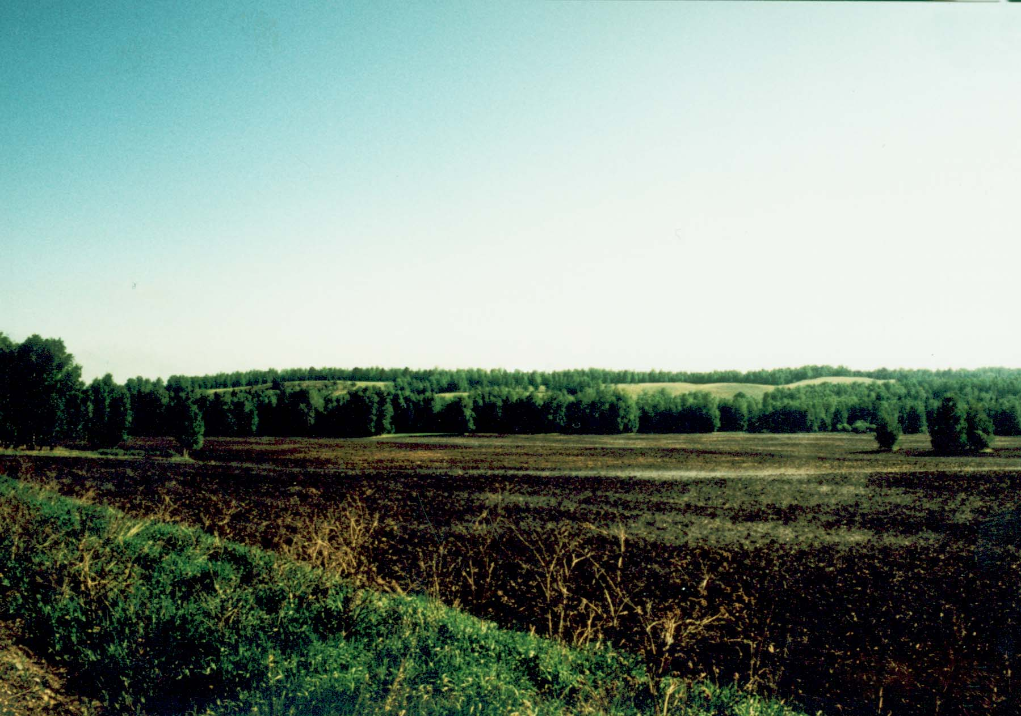
Bare Soil or ploughed field, Krasnoyarsk area

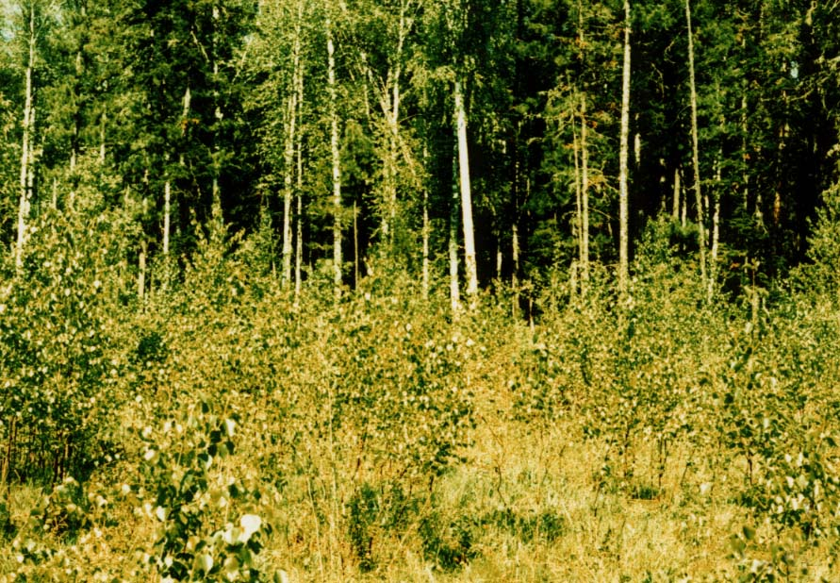
Clear-cut, Krasnoyarsk area, key 12

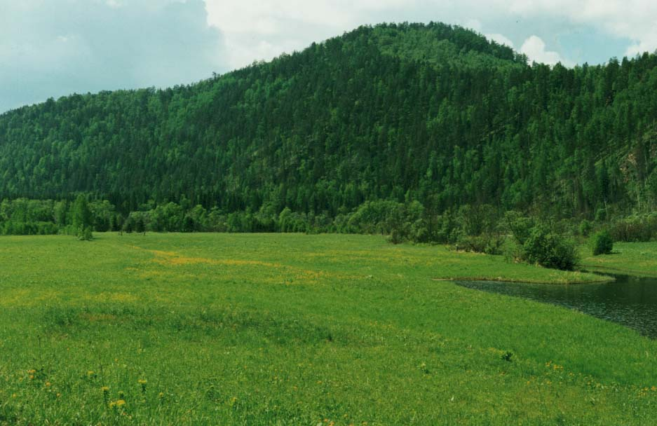
Fertile unforested land, Mana river

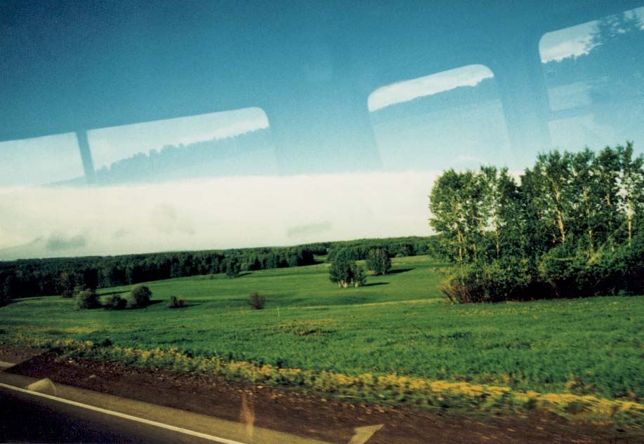
arable land, Krasnoyarsk area

- Analysis of the ERS and JERS intensity scenes

Practically, we found from analysing data from the Ust-Illimsk area (see page 17 for examples) that the areas we believe to be low/little vegetation areas have lower backscatter with respect to the surrounding forest (intensity difference threshold should be provided by the database) in JERS-1 intensity images (04 May 97 and 31 July 97) than in the three ERS scenes ( 23, 24 Sept. 97 and 27 May 98). Also clear-cut areas are much better defined in the two JERS scenes and on average have lower backscatter compared to the surrounding forest. The same analysis was performed on the following scenes: 32400_2457_0 for ERS and 961125B 970406B for JERS in the Krasnoyarsk region, Previnsky area, key 13. It confirmed that ERS intensity has difficulties in picking up clear-cut areas. However the JERS intensity scene of the 25th November 1996 does not improve the clear-cut discrimination whereas the JERS scene of the 6th April 1997 does. We’ve seen those clear-cuts during the Siberia field trip and they were relatively high biomass. (See photo with Shaun standing under the young birch regrowth for scale.)

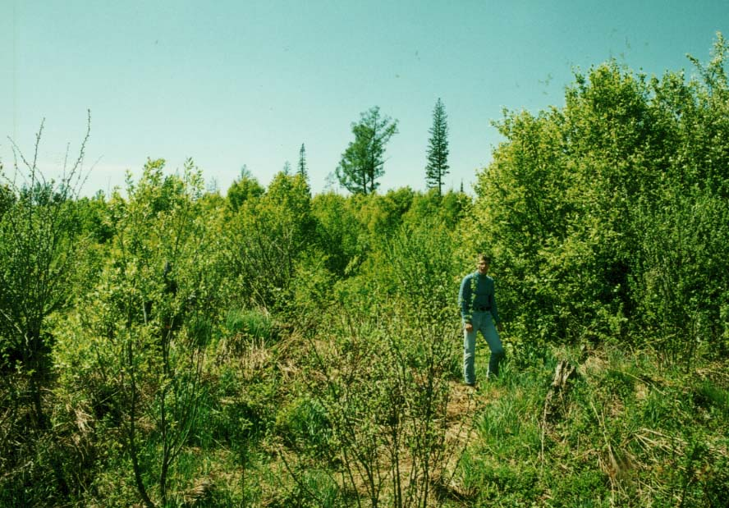
key 13, Previnsky area

In the higher biomass clear-cut case even L-band radiation ($λ=\text{23} \text{cm}$) will be more diffuse because of greater multiple scattering. High biomass backscatter clear-cut signatures are therefore closer to that from forests. What about the JERS difference? The weather data for November 1997 ( station 29471) give strong negative mean temperatures ( probably -10°C ) and indicate that there should be a snow cover at that time. The snow in October 1997, fell between the 11th and 21st October. Dry snow cover (my guess is that snow is dry because of the continental climate) has a volume backscattering coefficient equal to that of rain for the same precipitation rate. Therefore backscatter from clear-cuts covered with dry snow should become more correlated to that from forests. This is a possible explanation to the JERS scene of November 25th 1996 if the same weather conditions occurred in October 1996. As for the JERS April scene, one can guess that snow was probably thinning but the soil was still frozen (no weather data available in 1996 or April 1997) so that the backscattering coefficient from clear-cuts should increase and therefore decorrelate with that from forests. The same analysis can be applied to the two JERS scenes of May 4th and July 31st. The meteorological data (station 30117) for early May 1998 give temperatures close to 0°C and some precipitation so that it probably snowed around the 4th May. On July 31st there is no evidence of recent rain.

The three ERS scenes of the Previnsky area, reveal bright zones in the lower right of the images. The July 31st image contains the brightest and largest patches. Since the patches are concentrated around the river banks (the brightest is at the confluence of two rivers), they most probably represent large meadows like the ones at Mana river that were visited in the during the Siberia field trip (I vaguely remember some heavy drinking!!). This can be confirmed by looking at the backscattering signatures at Mana river ( the orbit and frame for Mana river are 32357_2493_0).
Although it is important to take into account topography and geology it is still possible to set some rules for the Swedish team such as:
“When there is a low or high (if rain) ERS intensity (and JERS intensity is low or high (if rain)) for a large patch irregular in shape (as opposed to man made structures) following a river or at the confluence of two rivers it most probably is a fertile unforested land.”
The above could become a general rule.

- Preliminary conclusion.

- JERS backscatter detects clear-cut and low/little vegetation areas better than ERS. This should always be the case except in very wet conditions.

- In dry conditions, JERS backscatter allows discrimination of clear-cuts, very low vegetation areas (bare soil, arable land or low grassland) and forest
- In wet conditions, ERS backscatter may allow discrimination of clear-cuts, low/little vegetation areas and forest (see ERS intensity scene over Siggefora, Sweden, page 4)

- JERS backscatter picks up relatively high biomass clear-cuts provided there is no snow cover and soil moisture is low. A JERS intensity scene in dry summer should be best. It is important to remember that usually boreal forest ground is rather wet in summer, so the detection of boggy clear-cuts may be more efficient with ERS intensity.

- JERS, ERS (summer acquisition is best) and/or river plus confluence structure should allow detection of fertile unforested land.

II - Bogs

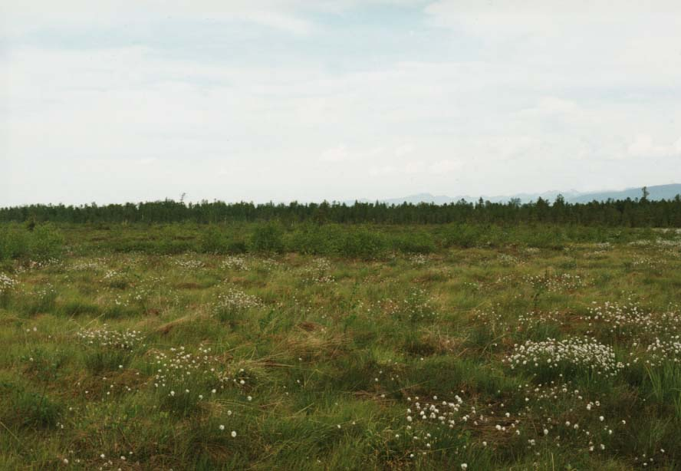
Boggy field, South Lake Baikal

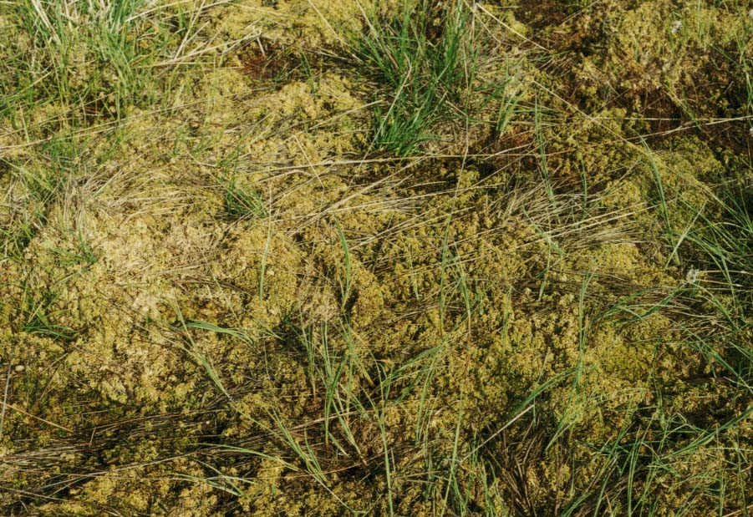
Close up on the boggy ground

- Analysis (see page 18)

A bog is an area of soft wet ground, consisting of decaying vegetable matter (see page 10). The high water content in bogs induces high backscatter, particularly at C-band.
Is it because:
- L-Band is reflected more specularly than C-Band?
- L-band reflectivity is lower than C-band reflectivity at the air liquid water interface (is this true?)?
- Water is colder in May than in July?
Does anyone know?

By comparing the wet ERS scene of Siggefora (page 5) with the ones on page 18 we found strong backscattering resemblance. The ERS intensity scene of May 27th shows a brighter patch. Summer in the boreal zone has a rather wet soil. We believe that the two ERS scenes of September were acquired at a lower temperature than given by the weather data. Minimum temperatures of -8°C can occur as early as the 15th September. Also the September ERS scenes were acquired at the nearly coldest hour of the day i.e 4.30 am.

- Preliminary conclusion

- JERS backscatter does not detect bogs clearly. This needs confirmation for all cases.

- ERS backscatter detects bogs clearly and particularly in dry summer conditions.

- ERS backscatter may not detect bogs in rainy conditions (especially if the surroundings are low/little vegetation areas)
III - Low and high biomass forest

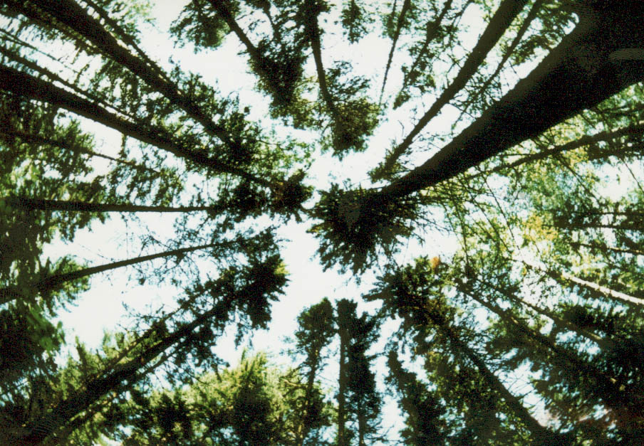
Mature and Healthy forest (high biomass), key 12

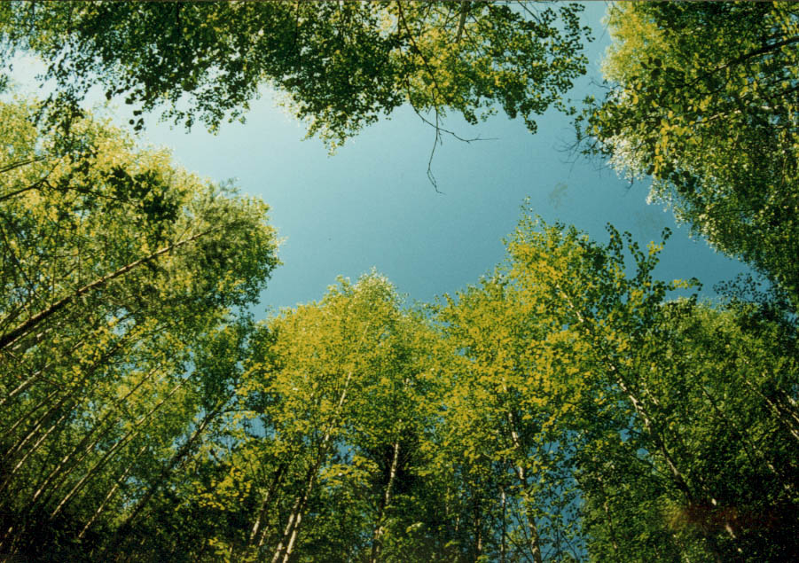
Lower biomass forest, key 13 Previnsky area, same fish eye lens

- Analysis

As mentioned in the introduction, there is an indirect relationship between coherence and forest biomass because it is controlled by the first order interaction of radiation with soil. The more the radiation sees the ground component the higher is the temporal correlation because soil is more inert than vegetation. As a result the lower the biomass the higher is the coherence and vice versa. Similarly JERS backscatter should also be linked to forest biomass. The more L-band radiation sees the ground the more it will be specularly reflected and the less the backscatter. As was seen before, C-band radiation does not pick up clear-cuts very well so it is unlikely to discriminate between low and high biomass forest (see page 19). Now, what is the definition of a low and high biomass forest. In radar remote sensing point of view, a low biomass forest is one for which the incoming radiation sees a lot of ground component. A high biomass forest is one for which the incoming radiation sees little or no ground component.
According to Chambers Science and Technology Dictionary, the biomass of a tree is the total dry mass of the tree. Therefore, in calculating the biomass of a given tree, the foresters take into account the trunk, branches, leaves and roots. In our case we are not interested in such an accurate definition of biomass. This is why we’ve chosen to relate our radar parameters to the growing stock volume. In general, the growing stock volume is the stem volume for all living tree species in a stand. It is measured in volume of wood (m³) per unit hectare (Bear in mind that on slopes the volume of wood per unit area is overestimated because the area is projected horizontally).
It is important to bear in mind that the radar signatures indicating low or high biomass may not correlate always to the growing stock volume, for example:
- A relatively high growing stock volume which implies a relatively high biomass forest could be detected as a relatively lower biomass one by the radar signatures if the individual trees have larger diameter trunks but are widely separated so that the incoming radiation will see a substantial amount of ground component.

- A relatively low growing stock volume which implies a relatively low biomass forest could be detected as a relatively relatively higher biomass one if the young trees are so densely packed that the incoming radiation sees little ground component.

The scenes to illustrate the radar signature for low and high biomass forest were chosen according to the growing stock volume map for Ust-Illimsk.
As expected the ERS intensity scenes do not discriminate between low and high biomass forest. For JERS we would expect L-band backscatter to have a similar signature for low biomass to that for relatively high biomass clear-cut areas. If we compare the backscatter signatures for the JERS scenes of 6th April 1996 (key 13, Previnsky area) (page 17) with that of 4th May (page19) we clearly see that the areas we defined as relatively high biomass clear-cuts have a similar signature to the areas we believe to be low biomass forest: JERS backscatter difference [high biomass forest – low biomass forest] is not as obvious as for low/little vegetation areas or low biomass clear-cuts (threshold values are needed).
In those areas we believe to be low biomass forest (clearly the GIS does not give exactly the same results), coherence is rather high compared to the surrounding high biomass forest but is low compared to the clear-cut areas. Therefore coherence does contain the information to discriminate between high and low biomass forest and clear-cut areas. The need to define threshold values for coherence therefore becomes relevant.

2 - Preliminary conclusion

- JERS backscatter probably discriminates between areas of low and high biomass but the intensity difference is relatively low. Will this always be true? Is this intensity difference significant enough? Will the database provide us with the answer?

- ERS coherence seems to discriminate quite well between low and high biomass forest but we need to establish coherence difference thresholds for quantitative measurements of low to high biomass forest.

Overall Recommendations

- In dry conditions

JERS BACKSCATTER

- JERS backscatter allows discrimination of clear-cuts, low/little vegetation areas (bare soil, arable land or low grassland) and forest.

- JERS backscatter allows discrimination of very low biomass clear-cuts (close to natural low/little vegetation areas), low biomass clear-cuts and relatively high biomass clear-cuts. It will be difficult to discriminate between very low biomass clear-cuts and low/little vegetation areas.

- JERS backscatter may allow discrimination of low biomass forest and high biomass forest.

Therefore JERS backscatter alone should detect 6 classes

ERS COHERENCE

- ERS coherence may allow discrimination of clear-cuts, low/little vegetation areas (bare soil, arable land or low grassland) and forest.

- ERS coherence may allow discrimination of very low biomass clear-cuts(close to natural low/little vegetation areas), low biomass clear-cuts and relatively high biomass clear-cuts.

- ERS coherence may allow discrimination of low biomass forest and high biomass forest.

Therefore coherence seems to detect the same land cover classes as JERS backscatter.

ERS BACKSCATTER

- ERS backscatter allows discrimination of bogs and forests.

- ERS backscatter does not allow discrimination of low biomass clear-cuts and high biomass clear-cuts.

- ERS backscatter does not allow discrimination of low biomass forest and high biomass forest.

- ERS backscatter may allow discrimination of very low vegetation areas and clear-cuts.

Therefore ERS backscatter should detect additional class to the 6 identified above. Together with the river class ERS, JERS backscatter and coherence should theoretically be able to detect 7 land cover classes. If we include the more marginal fertile unforested land near rivers as a separate classes this amounts to 8 land cover classes.

- In wet conditions

- JERS backscatter may not be able to discriminate between the 6 mentioned classes. This needs more investigation
- ERS backscatter may not discriminate clearly between bogs and very low vegetation areas.

- ERS backscatter may discriminate clearly between clear-cuts and forest (see Siggefora ERS scene page 5)

In wet conditions therefore we should not expect to detect the same number of classes as for dry conditions with any confidence.

- In dry and wet conditions

If we have 2 ERS and 2 JERS intensity scenes, one in dry and one in wet conditions we can possibly discriminate between low and high biomass forest. According to Le Toan’s observations (on the Siberia field trip) backscatter from 100% forest cover stands will not be affected by the increase or decrease of soil moisture because the incoming radiation sees very little soil component, and in case of rain, most of the water is concentrated on the ground not in the forest canopy. On the other hand, backscatter from say 20% forest cover stand will either increase or decrease if soil moisture increases or decreases respectively. However such analysis compares the intensities, at one pixel, of two images acquired at different times, say 2 ERS or JERS intensity scenes on a rainy and on a dry day. Rigorous intensity calibration of the scenes is then necessary unless we look for intensity differences. We would need two reference frames with constant backscatter whether it rains or not. One reference frame would give zero backscatter return (river) the other would give 100% backscatter return (corner reflector).

1) Ust-Illmisk region, low/little vegetation areas, clear-cuts and fertile land
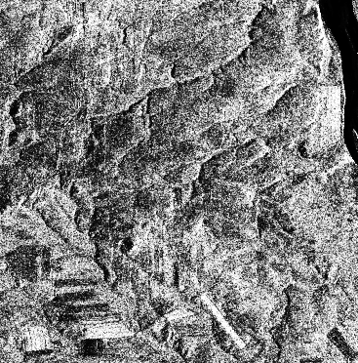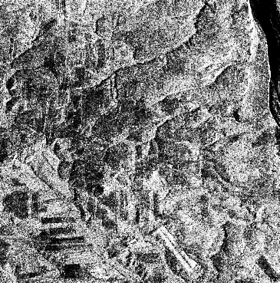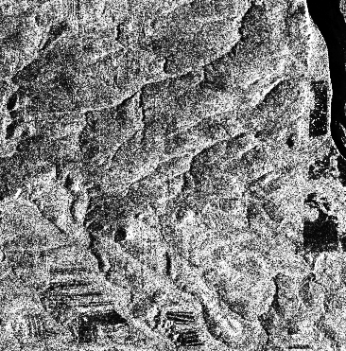

ERS-1 23 Sept. 1997 ERS-2 24 Sept. 1997 ERS-1 27 May 1998

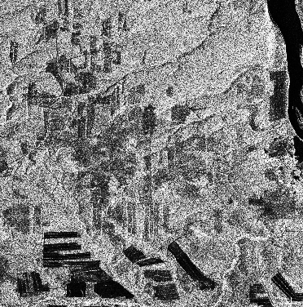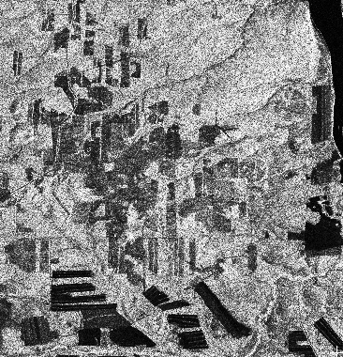

JERS-1 04 May 1997 JERS-1 31 July 1997

- Krasnoyarsk region, Previnsky, key 13 (32400_2457_0 and 961125B 970406B)

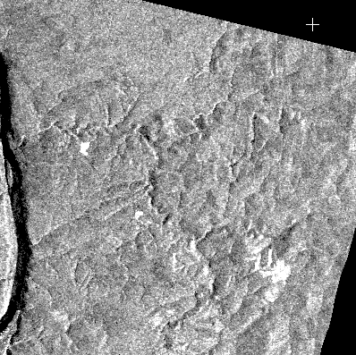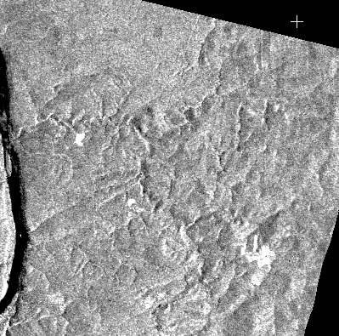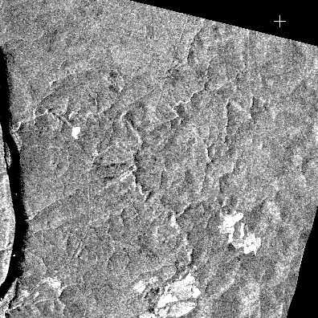

ERS-1 25 Sept. 1997 ERS-2 26 Sept 1997 ERS 03 July 1998

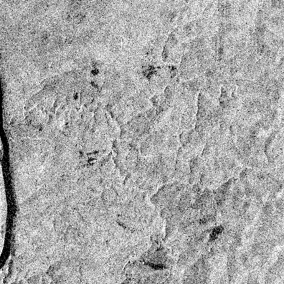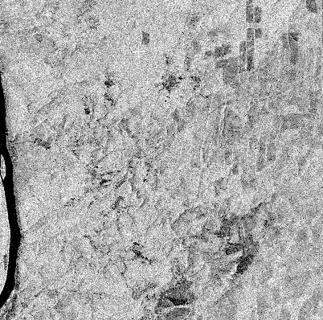

JERS-1 25 Nov. 1996 JERS-1 06 April 1997

Ust-Illimisk region Bogs (Permafrost?)

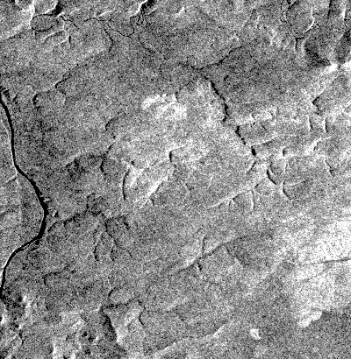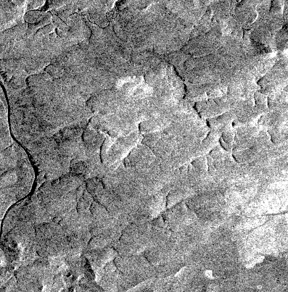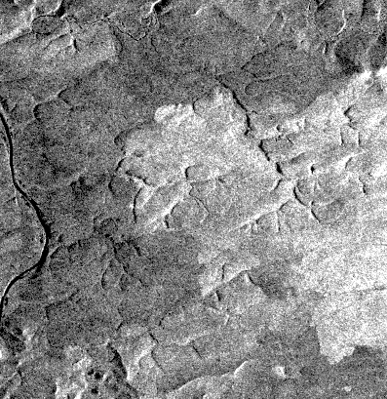

ERS-1 25 Sept. 1997 ERS-2 26 Sept 1997 ERS-1 27 May 1998

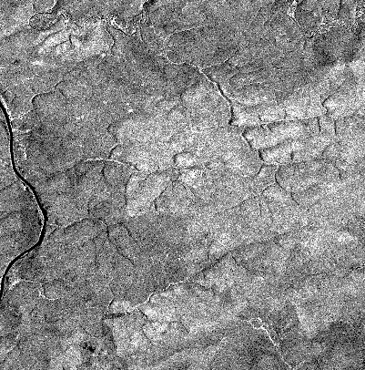

JERS-1 04 May 1997

Ust-Illimsk region, low biomass and high biomass forest

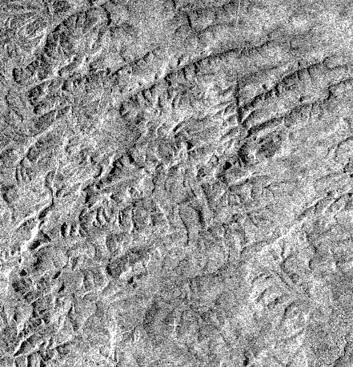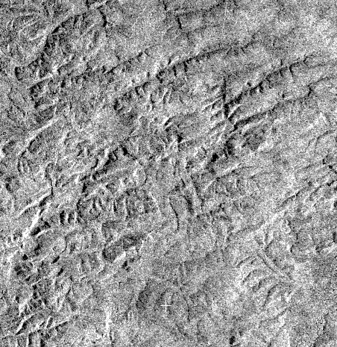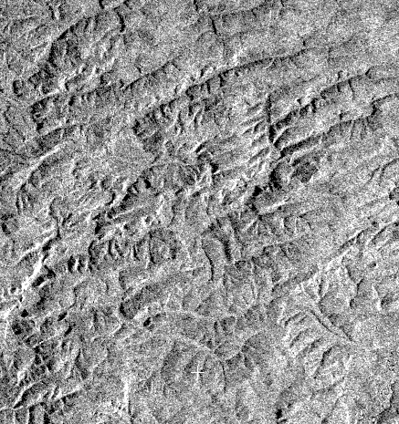

ERS-1 25 Sept. 1997 ERS-2 26 Sept 1997 ERS-1 27 May 1998

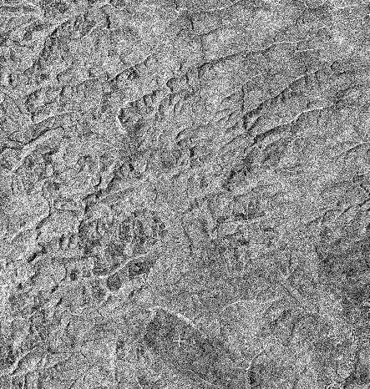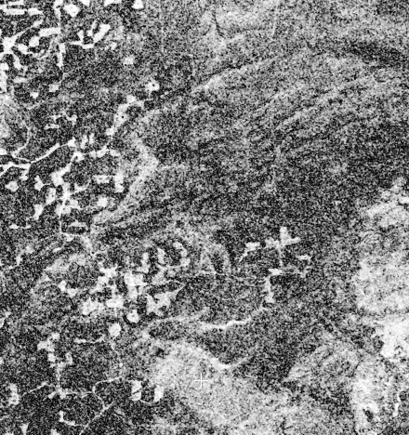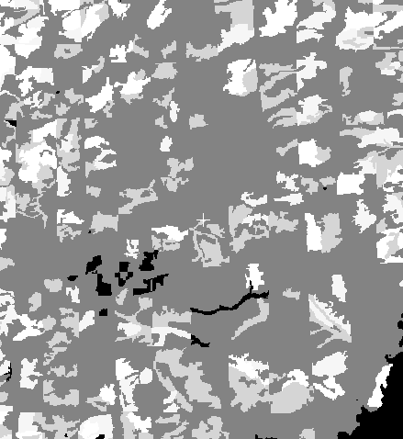

JERS-1 04 May 1997 ERS 25/26 Sept Coherence Growing stock volume merged into
4 classes (white high, dark low).
Part II - CLASSIFICATION PROCEDURE AND RESULTS

The following procedure is relevant for relatively low soil moisture content on the ground. In wet conditions a new procedure should be made.
Since we chose a supervised classification method we had to select training sites for the 8 land cover classes we wanted to classify namely:

- River.
- Bogs.
- Low/little vegetation areas (bare soil, low grassland, arable land and very low biomass clear-cuts).
- low biomass clear-cuts.
- relatively high biomass clear-cuts.
- Low biomass forest.
- High biomass forest.

Training site selection procedure.

We chose our training sites according to the previous radar signature analysis, but it was a fairly intuitive selection (and hence subjective) since we did not have any intensity difference threshold. For example low/little vegetation areas have a distinct signature which the eye picks up easily. Therefore, a more accurate training sites selection is needed. However we are fairly confident in our choices for the Ust-Illimsk test site.

- The river training site is the easiest and either ERS or JERS intensity images would do.

- The bogs training sites were chosen by looking at bright backscatter return in the ERS intensity image of the 27th May 1998

- The low/little vegetation areas training sites were chosen by looking at extremely dark backscatter returns in the JERS intensity image of the 31st July.

- The very low biomass clear-cut training sites were chosen by looking at very low backscatter returns in the JERS intensity image of the 31st July (so as to avoid snow cover in the 4th May scene).

- The low biomass clear-cut training sites were chosen by looking at low backscatter returns in the JERS intensity image of the 31st July.

- The relatively high biomass clear-cut training sites were chosen by looking at relatively brighter backscatter returns in the JERS intensity image of the 31st july.

- The low biomass forest training sites were chosen by looking at natural shaped patch having similar backscattering signature to that of high biomass clear-cuts in the JERS intensity image of the 31st July.
.
- The high biomass forest training sites were relatively easy to choose.

Images for training sites selection

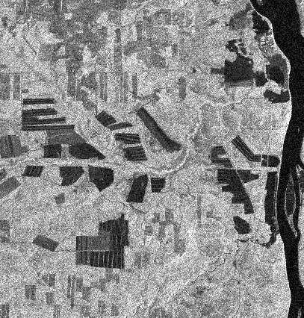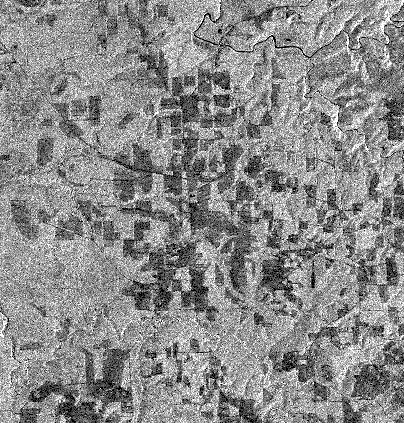
Bog appears bright high biomass clear-cut Low biomass clear-cuts
(relatively dark and regular
patches) and low/little vegetation
areas including very low biomass
clear-cuts (dark and regular patches)

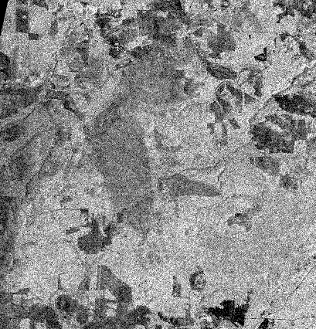
Low and high biomass forest
(the irregular patch in the centre
part is for low biomass)

Classification strategy

We’ve seen that, in dry conditions, JERS backscatter and ERS coherence give the most information for forest class detection.

The classification was performed in two distinct steps:

- Step 1

The initial classification was for the first 5 main land cover classes namely:
- river
- bog
- low/little vegetation area (including very low biomass clear-cuts)
- clear-cut
- forest

The input images were:

- ERS intensity of the 27th May 1998
- ERS intensity of the 24th Sept. 1997
- JERS intensity of the 04th May ( 31st July would have been best but it did not cover the whole segment)
- ERS coherence

- Step 2

A mask was created using the classification obtained in step 1 to separate the forest and clear-cut areas and all the other classes. A second classification was performed within this mask to retrieve the following subclasses:

- low biomass clear-cuts
- higher biomass clear-cuts
- low biomass forest
- high biomass forest.

The input images were:

- ERS coherence
- JERS intensity of the 27th May (31st July would have been optimal)

Results

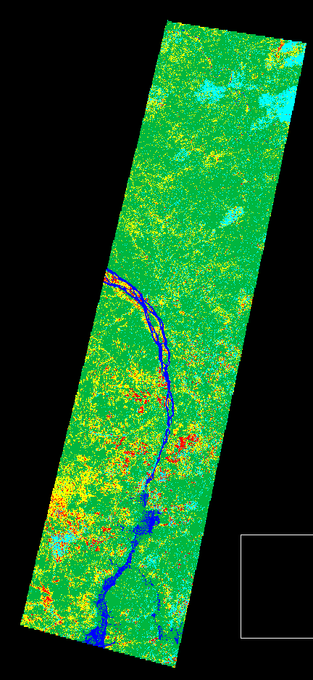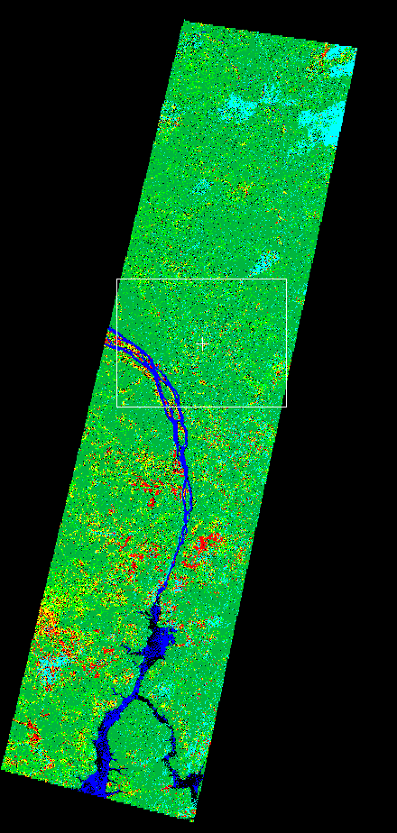

initial classification final classification

Dark blue: river Dark blue: river
Light blue: bog Light blue: bog
Red: low/little vegetation area Red: low/little vegetation area
Yellow: clear-cut Yellow: clear-cut
Dark green: forest Dark green: high biomass forest
Light green: low biomass forest

In the final classification, some clear-cuts may be more yellow, more red, or more light green. (see zoomed area of the final classification in the rectangle) (see zoom page 24)

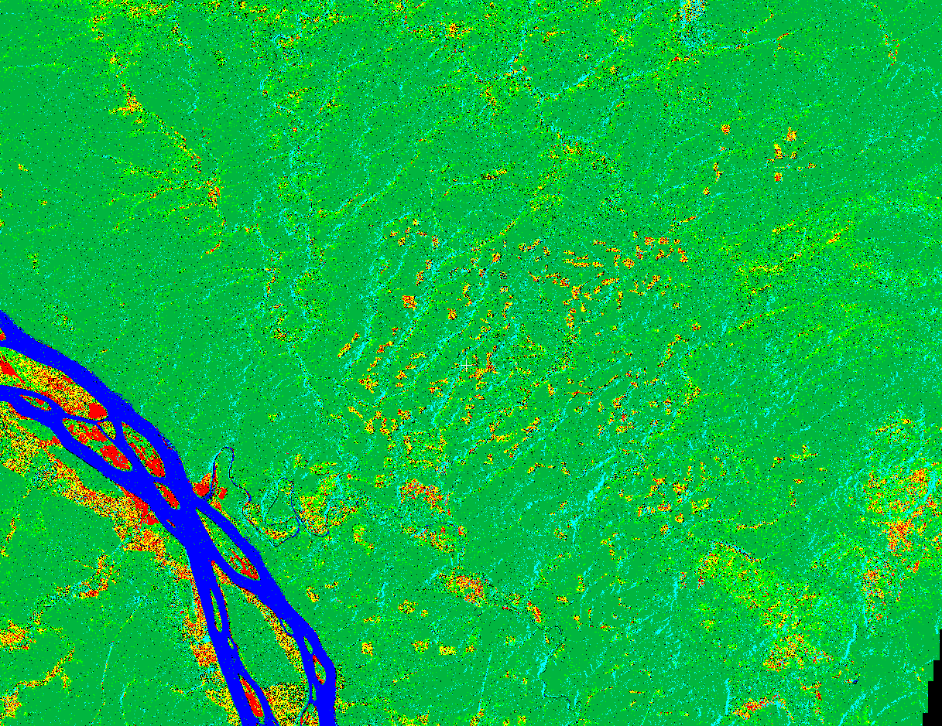

Although it may not show clearly (I should have zoomed much more closely on clear-cut areas) since some clear-cuts are more red others more light green and others more yellow, the clear-cut class can probably be divided into low and high biomass clear-cuts unless this is an artefact.

It is important to note that most of the light blue lines which are therefore classified as bog are in fact layover areas. We think we can avoid this problem by masking the layover areas.

Low and high biomass forest map ( I did not assign quantitative values)

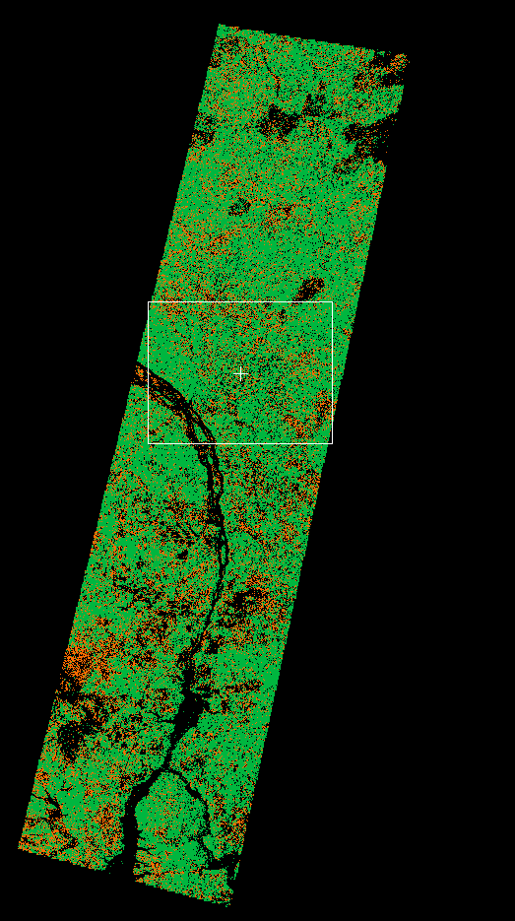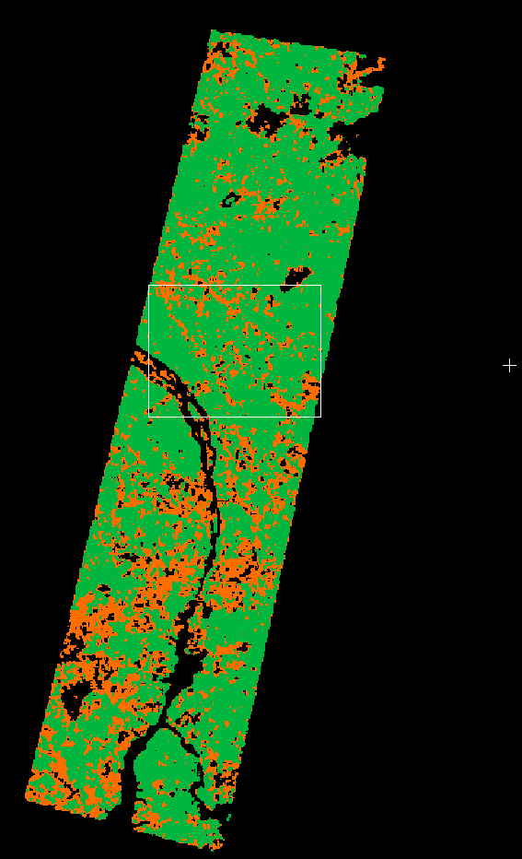

final classification final classification 3 by 3 median filter

red: low biomass forest
green: high biomass forest
black: all the other classes

The following page compares a section of the classification ( in the rectangle) to the GIS. I merged the GIS into two classes and gave it similar colours so that:
Red is low biomass forest
Green is high biomass forest

I leave to you any judgement on any correlation between the two images in page 26

I included in page 27 a final classification with all the classes represented but with a 3 by 3 median filter.
Classification low and high biomass forest
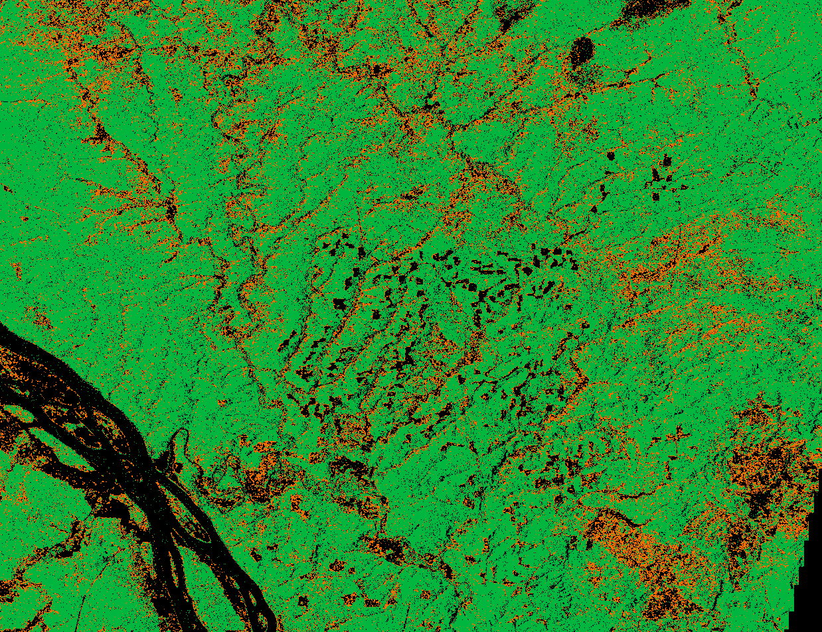

GIS, 2 classes low and high biomass forest. Red is low, green is high
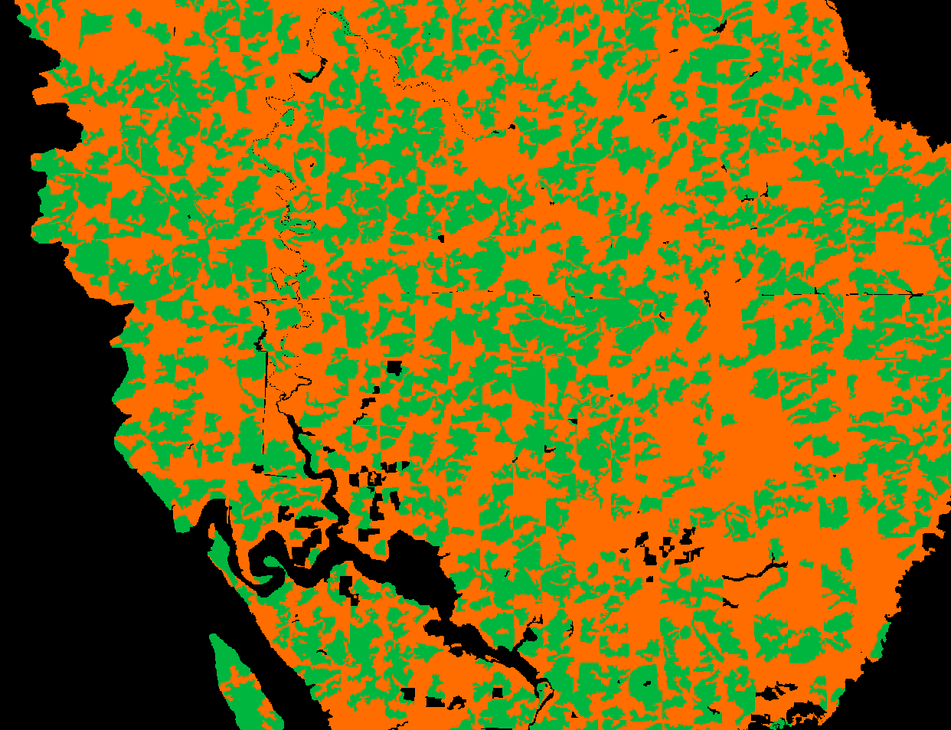

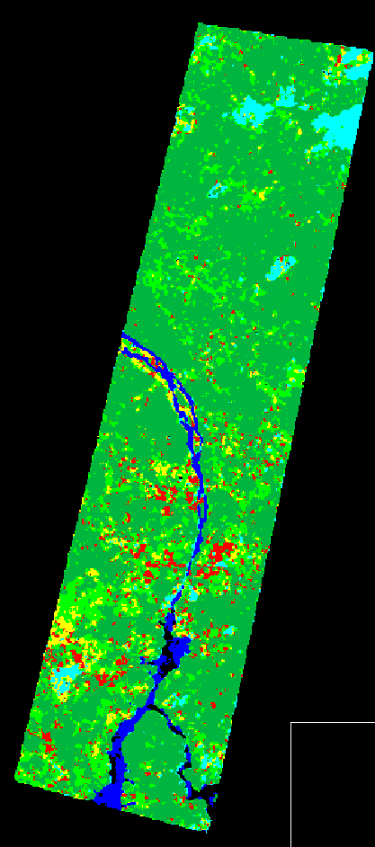

Final classification 3 by 3 median filter

Further details and physical proof are available as an internal ITE report
Possibly because diffuse reflection smooths out the sharp boundaries between say forest and clear-cuts.
Ulaby, Moore, Fung, Microwave remote sensing, Vol.1, p. 329
Mickael Gluck, SIBERIA project ground truth data workbook

