ISODATA and ICP
a. Increasing the number of iterations
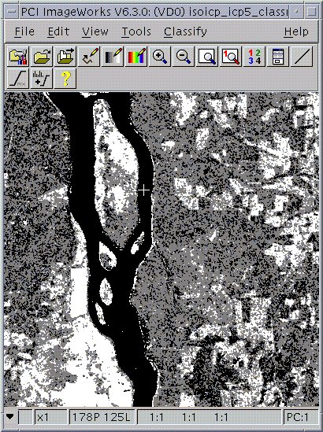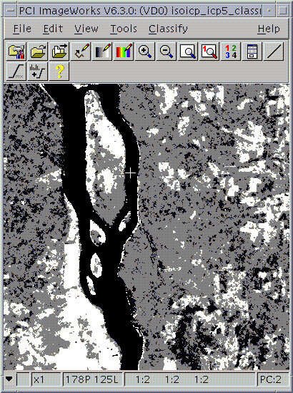
ISODATA initial classification ICP 5 1 2
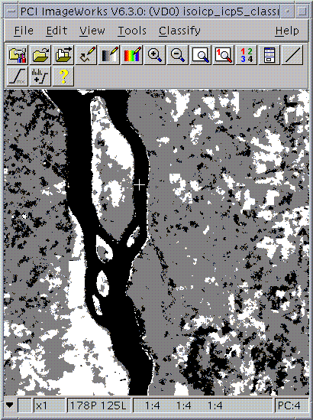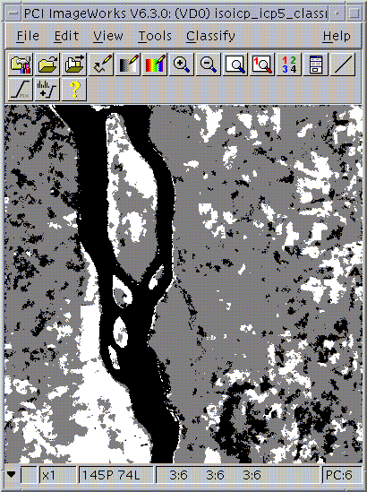
ICP 5 3 2 ICP 5 5 2
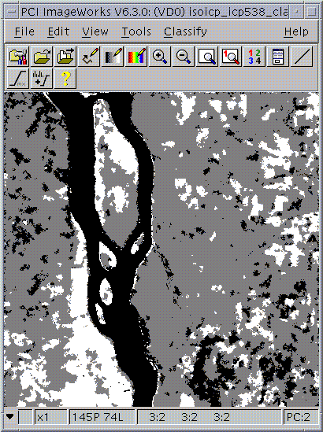
ICP 5 10 2

b.Increasing the weight of contextual information
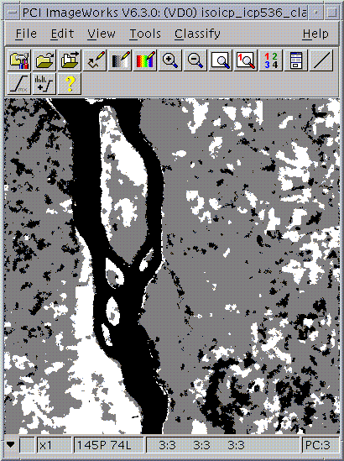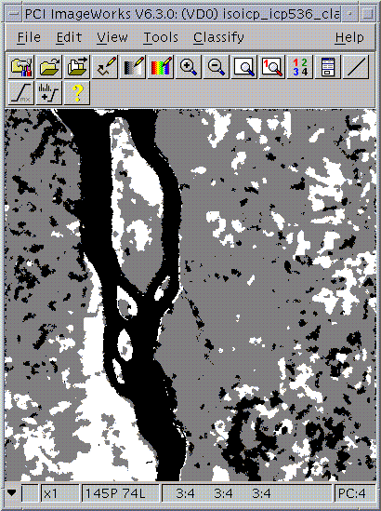
ICP 5 3 3 ICP 5 3 4

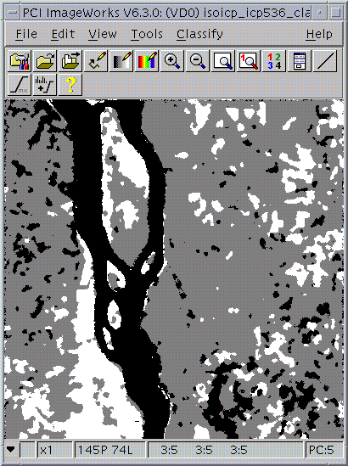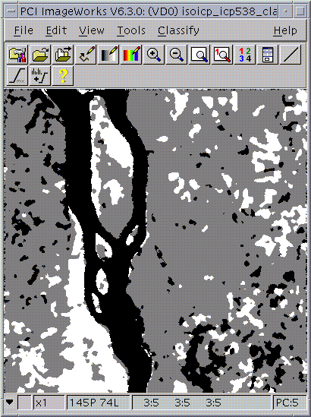
ICP 5 3 6 ICP 5 3 8

c. Increasing the window size from 5 to 7
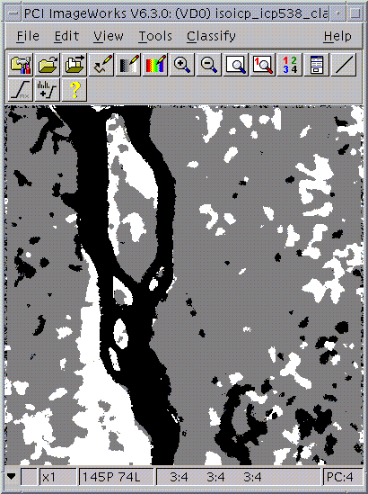
ICP 7 3 8

First conclusions

Looks good.
Increasing the number of iterations smoothes the image up to a certain limit. Above this limit, further iterations have little effect.
Increasing the window size smoothes the image, but produces artefacts at the edges of features in the landscape as well.
Increasing the weight of contextual information smoothes the image.

Recommended parameters are 3 iterations, 5x5 window and weight = 3.

