 | Ust-Illimsk | Bolshyamurta | Primorski | Ulskanski | ChunskiA | ChunskiB | Nishne A
0-20 m3/h | 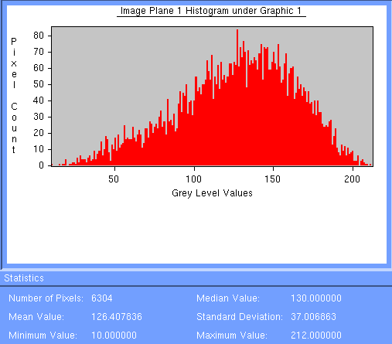 | 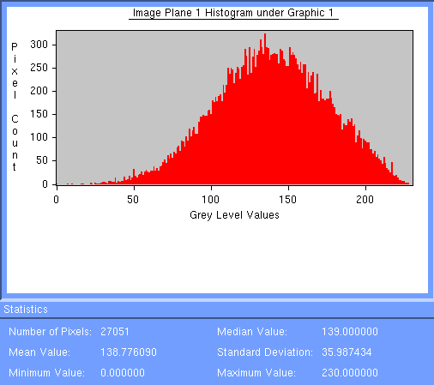 | 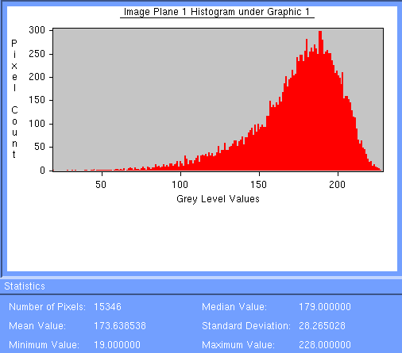 | 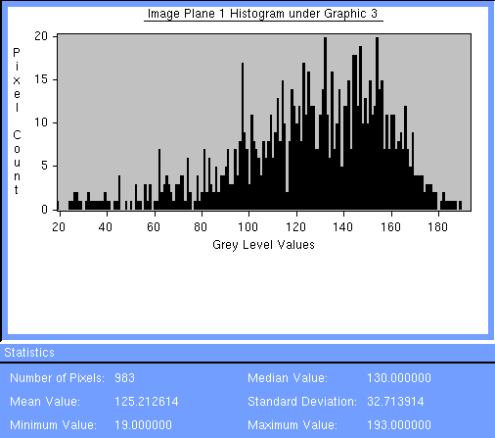 | 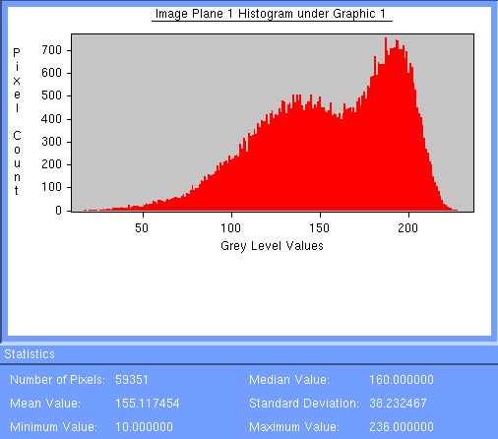 | No data | 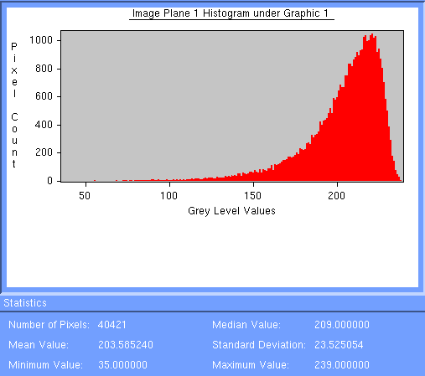
20-50 m3/h | 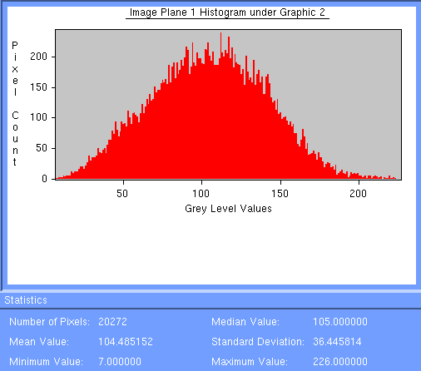 | 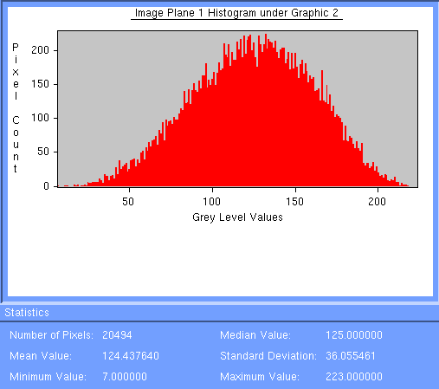 | 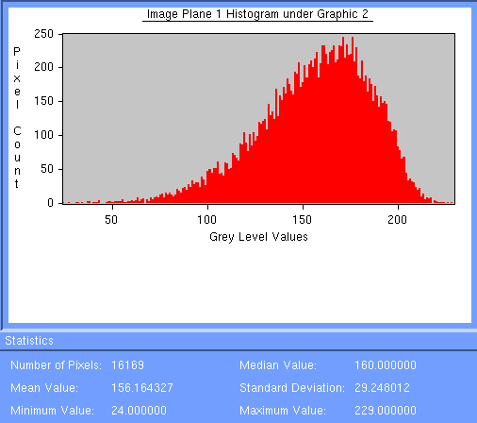 | 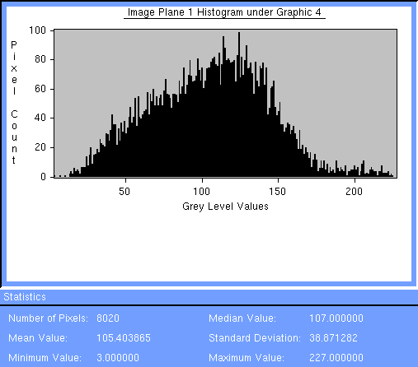 | 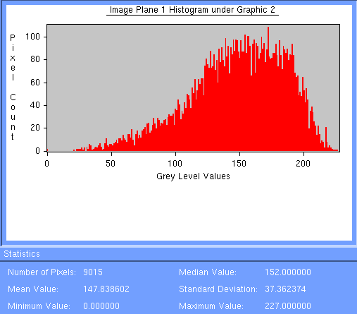 | 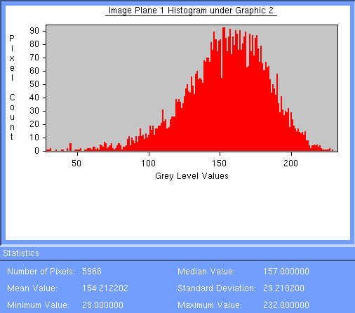 | 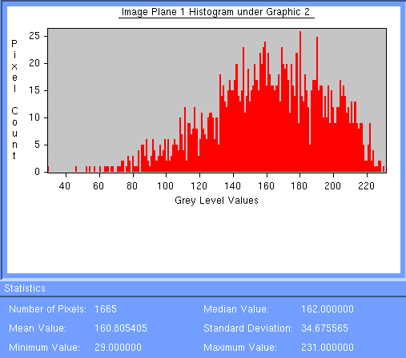
50-80 m3/h | 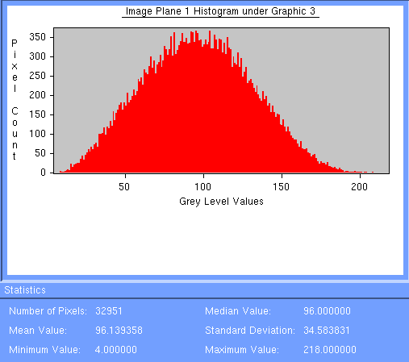 | 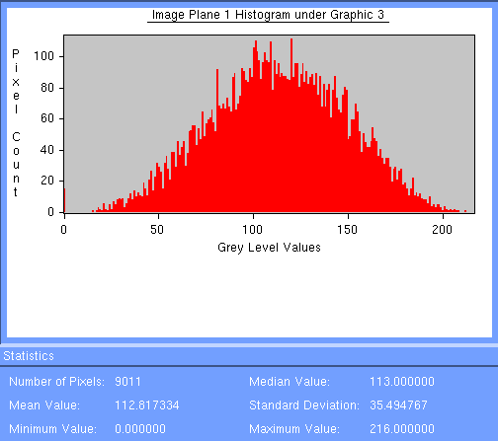 | 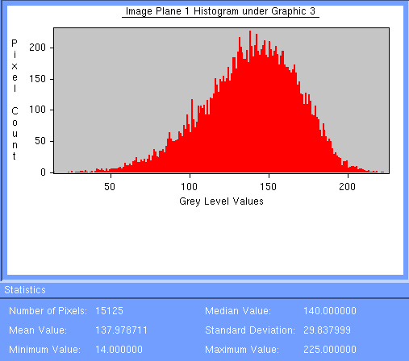 | 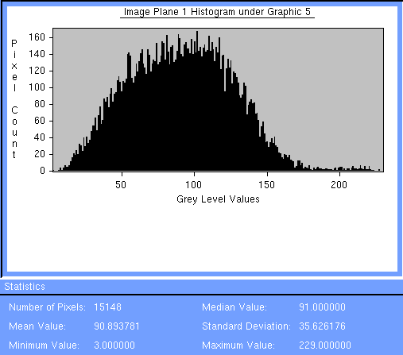 | 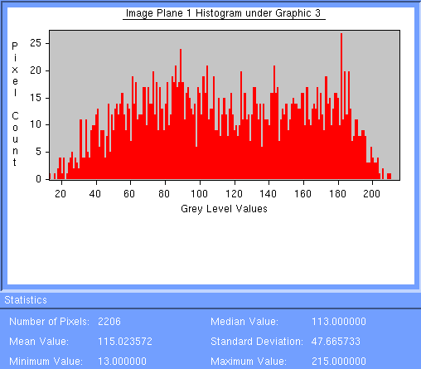 | 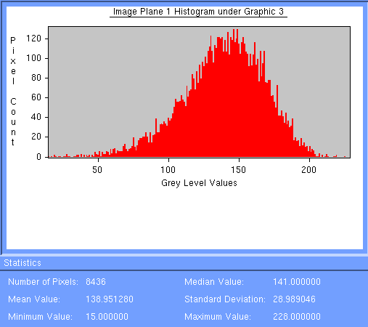 | 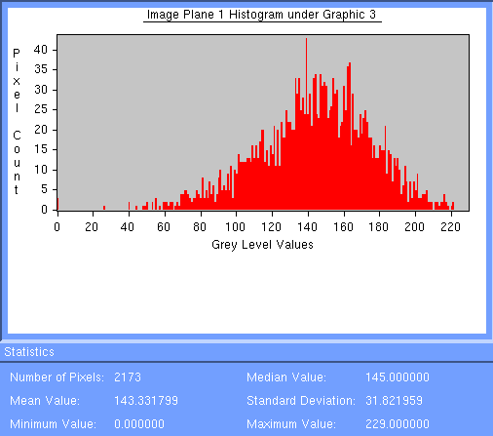
80-130 m3/h | 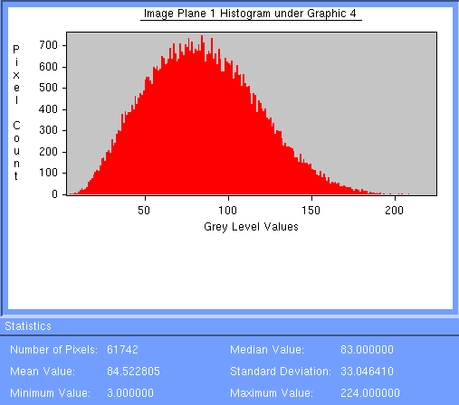 | 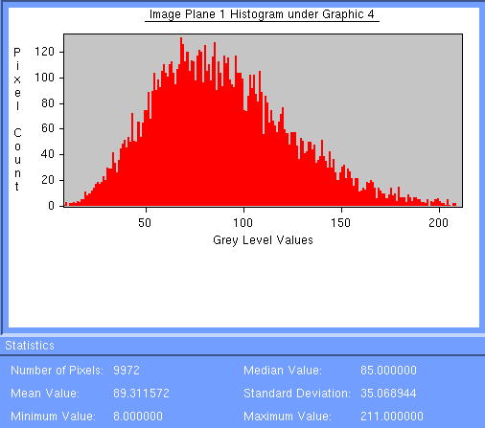 | 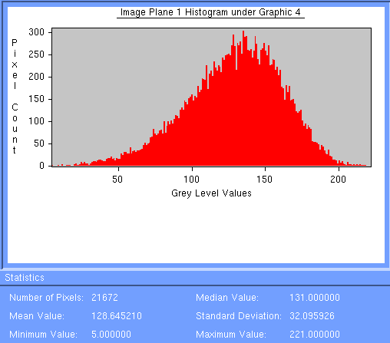 | 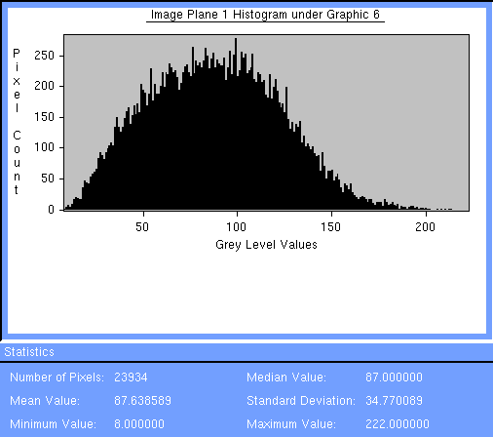 | 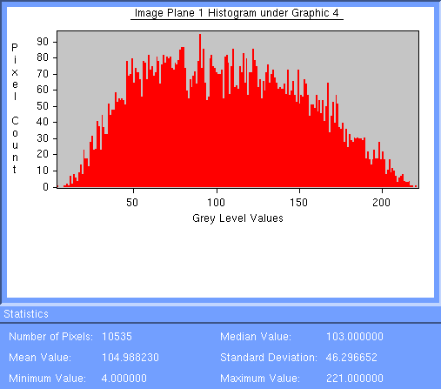 | 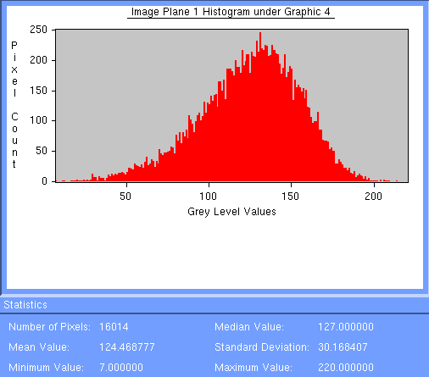 | 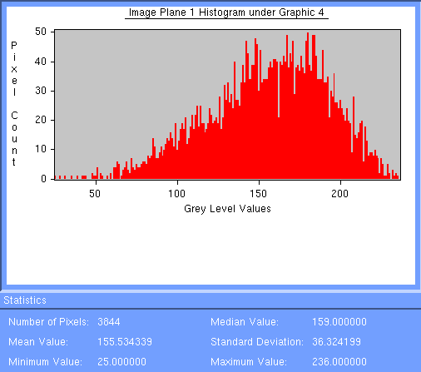
130-200 m3/h | 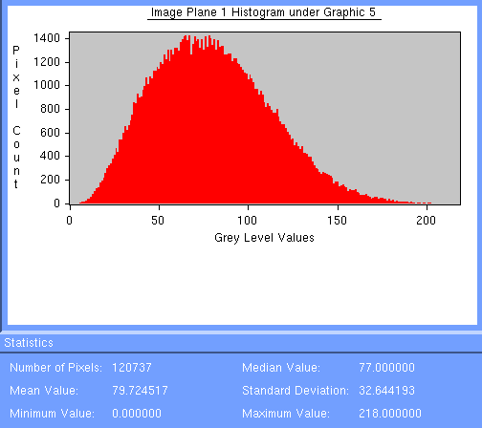 | 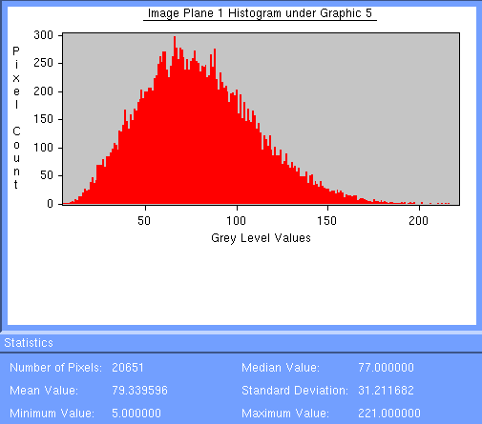 | 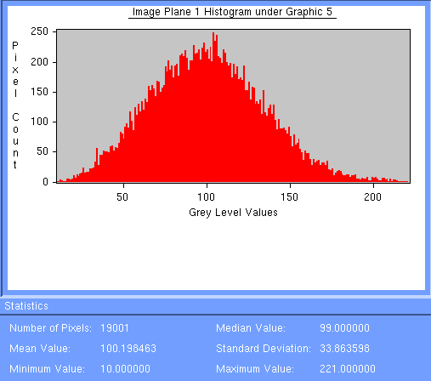 | 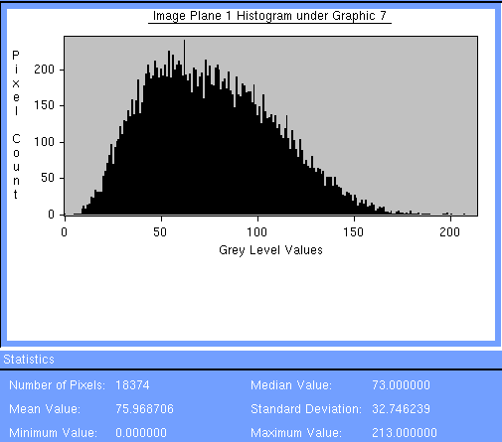 | 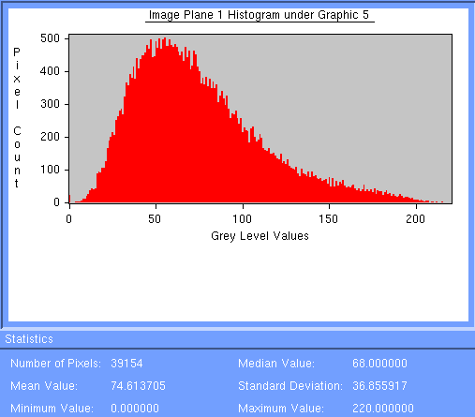 | 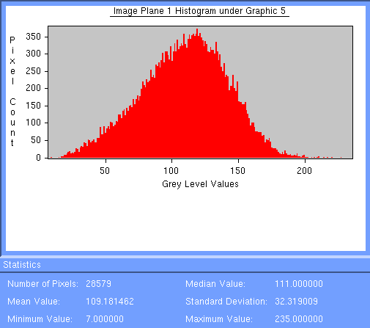 | 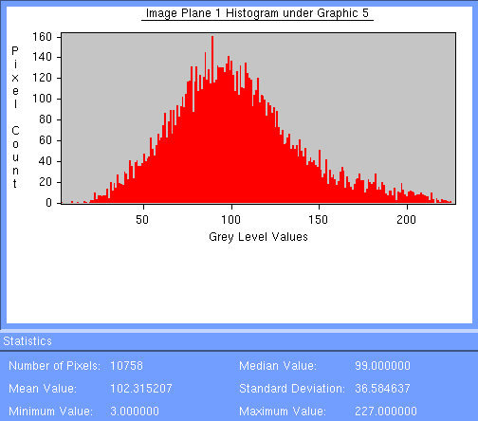
> 200 m3/h | 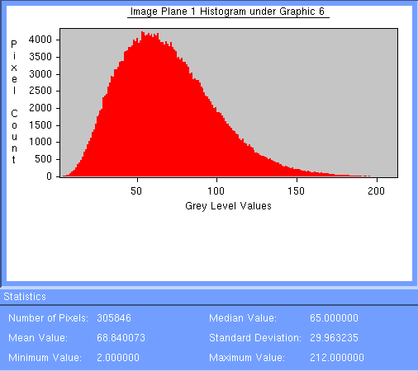 | 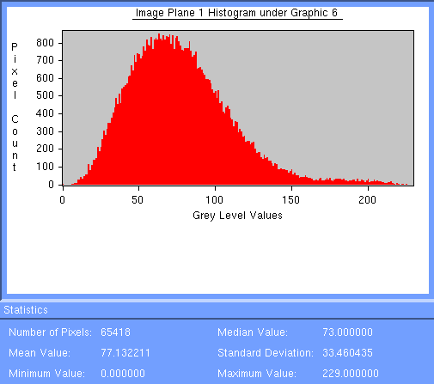 | 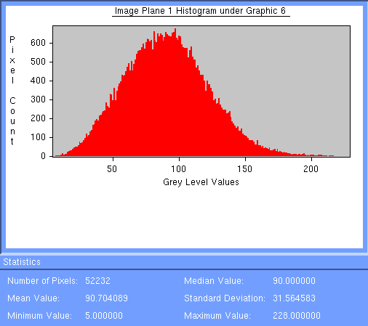 | 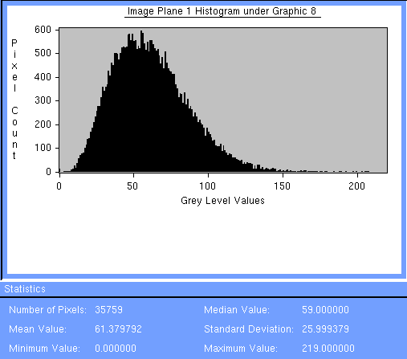 | 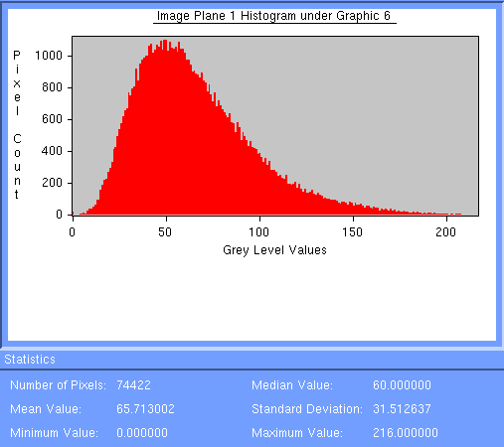 | 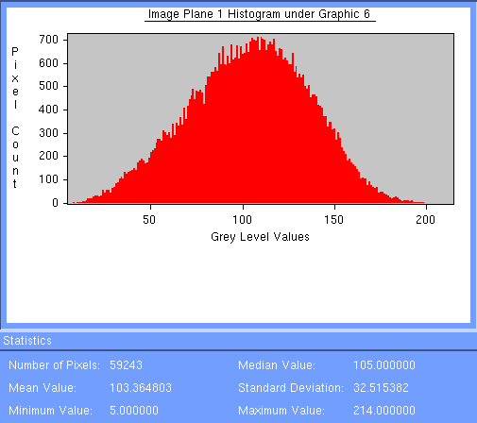 | 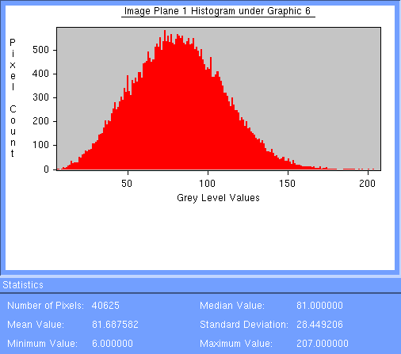
 | Ust-Illimsk | Bolshyamurta | Primorski | Ulskanski | ChunskiA | ChunskiB | Nishne A
0-20 m3/h | 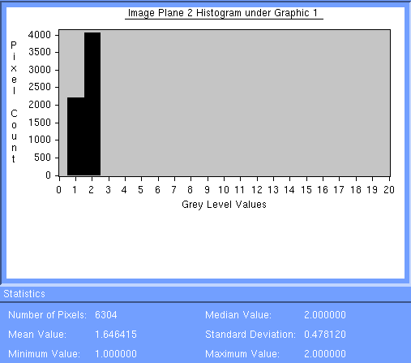 | 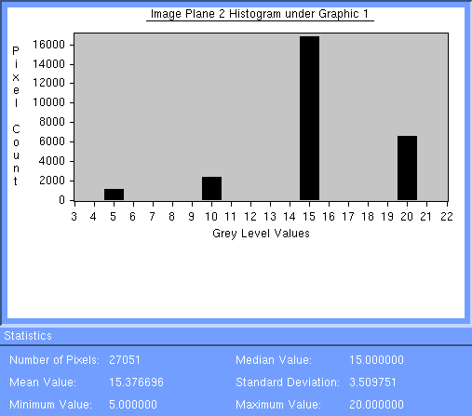 | 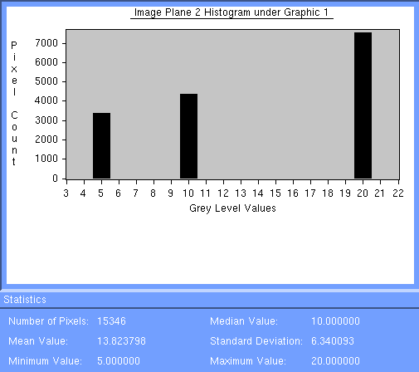 | 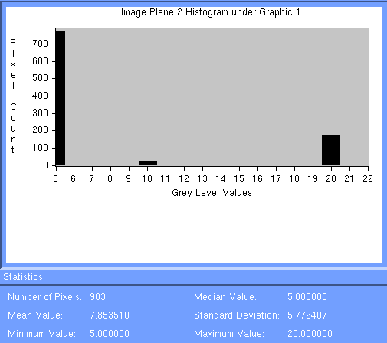 | 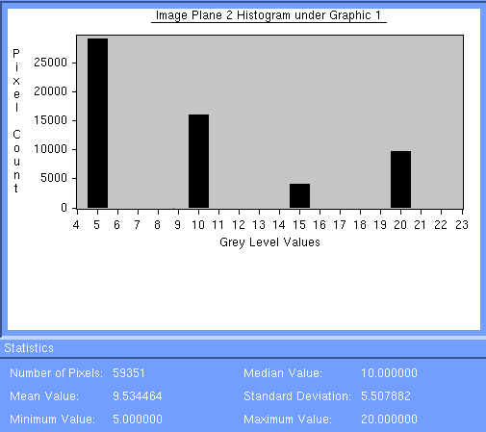 | No data | 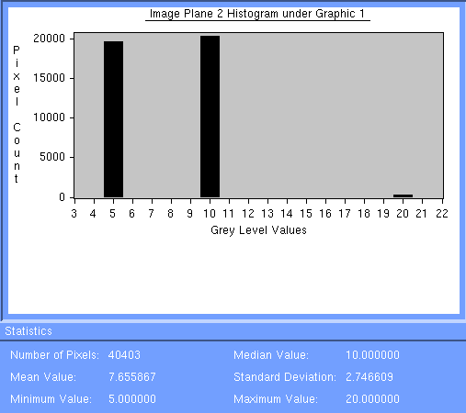
20-50 m3/h | 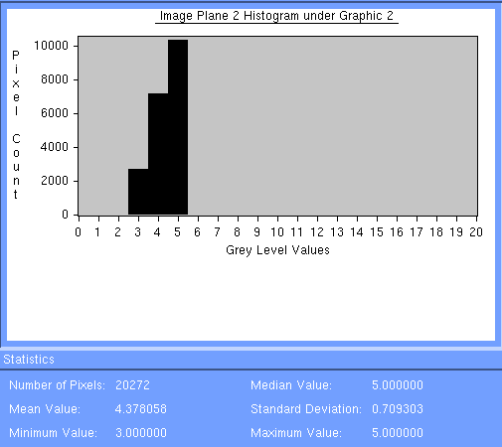 | 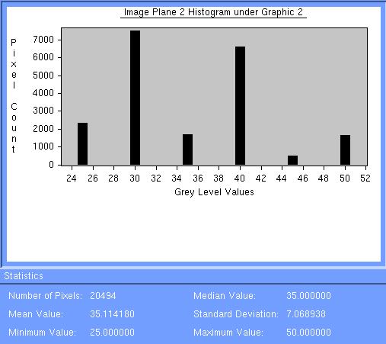 | 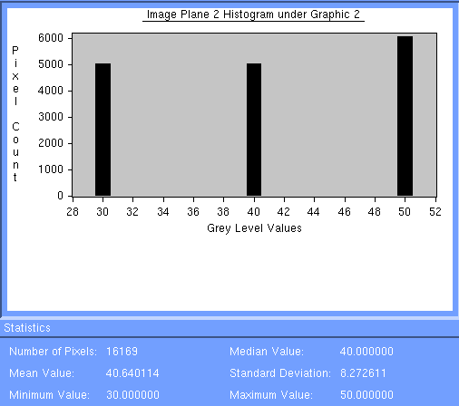 | 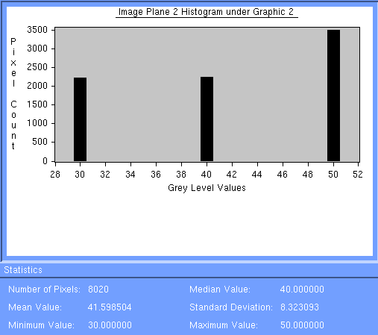 | 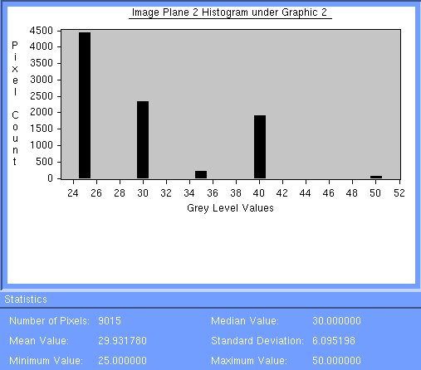 | 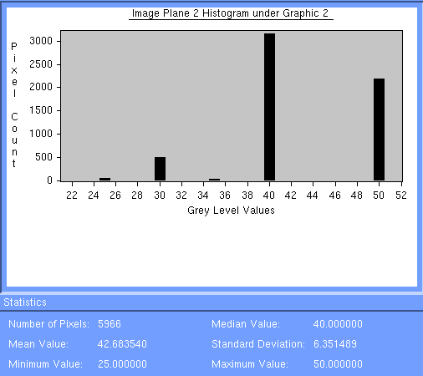 | 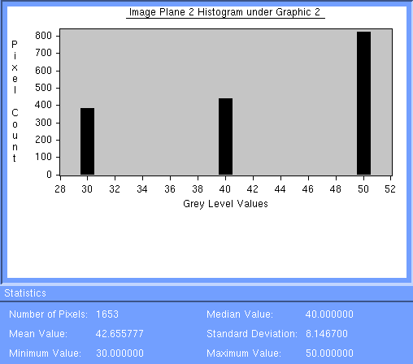
50-80 m3/h | 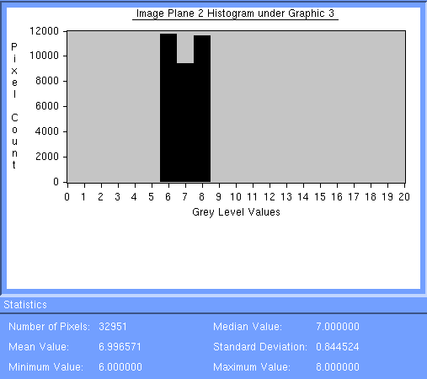 | 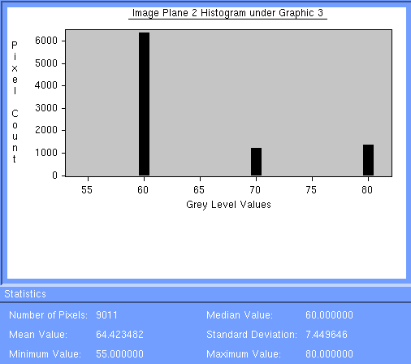 | 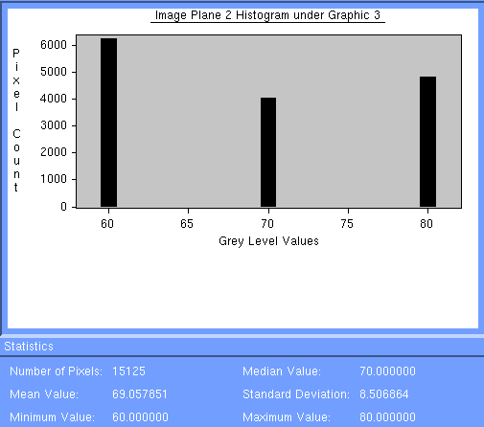 | 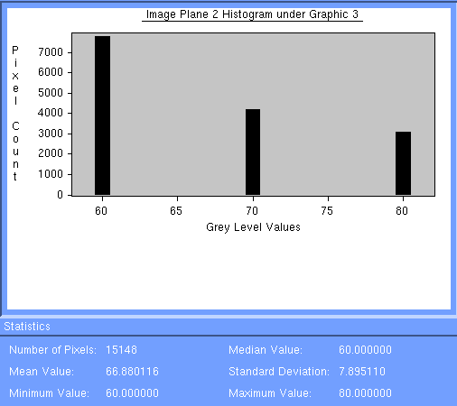 | 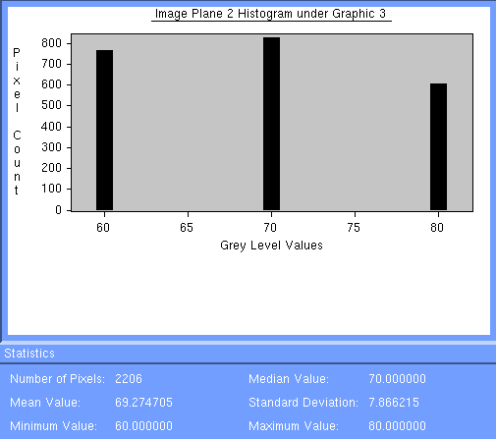 | 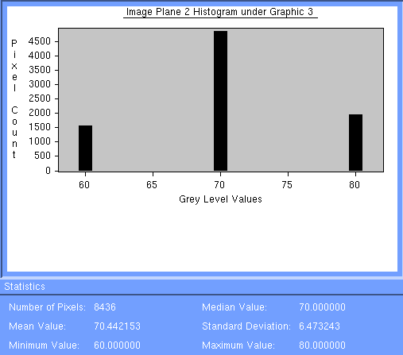 | 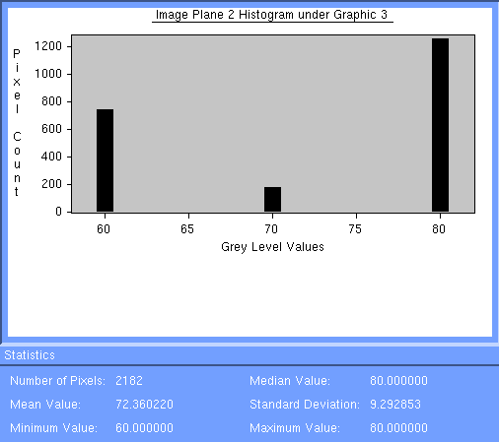
80-130 m3/h | 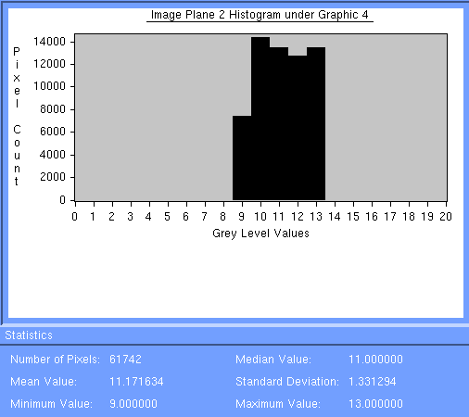 | 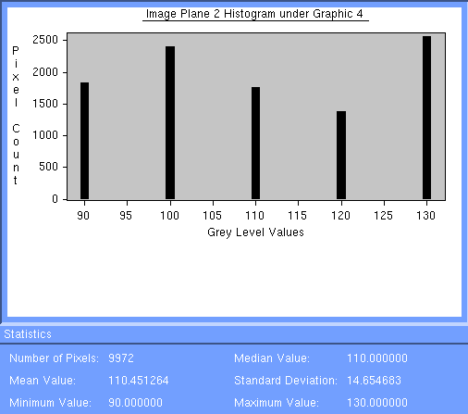 | 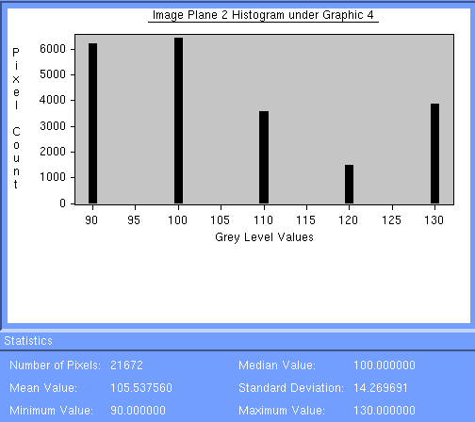 | 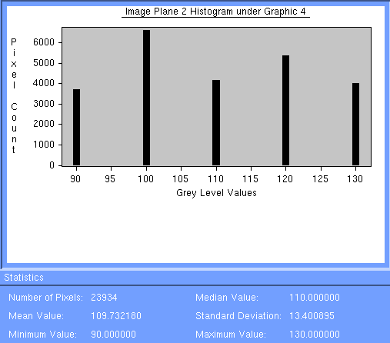 | 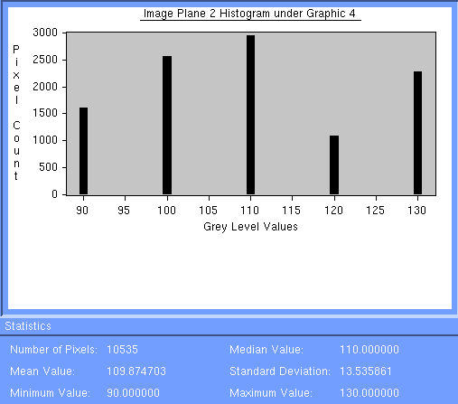 | 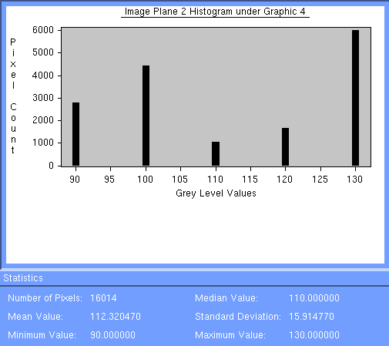 | 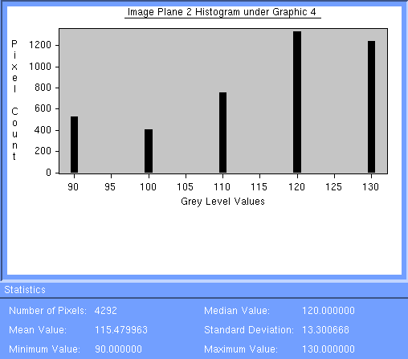
130-200 m3/h | 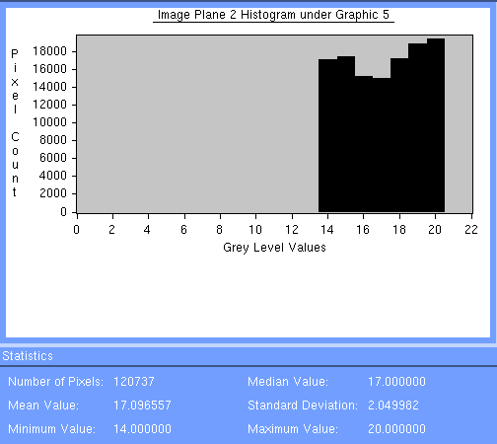 | 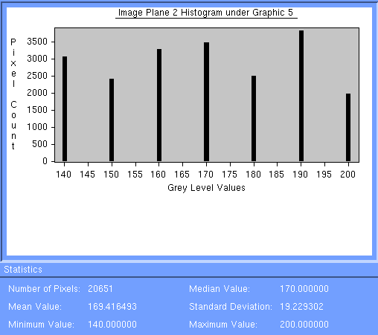 | 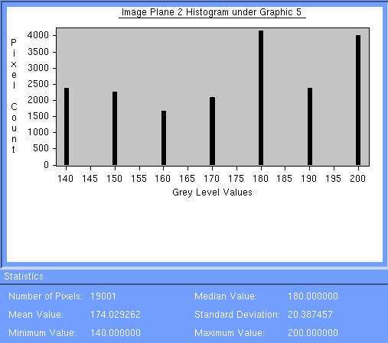 | 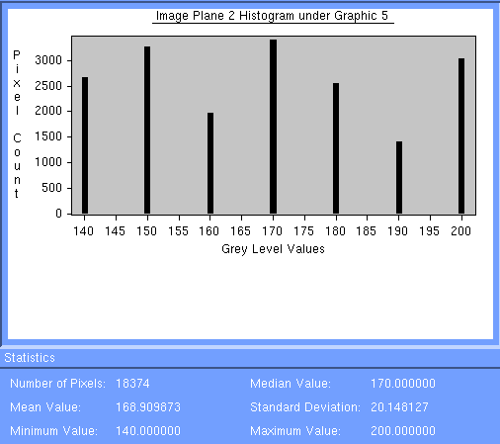 | 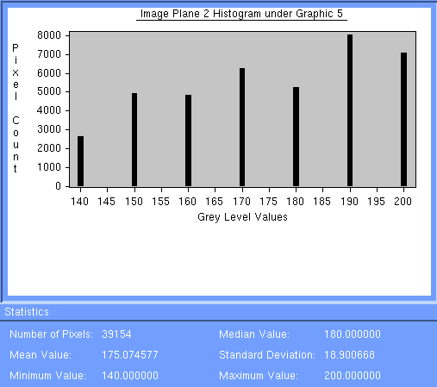 | 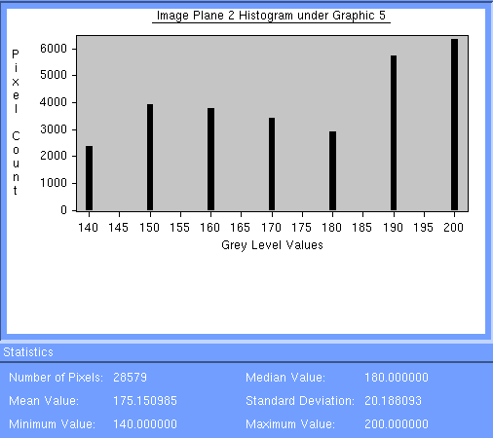 | 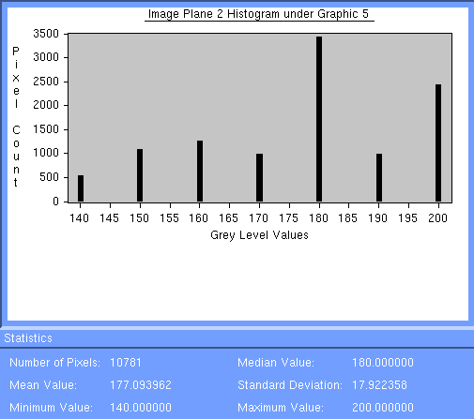
> 200 m3/h | 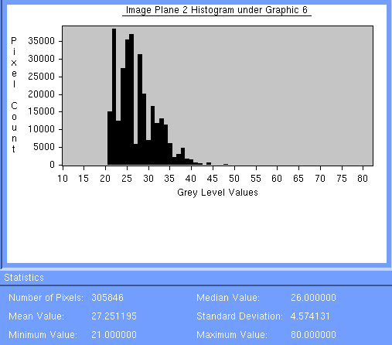 | 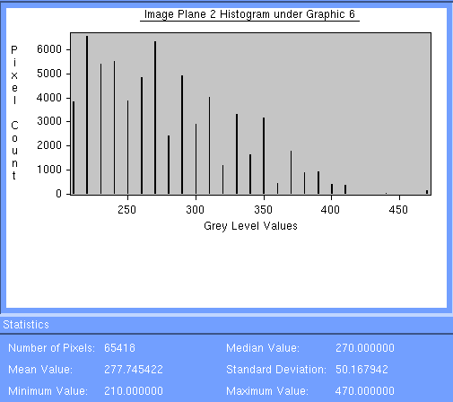 | 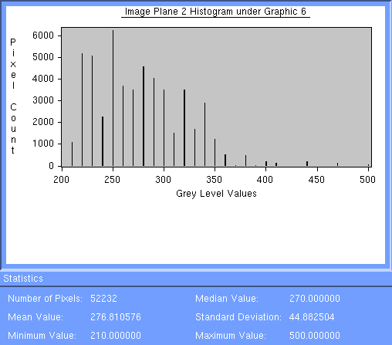 | 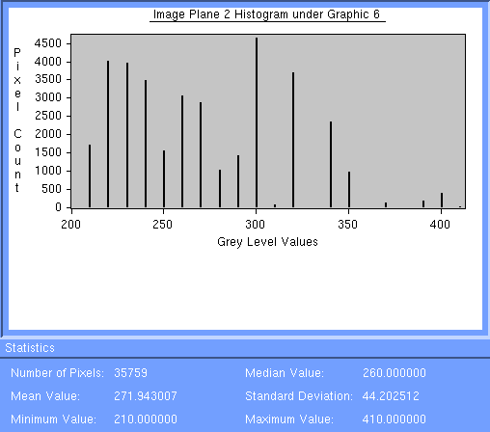 | 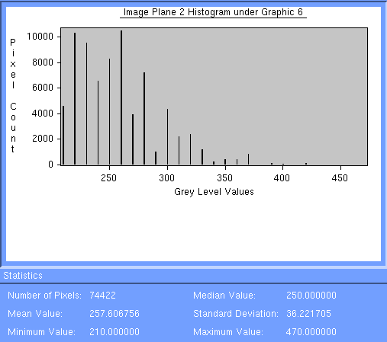 | 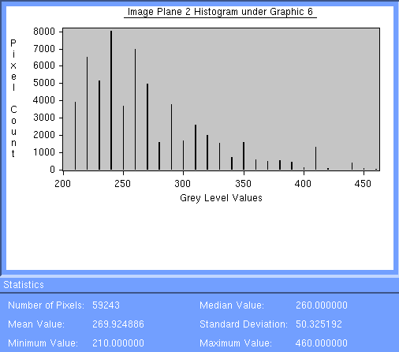 | 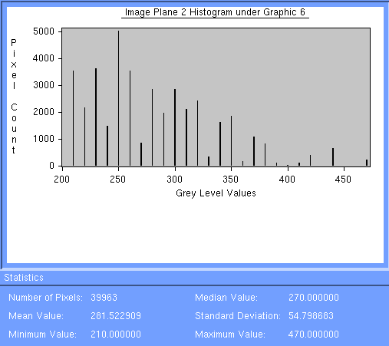
 | Ust-Illimsk | Bolshyamurta | Primorski | Ulskanski | ChunskiA | ChunskiB | Nishne A
Clear-cut | 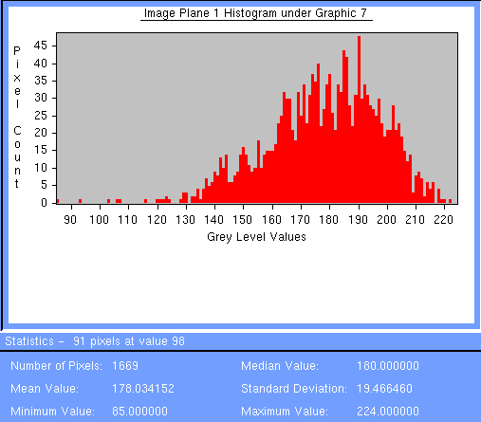 | 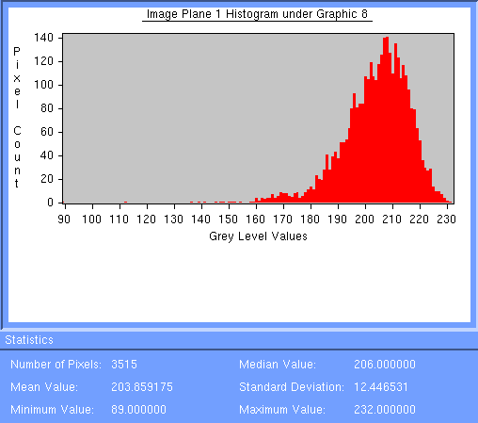 | 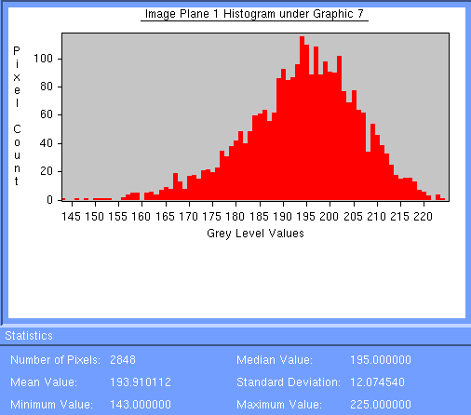 | 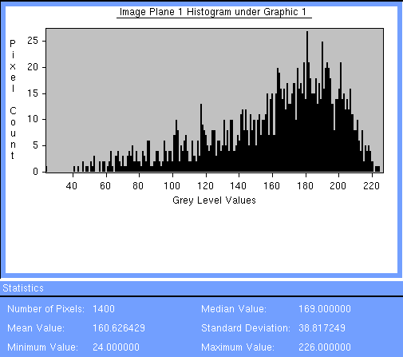 | 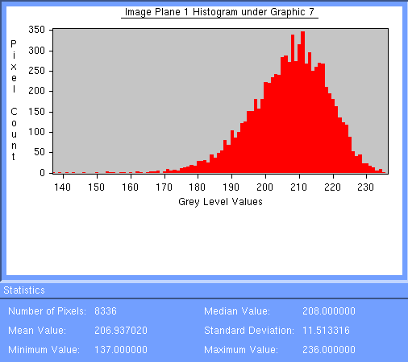 | 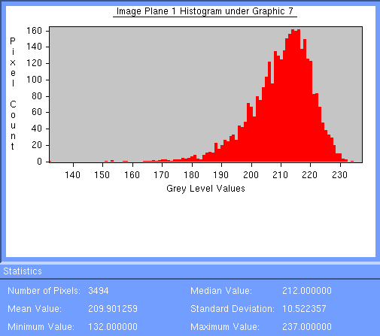
Bare soil |  | 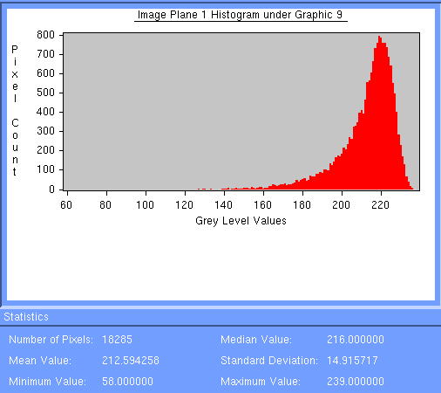
river | 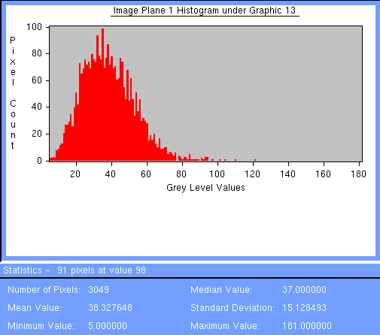 | 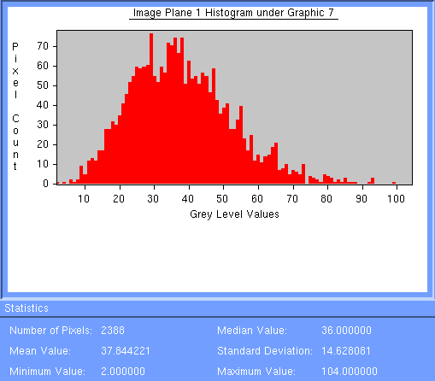 | 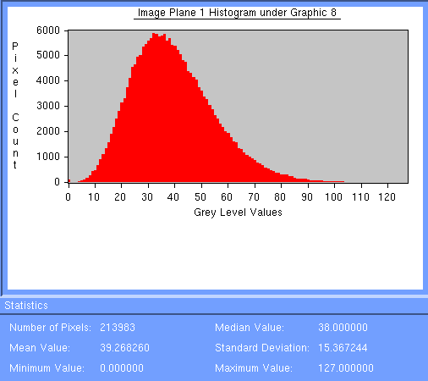 |  |  | 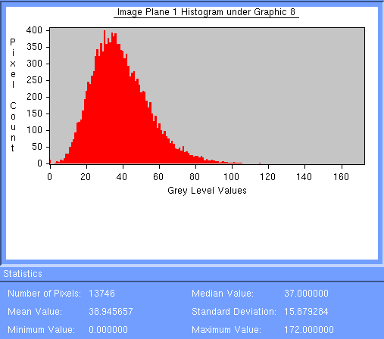
Freezin lake |  |  |  | 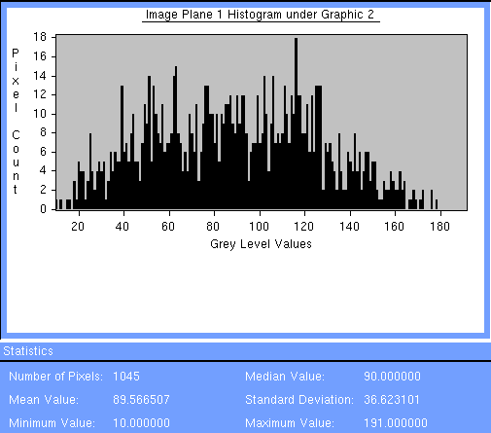

Mean coher ; Std dev  - - - - - - - - - - - - - - - -  Mean volume | Ust-Illimsk | Bolshyamurta | Primorski | Ulskanskii | ChunskiA | ChunskiB | NishneA
0-20 m³/h | 0.49 ; 0.15  ----------------------  16 | 0.54 ; 0.14  ----------------------  15 | 0.68 ; 0.11  ----------------------  14 | 0.49 ; 0.13  ----------------------  8 | 0.61 ; 0.15  ---------------------  9 | No data | 0.80 ; 0.09  ----------------------  8
20-50 m³/h | 0.41 ; 0.14  ----------------------  44 | 0.49 ; 0.14  ----------------------  35 | 0.61 ; 0.11  ----------------------  41 | 0.41 ; 0.15  ----------------------  42 | 0.58 ; 0.15  ----------------------  30 | 0.60 ; 0.11  ----------------------  42 | 0.63 ; 0.14  ----------------------  43
50-80 m³/h | 0.38 ; 0;14  ----------------------  70 | 0.44 ; 0.14  ----------------------  64 | 0.54 ; 0.12  ----------------------  69 | 0.36 ; 0.14  ----------------------  67 | 0.45 ; 0.18  ----------------------  69 | 0.54 ; 0.09  ----------------------  70 | 0.56 ; 0.12  ----------------------  72
80-130 m³/h | 0.33 ; 0.13  ----------------------  112 | 0.35 ; 0.14  ----------------------  110 | 0.50 ; 0.13  ----------------------  105 | 0.34 ; 0.14  ----------------------  110 | 0.41 ; 0.18  ----------------------  110 | 0.49 ; 0.12  ----------------------  112 | 0.61 ; 0.14  ----------------------  115
130-200 m³/h | 0.31 ; 0.13  ----------------------  171 | 0.31 ; 0.12  ----------------------  169 | 0.39 ; 0.13  ----------------------  174 | 0.30 ; 0.13  ----------------------  169 | 0.29 ; 0.14  ----------------------  175 | 0.43 ; 0.13  ----------------------  175 | 0.40 ; 0.14  ----------------------  177
>200 m³/h | 0.27 ; 0.11  ----------------------  272 | 0.30 ; 0.13  ----------------------  278 | 0.35 ; 0.12  ----------------------  277 | 0.24 ; 0.10  ----------------------  272 | 0.26 ; 0.12  ----------------------  258 | 0.40 ; 0.13  ---------------------  270 | 0.32 ; 0.11  ----------------------  281
Clear-cut | 0.70 ; 0.08 | 0.80 ; 0.05 | 0.76 ; 0.05 | 0.69; 0.05 | 0.80 ; 0.04 | 0.82 ; 0.04
Bare soil | 0.83 ; 0.06
River | 0.15 ; 0.06 | 0.15 ; 0.06 |  |  |  | 0.15 ; 0.06
Freezing lake ? |  |  |  | 0.35 ; 0.15
Orbit_frame |  | 32400_2457 | 32600_2475 | 32657_2493 | 32543_2439 | 32586_2439 | 32414_2493

